Experimentálne zariadenie na dezintegráciu vzoriek pred extrakciou
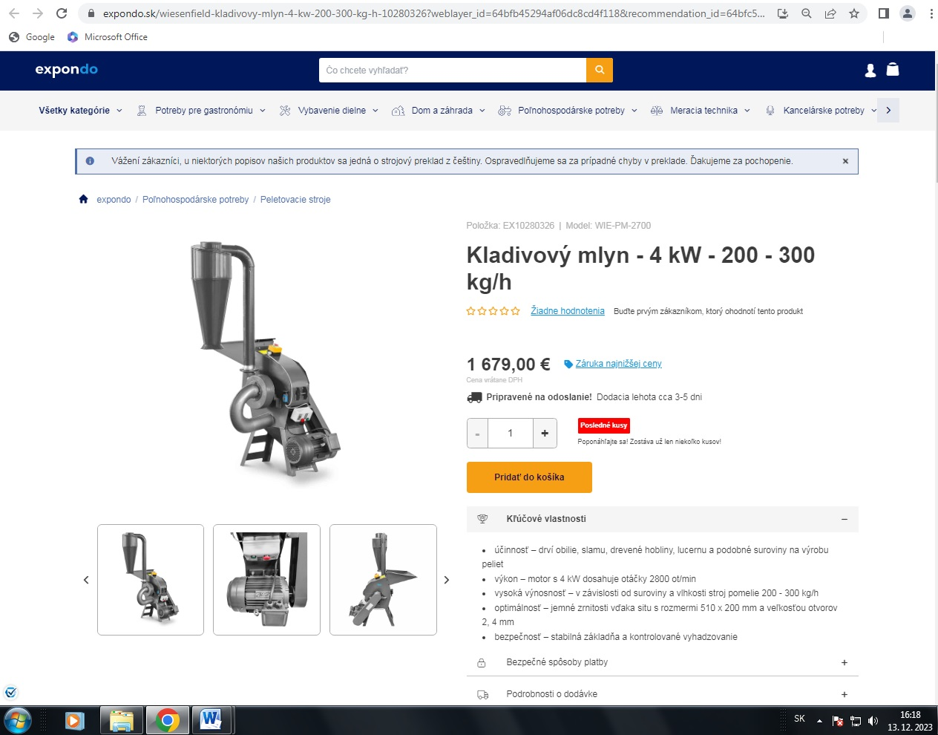
https://www.expondo.sk/wiesenfield-kladivovy-mlyn-4-kw-200-300-kg-h-10280326?weblayer_id=64bfb45294af06dc8cd4f118&recommendation_id=64bfc5e6dd801594b16e6777&product_id=EX10280326&_gl=1%2ay166r9%2a_up%2aMQ..%2a_ga%2aMTYxMTIxMjM1Ni4xNzAyNDc5NDEw%2a_ga_8Z2ZSZ9MKT%2aMTcwMjQ3OTQwOS4xLjEuMTcwMjQ4MDAyOS4wLjAuMA..&gclid=EAIaIQobChMIu9LRzNWMgwMViYuDBx25KAS-EAAYASAAEgJsqfD_BwE

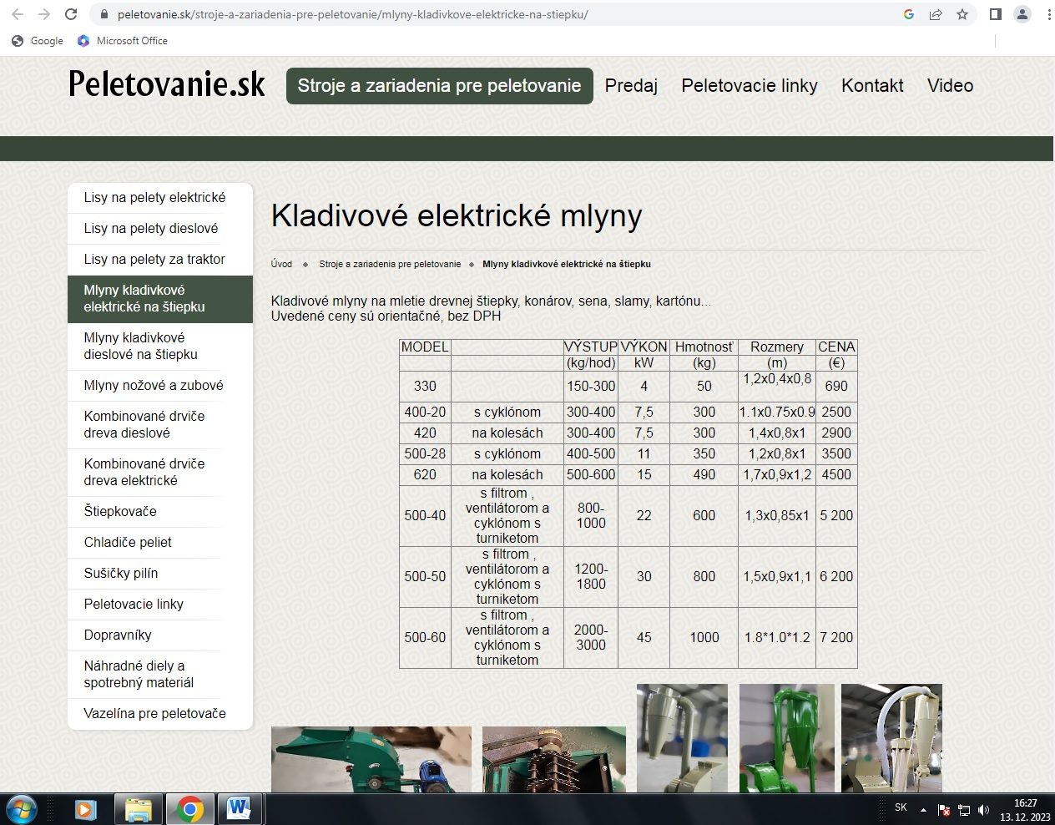
https://www.peletovanie.sk/stroje-a-zariadenia-pre-peletovanie/mlyny-kladivkove-elektricke-na-stiepku/

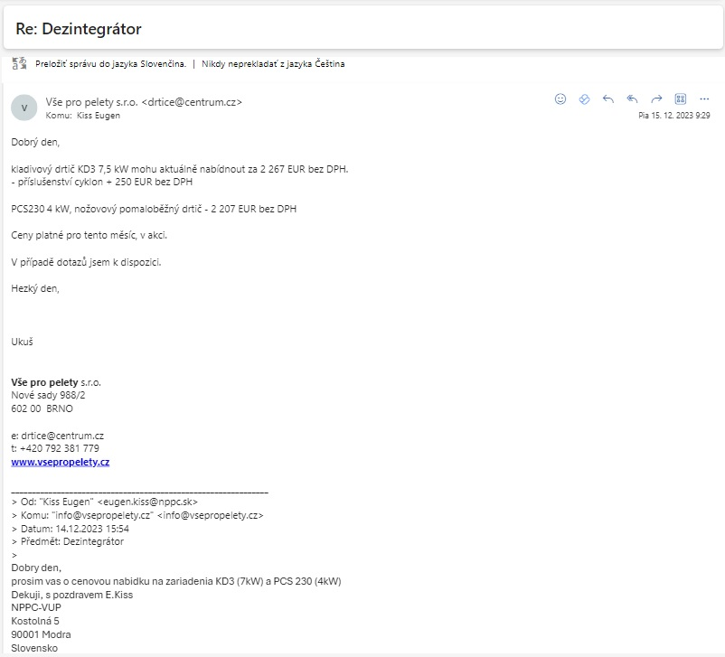
http://vsepropelety.cz/kladivkove-drtice/ (KD3, 7.5kW, 2267+250=2517Eur bez DPH)

