
8

ALFAGEN – ALUMINIUM AND AL ALLOY BILLET CASTING FACILITY
Annex 3 of Tender Documentation – Technical Specification
AL INVEST Břidličná, a.s.
Bruntálská 167
793 51 Břidličná
An open above-threshold public contract for the supply in compliance with S. 56 of Act No. 134/2016 Coll., „Public Procurement Act“, as amended, (hereinafter also as the "Act" or "ZZVZ"
Procurement procedure
1 General Information 6
1.1 List of Abbreviations 6
1.2 Introduction 7
1.3 Place of business, Project site 7
1.4 Company’s approach to the environment 8
1.5 Project purpose and objective 8
1.6 Other general requirements 9
1.6.1 Standards 9
1.6.2 Accessibility and replaceability 10
1.6.3 Safety 10
1.7 Scope of the Works – Major projected parts 10
1.8 Technical offer contents 11
2 Technical specification 12
2.1 Current state – description 12
2.2 Base requirements 13
2.2.1 Introduction 13
2.2.2 Basic technical parameters 15
2.2.3 Line layout 15
2.2.4 Melting cycle 16
2.2.5 Charging material 17
2.2.6 Anticipated Chemical Composition 19
2.3 MELTING FURNACE EQUIPMENT 20
2.3.1 Intent 20
2.3.2 Melting Furnace Scope of Supply 20
2.3.3 Reference Standards, and SPI’S 21
2.3.4 Take Off Points (TOP) 22
2.3.5 General Technical Data 22
2.3.5.1 Design Criteria 22
2.3.5.2 Furnace Shells 25
2.3.5.3 Cast steel faceplate 26
2.3.5.4 Replaceable refractory face plate 27
2.3.5.5 External guides 27
2.3.5.6 Skim apron 27
2.3.5.7 Refractory sill 28
2.3.5.8 Furnace Stirring System 29
2.3.5.9 Furnace Doors 30
2.3.5.10 General Furnace Burners and Combustion System 32
2.3.5.11 Furnace Exhaust 35
2.3.5.12 Fans 36
2.3.5.13 Refractory Lining 37
2.3.5.14 Molten Metal Receiving Port 40
2.3.6 Trough system 40
2.3.7 Ancillary Equipment 42
2.3.7.1 Melting Furnace Charging Machine 42
2.3.7.2 Rotary Salt Flux Injector (Fixed Injector) 44
2.3.7.3 Automated Dross Skimming Mechanism 46
2.4 HOLDING FURNACE EQUIPMENT 49
2.4.1 Intent 49
2.4.2 Holding Furnace Scope of Supply 49
2.4.3 Reference Standards, and SPI’S 51
2.4.4 Take Off Points (TOP) 51
2.4.5 General Technical Data 51
2.4.5.1 Design Criteria 51
2.4.5.2 Furnace Shells 54
2.4.5.3 Cast steel faceplate 55
2.4.5.4 Replaceable refractory face plate 55
2.4.5.5 External guides 56
2.4.5.6 Skim apron 56
2.4.5.7 Refractory sill 57
2.4.5.8 Furnace Doors 58
2.4.5.9 Furnace Exhaust 61
2.4.5.10 Refractory Lining 61
2.5 Required documentation 64
2.5.1 General 64
2.5.2 Drawings 65
2.5.3 Documents for construction readiness 65
2.5.4 Documents for Basic engineering 66
2.5.5 Documents for installation of the Equipment 66
2.5.6 Final Documentation 67
2.5.7 Others 67
2.6 Mechanical 68
2.6.1 General 68
2.6.2 Lubrication 68
2.6.3 Pneumatics and Hydraulics 69
2.6.3.1 General 69
2.6.3.2 Furnace specific 71
2.6.3.4 Holding furnace specific 72
2.6.4 Pneumatic tubing, hoses, fittings and ports. 73
2.6.5 Piping 74
2.6.6 Walkways, Platforms and Ladders 75
2.7 Electric and Instrumentation 75
2.7.1 General 75
2.7.2 Ambient conditions 75
2.7.3 Voltage and power supply conditions 76
2.7.4 Other conditions 76
2.7.5 Main technical features of the furnaces 77
2.8 Automation Instrumentation Equipment 87
2.8.1 General equipment specification 88
2.8.2 Melting furnace specific 89
2.8.3 Holding furnace specific 90
2.9 Control System and Automation 90
2.9.1 General 90
2.9.2 Level 1 automation system 91
2.9.2.1 General 91
2.9.3 Melting furnace specific 97
2.9.3.1 Control 97
2.9.3.2 Bath And Roof Temperature Control / Equipment 97
2.9.3.3 Specific application software 98
2.9.4 Holding furnace specific 99
2.9.4.1 Control 99
2.9.4.2 Bath And Roof And Metal Temperature Control / Equipment 100
2.9.4.3 Specific application software 101
2.9.5 Level 2 automation system 101
2.9.6 Others 102
2.10 Standardization 104
3 Scope of work 105
3.1 Structures – mechanical, electrical, instrumentation and automation 105
3.2 Designing – constructional and structural 105
3.3 Delivery 106
3.4 Spare parts 106
3.5 Supervision over installation, testing and commissioning 107
3.6 Work progress report 108
3.7 Drawings and documents – General 108
3.8 Specification of public procurement for installation work 108
3.9 Governing language 109
3.10 Others 109
4 Specific provisions 109
4.1 Assembly and testing at the Contractor’s site 109
4.2 Preparation for transport 109
4.3 Lock-out & Tag-out (LOTO) 109
4.4 Delivery to the Customer’s site 110
4.5 Technical media interface 110
4.5.1 Natural gas 110
4.5.2 Cooling water (plant wide open circuit with cooling towers) 110
4.5.3 Compressed air 110
4.5.4 Argon 110
4.6 Sub Floor or Floor Technical Room 111
5 Safety requirements 111
5.1 General 111
5.2 Requirements for mechanical safety 113
5.2.1 Protective covers and guards 113
5.2.2 Protective fencing 113
5.2.3 Safety switches and sensors 113
5.2.4 Protective brakes and emergency stop 113
5.2.5 Distance from dangerous parts 113
5.2.6 Protection against falling objects 113
5.2.7 Rigidity and stabilization 114
5.2.8 Appropriate marking and indication 114
5.3 Requirements for electrical safety 114
5.3.1 Electric shock protection 114
5.3.2 Protection against electric discharge 114
5.3.3 Safety insulation 114
5.3.4 Ensuring safe voltage 114
5.3.5 Protection against overload and short-circuit 114
5.3.6 Safety grounding 114
5.3.7 Protection against humidity and dust 114
5.3.8 Protection against electromagnetic interference 115
5.3.9 Safety marking and indication 115
5.3.10 Regular inspection and maintenance 115
6 Service and maintenance 115
6.1 Reliability 115
7 Energy 116
7.1 General 116
7.2 Heat management: 117
7.3 Hydraulics: 117
8 Training 117
8.1 Operators 118
8.2 Maintenance 118
9 Painting 119
9.1 General 119

- General Information
- List of Abbreviations
Customer AL INVEST Břidličná, a.s.
AIB AL INVEST Břidličná, a.s.
MCC Motor Control Center
IPPC Integrated Pollution Prevention and Control
EU ETS EU Emissions Trading System
TiB Titan Bor
CS, CZ Czech language
UT Ultrasonic testing
PLC Programmable Logic Controller
HMI Human-Machine Interface, e.g. a touch screen
PC Personal Computer
Remote IO Remote input/output
MES Manufacturing Execution System
ERP Enterprise Resource Planning
OT Operational Technology
VPN Virtual Private Network
ICMP Internet Control Message Protocol
UAC User Account Control
LOTO Lock-out & Tag-out
MPCB Motor Protection Circuit Breaker
Y/D Y/D Starter
IGBT Insulated Gate Bipolar Transistor
LPBS Local push button stations
CPU Central Processing Unit
SAFETY PLC Safety Programmable Logic Controller
GSM Global System for Mobile Communications
LTE Long-Term Evolution
SSL Secure Sockets Layer
HW Hardware
SW Software
SNMP Simple Network Management Protocol
ICMP Internet Control Message Protocol
UAC User Account Control
SIEM Security Information and Event Management
TEFC Totally Enclosed Fan-Cooled
DCS Distributed Control System
CPU Central Processing Unit
OPC Open Platform Communications
OPC UA Open Platform Communications Unified Architecture
DHCP Dynamic Host Configuration Protocol
TOP Take over point
OEM Original equipment manufacturer
GHG Green house gas
SPI Serial Peripheral Interface (SPI), a common term used in in process control and automation systems.

- Introduction
Company AL INVEST Břidličná, a.s. (“Customer”) with its 800 local employees is a leading European producer of packaging materials and rolled semi-finished aluminium products. Its origins date back to the year 1852 when the construction of the flax processing company was launched. The company is a member of the European Aluminium Foil Association (EAFA), Packaging Institute SYBA, Southern Bohemian Chamber of Commerce and Czech Testing Laboratories Association.
Customer’s state-of-the-art research and development unit and certificates of ISO 9001:2008, ISO/TS 16 949:209, BRC/IOP, AD 2000 WO, EN 15088 guarantee the quality and reliability of its products. The company also holds various packaging and automotive certificates which are relevant for the subject of the present project.
Customer belongs to MTX Group a.s. – an industrial-business holding company based in Prague which mainly focuses on management, financing and coordination of manufacturing and trading member companies. In the Central European area, the company has its agencies in the Czech Republic, Germany, Austria and Poland. It primarily trades in metallurgical semi-finished products, production and sale of fuel coke, aluminium and copper products.
MTX Group a. s. is a joint stock company incorporated in the register of companies kept by the Municipal Court in Prague, Czech Republic, Section B, File 10649, as of 31st March 2006. The company has its registered office at Štěpánská 621/34, 110 00 Prague 1.
MTX Group a.s. was founded by Petr Otava Sr. In 2015 he was succeeded by his son – Petr Otava Jr. MTX Group expands remarkably to abroad, its activities affects a number of industrial branches. It manufactures parts for the automotive industry, and is involved in metallurgy and food processing as well.

- Place of business, Project site
The project will be implemented at Bruntálská 167, 793 51 Břidličná, which is the registered office of Customer. The whole affected area is a property of Customer. The project site will be a place of the overall coordination and management of the project, primarily the installation of new manufacturing facilities and constructions.
The project is planned to take place in the regions defined by the Czech government resolution No. 321/2021. The city of Břidličná lies in the Moravian-Silesian Region which is treated as economically problematic region in the resolution. The Moravian-Silesian Region is one of three coal-mining regions in the Czech Republic, as registered in the so-called “EU Coal Platform”.

- Company’s approach to the environment
Customer is committed to assume a part of responsibility for the conservation and protection of the environment within the region. In 2018 a voluntary agreement was signed with the Moravian-Silesian Regional Authority which governs the obligations of individual parties. The obligations deal with e.g. reduction of dust nuisance, compilation of a power management study and a comprehensive power management conception which would reduce the power demand of production and service operations. The agreement also covers the replacement of diesel forklift trucks with electric ones.
To guarantee the continuous quality of final products and to achieve the sustainable growth of production the most important strategic investments are not only those to the technology upgrade but also those of the environmental nature which address the environmental protection and predominantly the air pollution control. That is how the company complies with the environmental management requirements as per ISO 14000 and prepares itself to acquire this certificate.
Considerable financial resources are expended every year for a comprehensive solution and improvement of the environment.
AL INVEST Břidličná a. s. is also a member of the EKO-KOM collective compliance system.
The company is a holder of the Integrated Pollution Prevention and Control (IPPC) permit the parameters of which are always complied with on an annual basis.
Machinery used in the manufacturing plant is registered in the EU ETS system. Emission assessment is compiled annually.

- Project purpose and objective
The subject of the project concerns replacement of all the existing melting and casting technology. The technology encompasses both the melting and the casting furnaces for billet casting and the continuous casting technology.
The project objective is the implementation of the state-of-the-art technologies with a reduced energy demand, primarily the reduction in natural gas and electrical consumption (total energy consumption need to be reduced by min. 35 %) in the melting and casting procedure which would also lead to a considerable reduction in the environmental impact. In addition, the implementation of the state-of-the-art technology will result in reduced waste from the technology and most recent control devices used to achieve a higher level of automation.
The new technologies feature melting of primary aluminium plus aluminium scrap in melting furnaces and new casting technology with a lower power demand due to a lower natural gas / electrical consumption within the melting / casting process, namely with the newly implemented technology of regenerative burners and other state of art technology which would lead to a considerably reduced environmental impact by emissions.
The project also includes construction of new buildings within the company premises, acquisition of new machinery and construction of necessary utility lines and directly associated investments.
Contractor shall make the best effort to comply with the standards listed herein. Contractors may choose to seek deviation and obtain approval for alternatives if significant cost differential is anticipated. Under no circumstances shall the intended performance or safety aspects be compromised.

- Other general requirements
- Standards
All equipment supplied, and related work (layout, installation, and operation) shall perfectly comply with all CE and EU-local applicable laws and regulations, including, but not limited to, those relating to environment, health and safety of workers.
All equipment designed for fabrication in the European Union (EU) shall be designed to use commonly available metric standard commodities - e.g. mm thickness aluminium sheet, plate etc.
Design must comply with standards. Documentation of compliance must be provided to customer. Any OEM components supplied, which are not a part of the overall assembly, must be CE marked. The following list of directives shall be reviewed for applicability to the equipment being produced. If the event that the Contractor´s standards are not present the following EU directives need to be applied for their products.
- 2001/95/EC – Product Safety Directive
- 2004/108/EC – EMC Directive
- 2006/42/EC – Machinery Directive
- 2006/95/EC – Low Voltage Directive
- 2009/105/EC – Simple Pressure Vessel Directive
- 2009/125/EC – Eco-design requirements for energy related products
- 2037/2000/EC – Ozone depleting substances
- 842/2006/EC – Fluorinated Greenhouse Gases
- Guidelines for Handling Molten Aluminum (Available Online)
- 94/9/EC – ATEX directive
- 97/23/EC – Pressure Equipment Directive
- 92/58/EEC – Safety and/or Health Signs

The use of parts which are discontinued by manufactures is not allowed. Exceptions must be approved by Customer.

- Accessibility and replaceability
All working parts must be designed so as to ensure the easiness of their control, inspection, monitoring, lubrication and replacement during minimum down times, with the highest possible safety and ergonomics.
- Safety
All the equipment and machines must be designed with and incorporate safety devices wherever there is potential risk for the operators, and with adequate measures for safe access to the staff and the vicinity of the machines for operation and maintenance. These items must not only include the conventional elements of the machinery but also additional covers, guards, barriers, steps, ladders, railings, coupling guards, belt covers, transmission, active scanners and chain covers etc. That are necessary for safe and ergonomic operation of the equipment. All the details of the structures that are necessary for correct operation and maintenance must be specified by the Contractor. The Contractor shall specify the safety needs which may produce compulsory blocking between functions and consequences for the operation.

- Scope of the Works – Major projected parts
The purpose of this document is to specify the technical parameters of the melting and alloy of aluminium via melting and holding furnaces for horizontal billet casting line. The defined technical parameters are binding for the deliveries within this public procurement. The submitted bids must meet these technical parameters.
The delivery concerns the aluminium melting and holding furnaces for horizontal billet casting line, including supervision of the installation. The delivery includes the following envisaged parts and components:
- Two (2) Melting furnaces with all related auxiliary systems (stirrer, refining unit, hydraulic, media, electric/automation) including refractory material / lining.
- One (1) Holding furnace with all related auxiliary systems (hydraulic, media, electric/automation) including refractory material/lining.
- One (1) Charging machine
- One (1) Skimming machine
- Communication with the parent system
- Mechanical, electric, instrumentation, automation general standards
- Securing the working sites according to applicable standards
- Compliance with hygienic limits upon occurrence of all hygienic factors which may affect the employees’ health and their risk level for the personal health during particular shift (Act No. 258/2000 Coll., as amended, namely Section 37 on the Protection of Public Health and implementing provisions).
- CE declaration of conformity
- Documents, certificates, labeling of control switches, selectors, tables, tags, etc. in Czech
The Customer hereby points out that the present list is not exhaustive and may not necessarily establish a complete scope of the Works for the Contractor.
The major work of scope includes the following: Design, purchase of materials, manufacturing, assembling, inspection, painting, packaging, transportation, erection and commissioning supervision (erection performed by the Customer), refractory installation has to be fully covered by the Contractor (man power for refractory installation within Contractors scope), performance tests, performance guarantee, training, and manuals.
The Contractor should carry out this project from design to the performance tests based on this purchase specification. As to possible modifications that may occur in the process of conducting the project, the Contractor shall discuss with and get a written approval from Customer.
The Contractor is encouraged to suggest, through a technical proposal, more advanced technologies, and design contents than those described in this purchase specification.

- Technical offer contents
Following documents shall be provided with transmittal of the offer:
- Detailed technical description of the entire line (including description of individual sub-devices / equipment) – including design criteria for melting and holding furnace.
- Estimated layout indicating the overall arrangement (top and side view) and configuration - including sub-devices,
- Estimated places with elevated noise level (above acoustic pressure level L 82 dB - measured at a height of 1.2 m above the floor)
- Estimated consumption at take over point (TOP) of cooling water, process media (compressed air, argon, oxygen ... as required for the scope) and their quality requirements (data shall be understood as basic information – but fitting 90 % to final values confirmed during basic engineering) - minimum content:
  - Temperature (°C): Supply line and delta (between supply - / return line)
  - Pressure (MPa): Supply line and delta (between supply - / return line)
  - Flow rate (m³/h): Constant and peak
  - Quality
  - All other key requirements as per corresponding media
- Estimated HVAC requirements (electric equipment, fans, hydraulic equipment, etc.)
- Estimated installed electrical power and calculation of electrical energy consumption per metric ton production (kWh/t)
- Estimate natural gas consumption per metric ton production (kWh/t) for:
- Melting cycle (from start of charging up to next start of charging).
- Average as per one year including year stoppage and other stoppages (preventive or production related).
- Estimate oxygen consumption per metric ton production (kWh/t) for:
- Melting cycle (from start of charging up to next start of charging for the incineration process).
- Average as per one year including year stoppage and other stoppages (preventive or production related).
- The Contractor shall provide with their technical offer a block diagram to demonstrate they understand how this oxygen lance will function in the atmosphere of the furnace. – valid in case of offering oxygen lance instead of traditional incinerator.
- In case of using a traditional incinerator (instead of oxygen lance), the Contractor has to add required kWh/t of the incineration burner to the melting energy consumption.
- Refractory Lining Detail with your Calculations.
- A non-binding estimate of the annual dross produced with a similar or peer furnace, with similar organic loading = higher than 1 % up to < 5 % VOC level of total charge*.
- A certificate from a peer customer of the supplier testifying to the reduction in cycle time which the customer was successful in realizing thru the adoption of their earlier supplied PMS/EMS system.
- Filled design criteria for melting furnace as per chapter 2.3.5.1. and for holding furnace as per chapter 2.4.5.1.
- Single line diagram with TOPs.
- Flow diagrams for each media with TOPs
- Other important information (accessories or production method) not specified above which the Contractor considers to be worth mentioning to the Customer in the technical offer to ensure safe and reliable functioning of the line.
- Filled prefered equipment vendor list.
- OPEX costs per produced MT – split into:
- Energy costs
- Consumable costs
- Maintenance costs
- Capital spares (part of commerical offer)
- Wear parts, consumables required for the first 6 months of production
- Man power requirement per shift
* it is to be understood that dross is the product of scrap oxidation, which floats to the top of the molten bath.
- Technical specification
- Current state – description
The operator is preparing the charge using the handling devices. The charge consists of three input raw materials: primary pure aluminium, internal aluminium scrap and external aluminium scrap. Using the forklift truck with a charging bucket, the operator drive the charge into the melting furnace (18 t). Two gas burners with adjustable power melt the input material. The melting furnace is connected to the parent control system which controls the movement of the ceramic partition for the correct melt level. With the metal melted, the operator draws the skims off its surface. A liquid metal with a temperature of 720 °C comes off the furnace. A sample of the liquid metal is taken and the chemical analysis of the melt is performed. The liquid metal is then processed in the refining unit where the melt is being refined (using the injected refining salts). The melting furnace is also filled with alloying elements and pre-alloys (as per the required formula). As soon as the proper chemical composition of the melt is achieved (based on the sample taken), the liquid metal is poured from the melting furnace to the casting furnace. A plugging bar is manually drawn out of the casting furnace. A liquid metal with a temperature of 720 °C comes off the casting furnace. The melt continues through metal distribution system to deggasing unit and filtration unit where it get rid of impurities. After filtration the melt ends in casting line, where billets are produced. The casted billets are then processed according to the particular Customer’s requirements.
The production of billets is currently controlled by the SIEMENS control system. The line is connected to the parent system MES (SYBAS).

- Base requirements
Apart from the delivery of the items specified above, the Contractor is also expected to provide supervision over the entire installation process. The supervisor must be present at the installation site (from 8 am to 6 pm on weekdays and from 8 am to 12 noon on Saturdays). Whenever the supervisor is absent from the installation site, he/she must be available on his/her phone for consultation (24/7). Supervision forms a part of the price quotation, at maximum possible amount. Furthermore, the Contractor is responsible for commissioning the entire working site, so that the whole line is fully functional. The Contractor is present during Cold Commissioning, Start-up and Hot Commissioning, Initial Operation Tests and Performance Tests as well.
Take over points, including conversions, will be prepared by the Customer as per the project documents provided by the Contractor. Within the delivery, the Contractor will submit the technical specification for the practical completion of the Works so that the Customer is able to prepare and arrange for the necessary conversions before the delivery itself which would enable the operation and compliance with all the standards applicable to the operation. The technical specification must define all the requirements for the line, such as: take over points, layout, building foundations (loads, pits, etc.), climatic conditions and requirements set out by the relevant occupational health and safety standards, so that the line is allowed to be put into operation.
The line must comply with the noise and hygienic limits (with technological load). The limit of the acoustic pressure level L_{A} must not exceed 82 dB in the place where the operator will move (measured at a height of 1.2 m above the floor).
The line must comply with all statutory requirements and provisions concerning the protection of the environment.

- Introduction
- It should be understood by all parties that, today’s forging producers have limitations which ensure a minimum percent prime metal input as prime is perceived as a clean input. Economics and the race for recycling will compress this minimum over time to a reasonable level in the single digits. Some traditional clean scrap melting equipment may fit well within the scope of the materials processed today and the Customer project team has been active communicating on this regard with some of the various furnace supply companies. The input materials that Customer intends to consume in the years forward are considerably different from the traditional clean manufacturing scrap which offers no attractive recycle discount when compared to prime remelt ingot. We will be most interested in companies who are willing to work with our plan of adding a scrap with average of 2–3 % Volatile Organic Contents (VOC), from third party or post consumer sources with what we consider to be clean internal scrap containing less than 1 % VOC to a charge containing a small amount of prime.
- We want your assistance, by helping us move our thoughts forward as we purchase a furnace today, anticipating the moderately clean material in the future.
- Forging products are extremely fatigue sensitive to coarse intermetallic and internal inclusions and forging surface defects. To overcome this surface defect sensitivity, Customer intends to peel/scalp the as cast surface and this material will be a minor portion of the material being re-charged into the melting furnaces, or that which contains less than 1 % VOC. The coarse intermetallic and internal inclusion sensitivity originates with the incoming scrap, and this is normally overcome by traditional settling, degassing and filtration processes and procedures at the connected downstream process.

The focus of this request is to solicit your feedback in an offer format, for a series of melting and holding furnaces for our new facility. The success of our project is based on four key points, for Customer‘s project team, listed in priority, are as follows:
- Minimize the amount of GHG’s which are generated in our process. This is measured by kWh/t of natural gas and electricity consumed during the scrap hearth drying, melting, and holding-casting portions of our process. The total target is 650 kWh/t, over the entire year’s production when considering the three steps we just mentioned.
- This project’s focus and thus funding is based on substantial reduction in green house gasses, consequentially we have chosen Roof Mounted Electrical Resistance Heaters at the holding furnace as our heating means. In doing so, insulation at the walls, hearth and roof becomes paramount in that every kW of energy lost thru the walls or structure must be replaced with additional energy to replace the heat which is lost. As a Contrator on this project, we encourage you to choose well respected high alumina materials in contact with the molten aluminium and hyper insulative layers near the steel walls. Eventually, we will be asking for very specific Product Acceptance Tests and Gurantee’s and thus, we ask you to keep this in mind because every kW you keep from escaping to atmosphere will help you meet or exceed our expectations.
- Minimize the amount of GHG’s carried with the prime and scrap inputs. Scrap inputs vary considerably in the marketplace, most clean materials containing less than 1 % volatiles which is in high demand making the cost of these inputs close to or at par with prime in cost. The direction, on the short term will be to bring in relatively clean materials but with volatiles up to 3 % in total charge and in one charge up to 5-7 % in total, Volatile Organic Contents (VOC)* which will open the door to consume a greater percentage of third-party manufacturing scrap.
- To minimize the concentraton of inclusions which are trapped in the liquid after melting, by reducing the moisture and VOC’s which are submerged during melting, including the steps in the melting furnace of Rotary Flux Injection followed by settling prior to transfer to the holding/casting furnace. We estimate that, based on industry experiences the Rotary Flux Injector plus 45 minute settling can reduce the total inclusion content, as measured by PoDFA by 25-30 %, meaning that if our average inclusion count prior to Rotary Flux Injection is 0.4 mm²/kg then at transfer we should experience an inclusion concentration of 0.3 mm²/kg.
- Minimize the Capital Costs (CAPEX) and Operating Expense (OPEX), which is the normal game however, in this case the importance or priority of this item is less than the first two.

* it is to be understood that Melt Loss is the total of the moisture content lost to evaporation plus the Volatile Organic Coatings (VOC’s) which are lost during scrap heating and incineration.

- Basic technical parameters
- Final product: Horizontal Cast Forging billets
- Estimated capacity of cast billets: 25 000 tons/year (330 working days)
- Range of the molten metal process temperatures: 680–790 °C
- Estimated casting capacity: 3,5 – 4,7 tons/hour
- Input material processed: See chapter 2.2.5
- Output Alloys produced: See chapter 2.2.6
- Contractor needs to count with production in 330 working days (14 days year plant shut down and each week 8 hours scheduled shut down for preventive maintenance).
- Contractor needs to define down time = no production time based on machine down time (unscheduled break downs and scheduled breaks between casts).
- Line layout
This is the preliminary projected floor plan of the hall section, indicating the area intended for the process (Fig. 1)
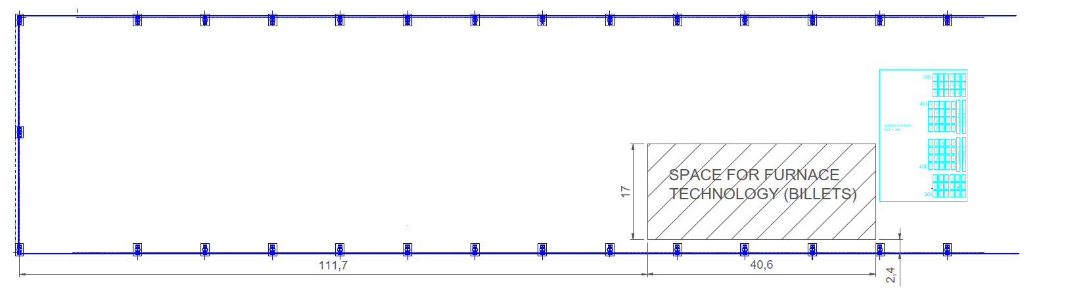
Fig. 1: Available area for Furnaces and accessories for billet casting facility
Contractor to specify within the technical offer required space up to TOP to downstream connected strips casting line.
- Melting cycle
The industry has demonstrated in the past that as the percentage of scrap is increased over time, the holding energy consumed increases as settling time is increased aiming to reduce the total number of inclusions per ton present in the liquid stream exiting the furnace destined to the degasser and the filter. Customer has experience in consuming scrap today and this experience has demonstrated that:
- Charging high VOC scrap, followed by a high fire event traps VOC in the molten
- Charging moist scrap, followed by a high fire event traps water vapor in the molten
- Charging any material with any carbon residue of combustion followed by a high fire event traps volatiles in the molten.
To offset this unavoidable increase in inclusions, Customer anticipates longer than normal holding periods which penalizes the total kWh/t consumed per ton annually. To offset, Customer is considering a scrap charge step, followed by a dry, de-oil or de-coat lightly painted scrap step before engaging the Regenerative Burners in a High Fire mode. Customer believes that the melting chamber walls, and ceiling contains enough heat to warm, dry and de-oil or de-coat lightly painted scrap, via radiation. Doing so, Customer anticipates:
- An increase in the total Melting cycle time as Customer dry hearths our scrap and give some time plus a little energy to dry and de-oil or de-coat lightly painted scrap.
- A cycle which resembles the following:
- Starting with a “Hot Wall-Roof” i.e. the roof thermocouple indicates a temperature greater than 1100 °C.
- With the door open, charging via a charging machine, (9.0 Tons) (5 minutes)
- Prime set on the sill, via a fork truck, (4 stacks = 4 Tons), (2 minutes)
- Closing the door, allowing radiation to dry and de-oil or de-coat lightly painted scrap, (20 minutes)
- High Fire, to allow the roof refractory thermocouple to return to the normal operating or hot range (15 minutes).
- With the door open, charging via a charging machine, after advancing the prime, (9 more Tons) (5 minutes)
- Closing the door, allowing radiation to dry and de-oil or de-coat lightly painted scrap, (20 minutes)
- High Fire, to allow the roof refractory thermocouple to return to the normal operating or hot range (15 minutes).
- With the door open, charging via a charging machine, (8.5 more Tons) (5 minutes)
- Closing the door, allowing radiation to dry and de-oil or de-coat lightly painted scrap, (20 minutes)
- High Fire, to allow the roof refractory thermocouple to return to the normal operating or hot range (15 minutes).
- With the door open, charging via a charging machine, (7 more Tons) (5 minutes)
- Closing the door, allowing radiation to dry and de-oil or de-coat lightly painted scrap, (20 minutes).
- For your information: a 38 ton charge, 50 % of the charge containing 3 % volatiles equales to approximately 550 kg VOC per charge.
- High Fire, to convert the pre-heated but not totally melted scrap to molten to 750 °C. 7.61 hours (457 minutes) rough calculation, 7.23 hours (434 minutes) with PMS/EMS Stirrer.
- Stirring with the PMS/EMS Stirrer during the last 3 hours of the high fire portion, intermittently with CCW-CW rotation, Periodically, the PMS/EMS Stirrer will be shifted to the right and left 0.5 m each to assist in gathering the dross which has collected on the molten surface and against the furnace wall.
- Skimming + 1st sample (10 minutes)
- Alloying, “First”, with Rotaty Impeller Melt Processing (45 minutes),
- Quantometer (2nd sample) (15 minutes),
- Alloying, “Final” with PMS/EMS Stirring, (10 minutes)
- Skim/Settling (45 minutes)
- Transfer to Casting Furnace (15 minutes of 35 MT liquid metal)
- Roughly a 12.65 hour cycle (759 minutes) without a stirring device,
- Less than 12,27 hour cycle (736 minutes) with stirring.
- A flat bath area appr. 23.8 m2, depth 800 mm.
- Customer believes that an oxygen lance, engaged during the dry and de-oil or de-coat portions of the cycle will incinerate the volatiles preparing them to be send to the Air Pollution Control (APC) equipment.
- Customer also knows that an incinerator, located adjacent the furnace engaged during the dry and de-oil or de-coat portions of the cycle will incinerate the volatiles preparing them to be send to the Air Pollution Control (APC) equipment.
- Extra wall height and roof may be in scope as well as specialized refractory which may withstand the additional thermal fatigue normally associated with hearth drying.
- To minimize the total Holding kWh/t consumed, they are considering installing highly efficient molten metal filters (40 ppi will increase to 70 ppi) to reduce the purification stage (settling and flotation).
Eventually, Customer will install a proper scrap cleaning and de-coating with melting line at an adjacent location but this is right now in the planning stage, and Customer cannot rely on this line on the short term.
To help assist you, as you get your head around our task, let’s look at the types of scrap to be recycled and then the compositional ranges Customer is working toward.

- Charging material
Customer has minimum scrap allowances per batch from Customer’s, allowing 40 % - 60 % scrap and a balance of prime aluminum remelt ingot. It is expected that the Customer will continue to push a reduction in GHG, and thus a reduction in prime aluminum remelt ingot consumed over time as the EU pushes for reductions in fossil fuel based GHG’s consumed in the manufacturing process. With this in mind, the furnace Contractor must design a system which is economically attractive today, anticipating a very different input mix in the year 2030.
Most of the external scrap in the market is baled or compacted for ease with logistics and economies in shipping. Loose scrap less than 1.0 mm thick has a loose density less than 280 kg/m³ and baled or briqueted scrap greater than 300 kg/m³, typically 450 kg/m³, with some scrap formats, with density greater than 600 kg/m³. Local loose scrap, can be transported loose economically while EU sourced scrap which is transported via truck or container is normally baled. Our process is designed to operate in with higher VOC’s, loose so that air can flow around the scrap easily, heating the scrap and liberating the VOC’s with time so the VOC can be consumed with an oxygen lance or incinerator. With this in mind, we have sized the automated scrap charging machine to charge loose and a lesser amount of baled scrap by volume (m³) rather than scrap weight (kg). Eventually, we may need to shred the higher density bales but that is a separate project.
For Forging Alloys: Green denotes scrap which typically has less than 1 % VOC’s, Orange denoting scrap which is in the marketplace which contains less than 3 % VOC’s, Red denoting scrap which is in the marketplace which contains less than 5 % VOC’s. ALINVEST estimates that eventually, the principal volume of material to be processed in this plant will consist of >90 % scrap as defined in below list with the remaining balance < 10 % originating with prime (99.7 %) as standard remelt ingots:
- EC Grade Conductor Wire (ACSR) – Talon, Tann, Tassel, Taste/AAAC, Tall, Tann, Tassel, Taste recycled scrap, up to 10 % per batch. There is a reported 2100 MT/m availability which seems rather large. This is old wire lightly oil coated and oxidized.
- Mixed Low Copper, Taboo, Taboo, up to 20 % per batch. This is an unknown, but normally I would expect there to be 1000 MT/m EN 6082.
- Miscellaneous Scrap, Tally, up to 15 % per batch.
- New Extrusion Scrap, Tata, Tutu, up to 50 % per batch, Toto up to 25 % per batch. There is 55,000 MT/a available in the market. I would estimate that the Tata and Tutu percentage to be 25 % and the Toto the greater percentage as the recycle market may not be able to take this material.
- Extrusion Tread 6063 and 6082 (No Thermal Breaks):
- Clean Briquetted < 750 kg/m³ up to 20 % per batch. There should be 500 MT/m in this area.
- New < 1 % VOC Baled < 500 kg/m³ up to 15 % per batch. There should be 500 MT/m in this area.
- New < 5 % VOC Baled < 500 kg/m³ up to 10 % per batch.
- Clean Beverage Can Manufacturing Scrap, Take, (Class 2) up to 10 % per batch. This normally goes back to the can sheet manufacturer. Most can producers do not like to take back this input as this carries a very low discount to prime and so we may be able to step in and steal this scrap.
- Clean Bare Forging Skeletons, up to 40 %.
- Clean Peeler Scrap, up to 20 %.

- Anticipated Chemical Composition
Table 1. Anticipated Chemical Composition for Alloy 6182-729
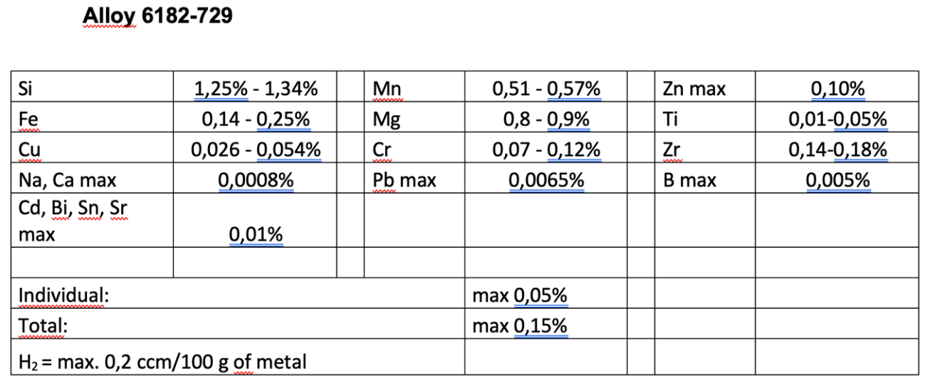

Table 2. Anticipated Chemical Composition for Alloy 6110A-724
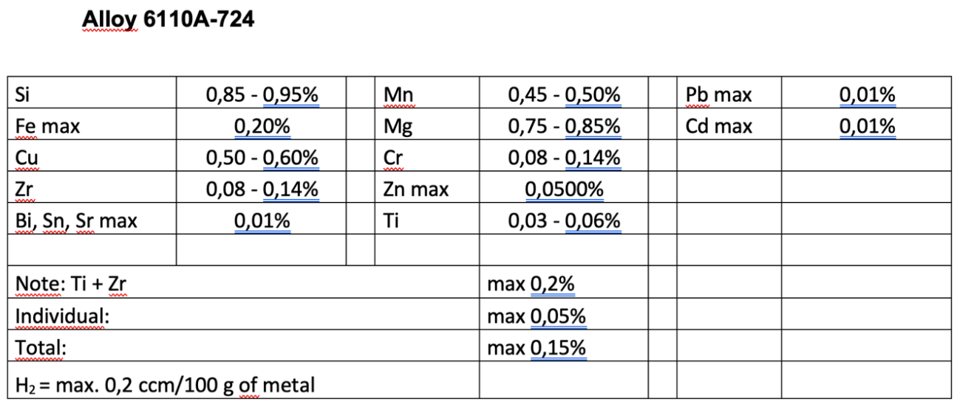

Table 3. Anticipated Chemical Compostion for Alloy 6110-723
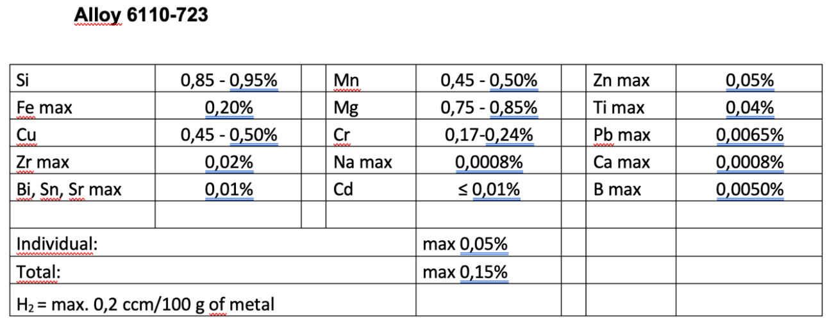

Table 4. Anticipated Chemical Composition for Alloy 6082-719
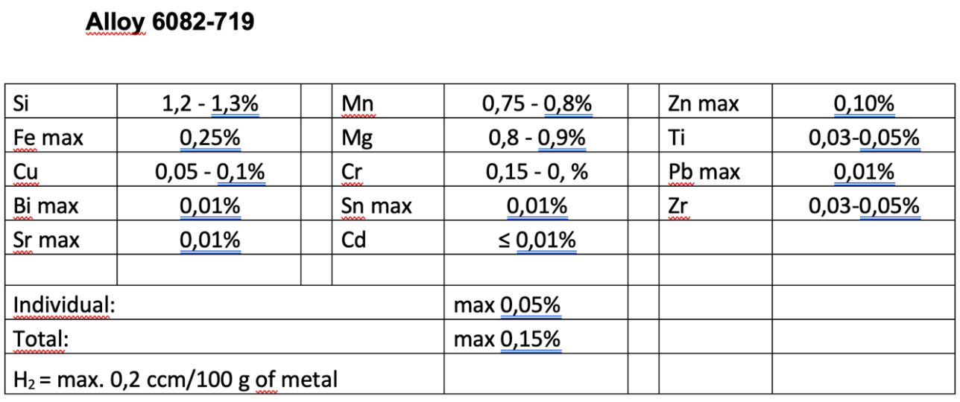

- MELTING FURNACE EQUIPMENT
- Intent
The intent of this document shall be to identify the specifications and requirements needed to provide a bidding quote for qty of two (2) tilting melting furnaces. Customer has a 35 MT liquid capacity per furnace in mind.
Project scope, capacity, layouts, designs, product formula, and process models shall be maintained strictly confidential. Contractor shall not disclose this information at any time without permission from Customer.
- Melting Furnace Scope of Supply
This specification, in conjunction with the referenced specifications, codes, and standards, identifies the minimum requirements for the design, manufacture, and supply of the following:
- Two (2) - 38 MT Tilting Melting Furnaces with 37.5 MT cold charge / 35 MT liquid metal transfer to the connected tilting holding furnace:
- Furnace shell.
- Pouring Spout.
- Main Door and door drive mechanism.
- Charging Machine.
- Rotary Flux Injector (RFI) Door and drive mechanism.
- Rotary Flux-Gas Injector.
- Dross-Skimming Machine.
- Hydraulic tilting-door opening system.
- Refractory (Materials, installation, dry-out).
- Combustion system.
- Air cooled camera-video system
- Flue or exhaust duct mounted Oxygen and Temperature Sensors.
- Furnace pressure control system (Damper & control devices).
- Hood & fume collection duct system.
- Oxygen lance capable of correcting the oxygen level during incineration (if no incinerator installed).
- Or (as an alternative to Oxygen lance): An incinerator operating above 800 °C to incinerate the Volatile Effluents.
- Walkways and platforms where needed.
- Bricked in port to eventually accept metal from a crucible.
- Rotating spout covering door (Pneumatic).
- Retractable Thermocouple Device (Gear Motor).
- Safety guards.
- Transfer Troughing from the Melter to the Holder
- Utility supply piping (T.O.P ~ Furnaces).
- Electrical power & control system.
- Control panels & H.M.I.
- Combustion gas exhaust/effluent duct system.
- Environmental equipment (TA Luft Guidance)
- CE mark indicating that the manufacturer affirms the goods conformity with European health, safety, and environmental protection standards.
- The Contractor shall be fully responsible for designing and providing a complete system that will meet or exceed the general and performance requirements set forth by this specification.
- The Contractor shall supply prior to installation complete detail design documentation/drawing with Bill of Materials for the furnace identifying all components which are identified in the assembly drawings and manuals which are considered as refractory material / consumables.
- The Contractor shall also provide necessary drawings (Assembly or Manufacturing) which may be needed over the life of the furnace to maintain the refractory lining, the pre-cast shapes, castable and repair the furnaces.
- Any patented or trade secreted items shall be identified in the offer, enabeling Customer to provide due protection of the Contractors rights.

- Reference Standards, and SPI’S
The following is a list of Standards and SPI’s having pertinent information and details for this project. The latest editions of specific codes and standards shall apply.
- Specifications
- Noise DIN 45635 (82 db) and DIN 45641 (8 hr 82 db) (available online).
- Effluents TA Luft 2002 (available online).
- Burner and Flames EN 746, EN 1539 (available online).
- Guidelines for handling molten metal (described in Annex_10_TD_Guidelines_for_handling_molten_aluminium)
- Combustable Dust Standard (described in Annex_11_TD_ALINVEST_Combustible_Dust_Standard)
- The following English text of the First General Administrative Regulation Pertaining the Federal Immission Control Act (Technical Instructions on Air Quality Control – TA Luft) (described in Annex_12_TD_taluft)

- Take Off Points (TOP)
- The Contractor is responsible for identifying the TOP (Distance and Conditions) for the following (whatever is applicable):
- Natural Gas
- Oxygen
- Compressed air
- Electricity
- Effluent Isolation ductwork, Temperature and Nm³/min
- Water
- Incinerator exiting ductwork if an incinerator is needed.
- Molten Metal Trough/Joint.
- What ever is needed for operating the furnace.

    - General Technical Data
      - Design Criteria
The Contractor shall clearly state the annual rated output for each furnace (TPH) and burner system (MW). Cold charging material delivered via the main door by automated charging machine or forklift but may be charged eventually as a liquid from a crucible door or via the trough system. Small chemical alloy corrections to be made through the main door with a fork-truck or mobile charging machine. The equipment shall be designed for heavy industrial service, for continuous duty, 24 hours per day, and 7 days per week with minimal maintenance. The design criteria are below in Table 5:

Table 5: Melting Furnace Design Criteria
ITEM | PARAMETER | UNITS | VALUE | COMMENT
1 | TYPE | MELTER | Tilting, DRY HEARTH | Hydraulic tilting
2 | BATH CAPACITY | MT | 38 | 35 MT melt transfer to the holding furnace.
3 | MINIMUM HEEL |  | DRY HEARTH | 5 %
4 | AVERAGE HOLDING TEMPERATURE | °C | 730
5 | BURNER TYPE |  | Regenerative (REGN)
6 | NUMBER OF BURNERS |  | * | Contractor to specify
7 | NATURAL GAS SYSTEM CONTROLS |  | YES
8 | FUEL CONSUMPTION | kWh/t | * | Contractor to specify.
9 | COMBUSTION AND EXHAUST FANS | kWh/t | * | Contractor to specify
10 | PILOT SIZE | kW | * | Contractor to specify
11 | NOMINAL FLAT BATH OVERALL DIMENSIONS | m² | * | Contractor to specify final dims. Furnace depth to be based on required door width and other parameters.
12 | HEARTH, COLD FACE (SHELL) TEMP | °C | * | Refractory to be specified by Contractor
13 | SHELL TEMPERATURE | °C | * | Contractor to specify
14 | HEARTH FREEZE PLANE | mm | WITHIN WEAR LAYER OF FURNACE * | Contractor to provide calculations of freeze planes in floor and sidewalls below melt line
15 | POURING SPOUT |  | YES
16 | ELEVATION OF PIVOT POINT ABOVE FLOOR | m | * | Contractor to specify
17 | PIVOT POINT | mm | * | Above designed metal level
18 | FURNACE TILT ANGLE (MAX) | DEG Rotation | * | Furnace must be designed to be fully emptied
19 | TILTING TIME, EMPTYING | MIN | * | Will be controlled manually or remotely from main control system
20 | TILTING TIME, DESCENDING (EMPTY) | MIN | < 2 | Will be controlled manually or remotely from main control system
21 | TILTING MECHANISM |  | Proportioning Valve | To be controlled from Melter Control system
22 | MAXIMUM METAL DEPTH | mm | *
23 | FREEBOARD, MIN | mm | 100 | On pivot side
24 | Ramp Angle at door | DEG (°) | 30 – 35 * | Sill to bottom of furnace
25 | SILL ANGLE | DEG (°) | 3 – 5 | Sloping down towards ramp
26 | SILL WIDTH | mm | 1200 mm | With sill plate to direct dross to pan. Plates to have expansion gaskets
27 | FURNACE WALL HEIGHT | mm | * | Contractor to specify final dims.
29 | DAMPER | - | * | Pneumatically activitated Stack Damper.
30 | FURNACE PRESSURE (NOM. DRAFT) | Pa | 20 ± 5 Pa | With stack damper closed. Contractor to confirm
31 | STACK HEIGHT ABOVE CAST HOUSE FLOOR | m | * | Contractor to confirm
32 | REFRACTORIES |  | Recommended Monolithic | Contractor to also recommend refractory types and thickness
33 | RAMP ANGLE AT BACK | DEG (°) | 22 – 25 *
34 | FLOOR SLOPE | DEG (°) | 1.5 – 2 | With Draining Taphole
35 | BURNER RATING | MW | * | PREFERANCE TO BE BELOW 2.90
* Contractor denotes key inputs which are required within the Technical Offer.
      - Furnace Shells
- The furnace shall be fabricated and assembled in the Contractor’s workshop, as so much reasonably practical, using full penetration welds by welders trained and certified by local authority, prior to delivery.
- Furnace Bottom to be fabricated from structural steel grade S235J2 or equivalent.
- Shell and bottom shall be adequately reinforced against buckling using heavy-duty channel sections.
- The steel shell to be full penetration welded, continuous from 300 mm above metal level to the bottom of the hearth including hearth plates.
- The magnetic stirrer technology must be provided furnace Contractor. The typical magnetic face for these devices is approximately 1 700 x 1 700 mm. Please see section 2.3.5.8 for more details.
- Structural channels to be positioned with flanges facing down so as not to collect dirt.
- Shell structure shall not exceed 50 % of the material yield strength.
- Extra stiffening shall be provided around all doors, burner mountings, tapping spout and exhaust port. Contractor shall provide calculations for review.
- The Contractor shall provide a RFI access door-portal for melt processing. The door is best located on the wall, opposite the burners, adjacent the hydraulic tilting cylinder with the treatment flow oriented toward the diagonal corner, near the burner wall at the corner opposite the furnace trough outlet.
- The Contractor shall provide a Pouring (Tapping) Spout, opposite the main door. The refractory entrance shall be tapered, with increasing area toward the molten away from the exterior wall.
- The Pouring Spout opening must have a rotating refractory stopper to hydraulically or pneumatically temporarily seal the opening so that during burner high fire mode, flames or hot gasses do not escape the positive pressure furnace chamber. Alternately, a guillotine stopper, hydraulically or pneumatically closed may be provided.
- The opening jams and top lintels will be constructed from heavy, removable, replaceable cast iron or steel frame constructed in segments to allow for expansion and bolted back to the furnace door surround structure to allow for expansion and bolted back to the furnace door surround structure. Alternately, pre-cast section door jam and lintels may be used providing they have a segmented steel frame construction to allow for expansion and bolted back to the furnace door surround structure (Fig. 2). This construction prevents distortion of the doorway face and is foundry duty able to withstand the periodic bumping of equipment during skimming and stirring.
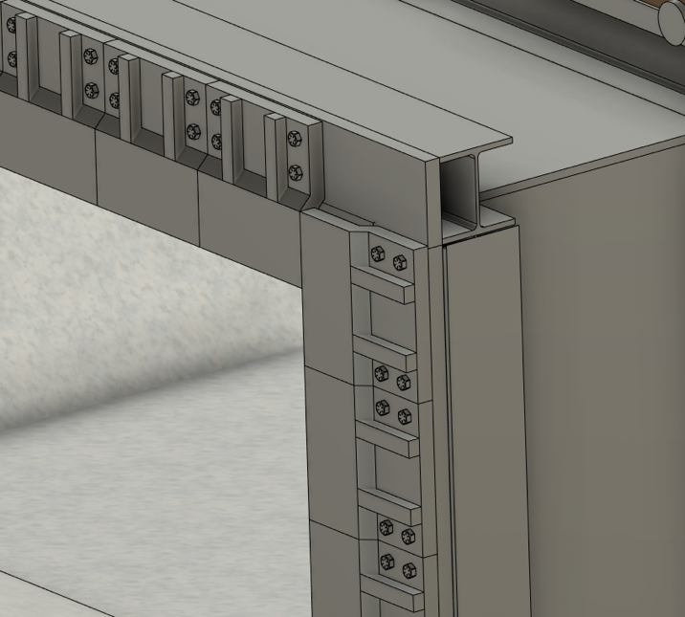
Fig. 2: Wide Flange Door Frame
      - Cast steel faceplate
The perimeter of the door opening seal surface shall be covered with ASTM A297 (HK) grade heat-resistant cast steel castings (Faceplate) bolted in place. (No water cooling, No air cooling). The bolt holes shall be counter-sunk drilled to prevent the bolt heads from protruding. Jam & lintel area to be 2” thick, sill area to be 3” thick with angled skim apron (Fig. 3).
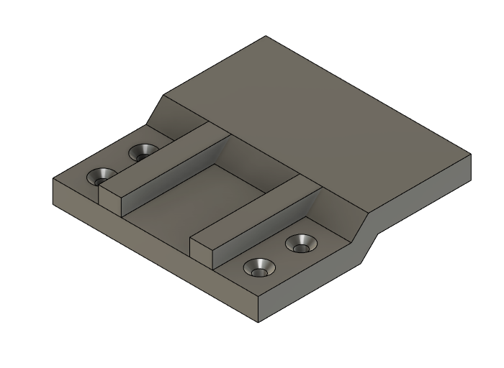
Fig. 3: Cast Steel Faceplate
      - Replaceable refractory face plate
Under special conditions, Customer can accept a replaceable refractory face plate in lieu of the ASTM A297 (HK) grade heat-resistant cast steel castings if the refractory face plate is adjacent the poured wall while still being adjustable over time.

      - External guides
Door guides shall have external guides, so the door does not deviate from the guides. The external guides shall be designed to be bolted for easy removal of the doors. Also, the guides shall be designed to be strong enough not to be damaged or deformed by flames from the door openings (Fig. 4).
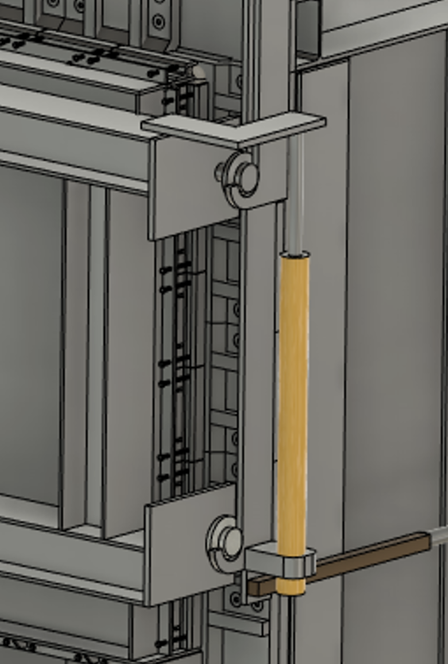
Fig. 4: Door Guides

      - Skim apron
A skim apron shall be installed at the sidewell sill for dross skimming and shall be designed to be bolted for easy replacement (Fig. 5 and Fig. 6)
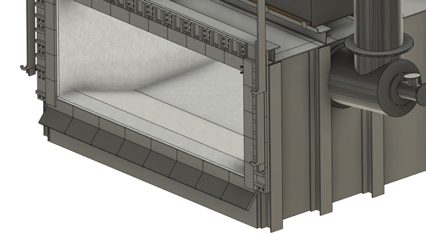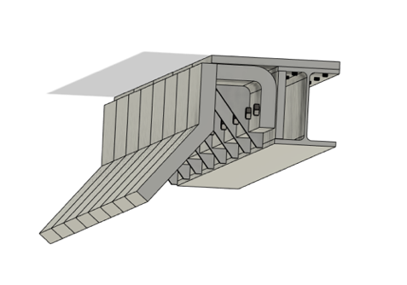
Fig. 5: Skim Apron
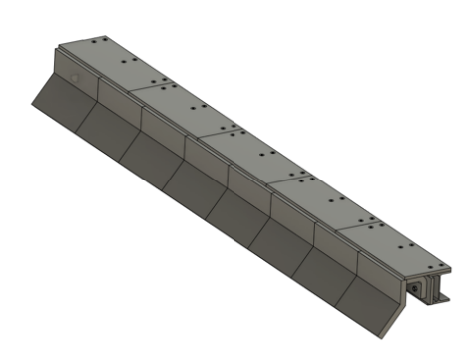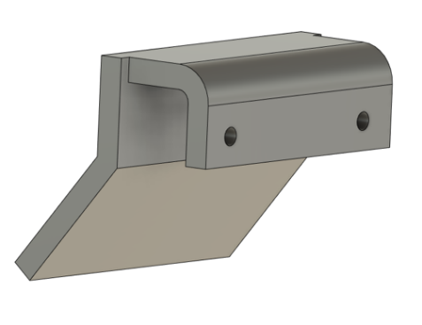
Fig. 6: Skim Apron (Views)

      - Refractory sill
The front sill refractory will be protected by a heavy, heat-resisting cast iron apron bolted back to the furnace structure in segments to allow for expansion. These apron segments have angled deflector plates for dross removal and are specially developed to resist the high level of mechanical shock which can occur during cleaning, fluxing and skimming in aluminum foundries. Heavy castings are fitted over the top of the sidewell wall refractories to protect them from erosion and damage during cleaning (Fig. 7)
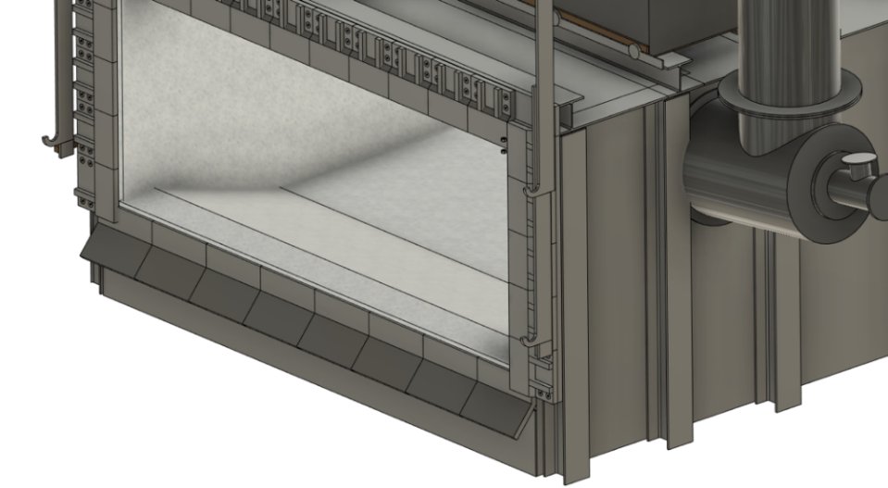
Fig. 7: Refractory Sill with Heavy-Duty Support Apron
- The door sill pre-cast refractories will be protected by a heavy, heat-resisting cast iron apron bolted back to the furnace structure in segments to allow for expansion. These apron segments must have angled deflector plates for dross removal and are specifically developed to resist the high level of mechanical shock which can occur during cleaning, fluxing and skimming in aluminum foundries. Actual sill depth should be greater than 1.0 meter and be sloped toward the molten.
- Furnace exterior temperatures as follows:
- Hearth. 125 °C (MAX). Min. Thickness 500 mm, Hot face 750 °C
- Lower Sidewall 75 °C (MAX). Min. Thickness 450 mm, Hot face 750 °C
- Upper Sidewall 55 °C (MAX). Min. Thickness 450 mm, Hot face 1100 °C
- Roof 55 °C (MAX). Min. Thickness 350 mm, Hot face 1100 °C
- Door 65 °C (MAX). Min. Thickness 350 mm, Hot face 950 °C
- Shell to include the following:
- Structural steel, plate and sheet metal
- Support steel for door lintels, jambs and sills.
- Door hoisting system
- Trough joint and connection flange

      - Furnace Stirring System
- Stirrer to include the following to include the following:
- 35 Metric Ton Furnace Stirring capability (as far as possible equipment should be same for 25 and for 35 MT furnaces to ensure standardization / interchangeable and unification spare part handling).
- Contractor shall plan on one stirrer being shared by two adjacent melters.
- Rail transport system between two furnaces with wire way for electrical service.
- Transfer time between one melting to the neighbour melting furnace shall not take longer than 3 minutes (measured from stop stirring operation on one furnace up to start stirring operation on next furnace).
- Provision to side shift the stirrer one (0.5) meter to either RH (right hand) or LH (left hand) side of center during Dross Collection stage.
- Contractor shall provide a PMS/EMS operating window under the furnace hearth of 1675 x 2675 mm for operation of the PMS/EMS system.
- Contractor shall provide austenitic stainless steel plate and structure in the proximity of the PMS/EMS system.
- Refractory thickness, 525 mm including the non ferritic stainless steel plate. We suggest to consider 50 mm thick plate in the calculation.
- If the stirrer is EMS based, the stirrer shall have a connected load no greater than 100 kW (including required water cooling equipment).
- If the stirrer is EMS based, the stirrer shall have an electrical supply, Frequency converter control, closed cooling water circuit. Circuit has to be designed as 1 (working) + 1 (standby) pump.
- If the stirrer is EMS based, the Contrator shall provide a UPS for the cooling water pump for 30 minutes to ensure cooling water circulation in case of black out.
- If the stirrer is a PMS based system (Fig. 8), the stirrer plus air cooling fan shall have an actual power consumption less than 15 kW.
- If the stirrer is PMS based, the stirrer shall have an electrical supply, Frequency converter control, air cooling circuit. Circuit has to be designed as 1 (working) + 1 (standby) air cooling fan.
- If the stirrer is PMS based, the stirrer plus air cooling fan shall have a connected load less than 30 kW (motor or any other related consumper + air cooling fan).
Fig. 8. Example of Permanent Magnet stirrer (PMS)
- Stirrer box (either EMS or PMS) located below the furnace need to be equipped with temperature sensor for continuous monitoring of temperature with respective warning/alarming in central pulpit HMI.

      - Furnace Doors
- Each tilting furnace shall include a single, full width door. The door shall be located across the front of the furnace on the side opposite the furnace pivot / pouring spout. The door seal shall be designed to require no additional cooling except that provided by convective ambient air currents.
- Absolutely no hydraulic lines may be located below metal level in the proximity of the door on the exterior of the furnace.
- Absolutely no electrical lines may be located below metal level in the proximity of the door on the exterior of the furnace.
- There shall be no services fastened to or attached to the concrete flooring or inside furnace basement wall below the furnace door.
- The furnace door mechanism to lift vertically and shall provide the following design features:
- Door at up-position to safely clear lintel to facilitate its change.
- Guiding arrangement shall provide sealing of the doors to the door jambs (Guide and lock).
- Mechanism shall be designed/setup for “easy” door removal and replacement for maintenance purposes.
- Lift mechanism shall be complete with electric motor or hydraulically driven hoist and chains.
- Wires and hydraulic lines shall be located behind a forward facing radiant panel shield and be protected from heat when the door is open.
- Four Safety chains shall be provided on each door to prevent the door from falling in the event of failure of the main hoisting chain.
- Horizontal clamp mechanism shall be provided for positive door closure when door is in closed position.
- This horizontal clamp mechanism shall also be provided to separate the door seal from the door sill and lintel structure.
- Motor drive for hoist shall be in a position away from direct heat impingement generated by the furnace.
- Furnaces to have a minimum 2.4 meter clear opening vertically and width as per furnace dimension.
- Doors for melting furnaces must be identical for spare part minimization and for universal usage of furnace charging machine(s) at all furnaces (25 / 35 ton melting and holding furnaces) within the overall project.
- Furnace to have a radiant shield, facing the door when the door is in the elevated or open position.
- The molten metal may eventually be taken into the furnace from a side entrance opening on the short side of the furnace. Each crucible will hold around 10 MT. This opening shall be provided in the steel structure but walled in with refractory brick.
- The door insulation shall be a single pour castable with a removable positive rope seal when closed.
- The furnace door jamb may in lieu of the horizontal clamping, may contain an angled steel guide and stop on each end to utilize the weight of the door to seal against the furnace. Additional chain length is to be provided for door to rest on cast house floor to support during maintenance.
- A counterweighted door is preferred to reduce electrical motor size.
- All components of the door lift mechanism shall be adequately protected from heat exposure of the furnace.
- It shall be the responsibility of the Contractor to provide a door that will maintain the seal with the furnace throughout its useful life with reasonable maintenance.
- Complete details of the proposed door drive, arrangement, slope angle and materials of construction shall be provided for approval by Customer.
- The door open/close functions shall be by a pushbutton located near the door for maintenance purpose or operation usage. Main operation via control system as per automatic sequence for charging/skimming controlled via central furnace pulpit.
- The door shall raise in less than 20 seconds and lower in less than 15 seconds.
- The open/proximity switches shall also ensure the furnace is operating on low fire or on pilot whenever the door is off the closed position. Cablelling and cable route should be protected from dirt and transient radiative heat.
- Each furnace door shall provide access for automatic charging, skimming, dross removal, and for access to clean furnace walls and hearth.
- Bottom of the door opening shall be located 50 mm above the maximum metal line in the hearth. The hearth shall be sloped upwards at the door to facilitate dross removal.
- Door shall be designed with castable refractory lining.
- All outer edges on the inside of the door will be short cast iron seal housings bolted around the doors to form a surrounding frame to accommodate a compressible fiber seal that presses against the door jambs and lintel when in the down clamped position. These seal castings can be adjusted while the furnace is hot to ensure a good tight seal against the furnace frame (Fig. 9).
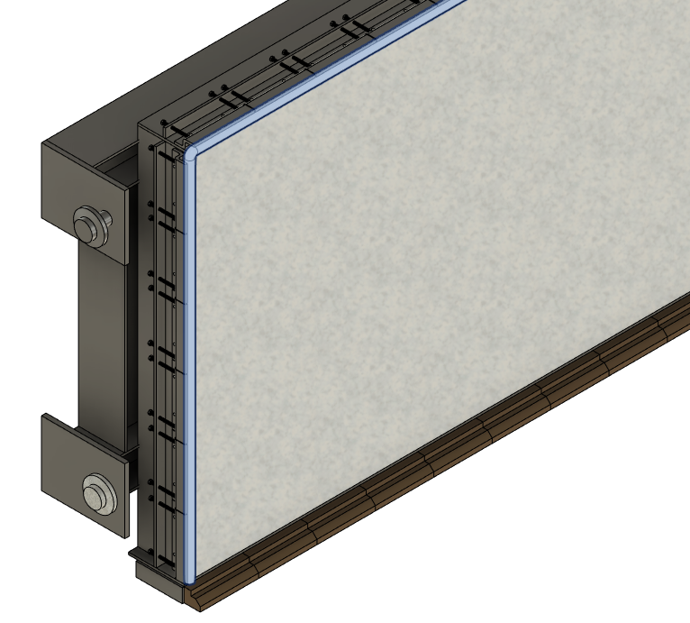
Fig. 9: Door Seal
- Water cooling of the door is not acceptable.
- Minimum door width 5.0 m.
- To be fabricated from A515M alloy steel plates of thickness to ensure a structurally sound door for the application intended.

      - General Furnace Burners and Combustion System
- The burners shall be Regenerative Burners for heating the furnace walls, roof and melting.
- Regenerative Burner Beds shall be designed with quick and reliable bed change features.
- Regenerative Burner Beds shall be interchangeable, 25 MT to 35 MT (Continuous Casting to Horizontal Direct Chill Continuous Casting) lines.
- It is considered to have two additional beds per furnace supplied with the Contractor.
- Regenerative Burner Beds shall include the following:
- Rectangular or full radiused ends or round cassette regenerative bed.
- Quick release connections, centering pins with guiding plates
- Tapered internal flange
- Stainless Media Plate
- Beds shall have an access door on the top of the bed for ease when adding additional media, as needed without significant furnace downtime.
- Large Fasteners with hand tightening turn to tighten nuts, if required
- Exchange time shall be less than 45 minutes with minimum required man power (target: 2).
- Customer prefers roof located burner beds accessible for removal and manipulation via overhead crane as shown in Fig. 10.
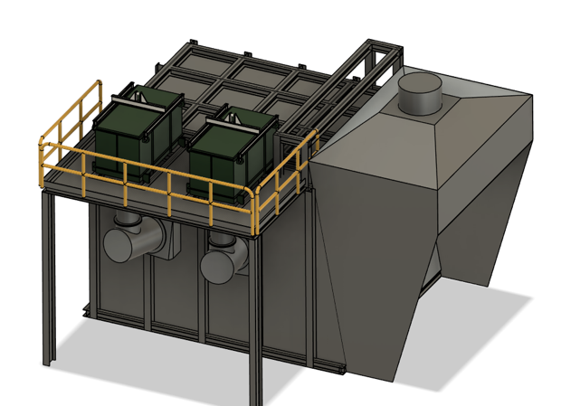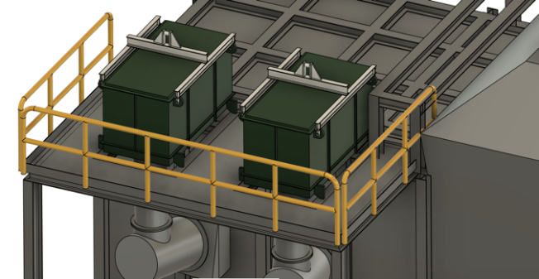
Fig. 10: Example of Roof mounted Quick Change Regenerative Bed
- Regenerative Burner Beds shall be designed and equipped with Air Cannons (Fig. 11) to break through contaminents with intermittent pulses of air, agitating the media bed and dislodging any particulate build up.
- Monitoring system (connected to control system via pressure sensors) shall be designed to detect and continuous monitor contamination of the Beds to prevent unanticipated downtime or emergency bed exchange in case decreased performance.
- The breach or exhaust flue must also contain a thermocouple sensor (Type R).
- The breach or exhaust flue must contain two (2) Oxygen sensors which are tied to an Oxygen Lance to release Oxygen into the main hearth and the same sensor shall be used to control the incineration burner if offered. One sensor shall be a redundant spare with software disconnection in case one sensor is out of operation or measuring not sensful values.
- Each sensor shall be equipped with a dust flush function, which periodically blows dust which unavoidably collects on the sensor.
- If the Oxygen Lance is provided, the Oxygen Lance must be able to manually turn on/off during the incineration cycle.
- The Oxygen Lance, shall be activated by the PLC which injects a jet of Oxygen over a period of time to correct for Oxygen levels which may be temporily below a desired operating threshold, terminating the jet before the upper limit of the desired Oxygen operating threshold.
- The Contractor shall provide with their technical offer a block diagram to demonstrate they understand how this Oxygen Lance will function in the atmosphere of the furnace or,
- If the Contractor intends to provide an effluent incinerator, then the incinerator must be able to manually turn on/off during the incineration cycle.
- The incinerator, shall be activated by the PLC which activates an incinerating burner over the incineration cycle to incinerate the VOC’s in the effluents gas stream.
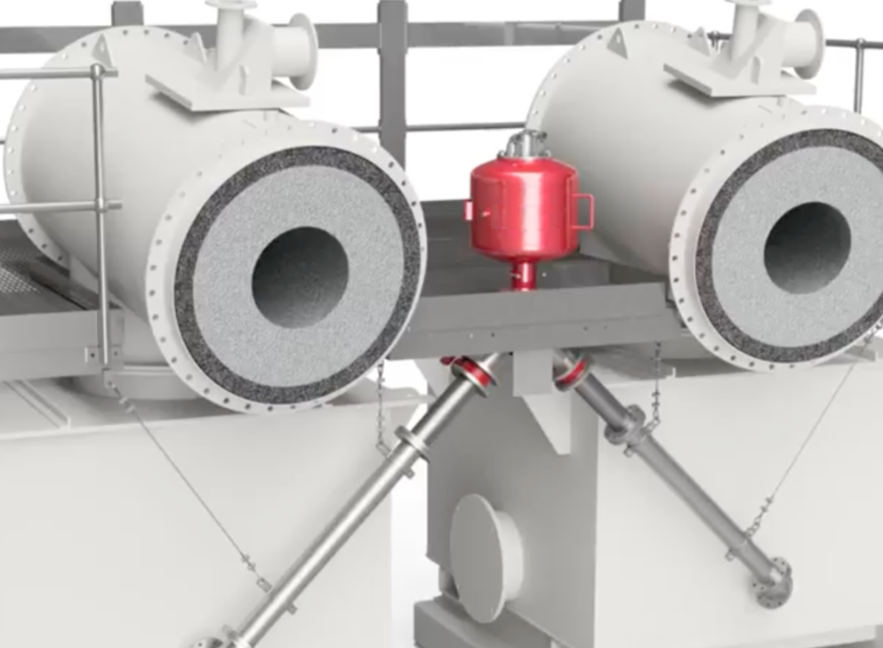
Fig. 11: Example of Air Cannon
- The combustion system shall include approved flame supervisory and safety system, including ultraviolet flame detectors with UV signal strength display gauge visible through the face of furnace control panel and on the HMI.
- The burner flame, pressure and safety protection system shall be capable of independent operation separate from the PLC system. However, all events and alarms to be monitored and recorded by PLC system.
- The burners shall be designed for firing on natural gas to support a minimum melt rate for alloying materials and hold to transfer temperatures of approximately 750 ºC. The furnace shall be fueled by natural gas to a set of Low NOx gas fuel burners. The burner(s) shall be located appropriately on the furnace. The burner assembly shall be mounted so as to allow charging and tapping.
- The site properties for natural gas are typically 18,8421 net KWhm³ but the control system must be able to accept different calorific values from different Contractors.
- The burners shall have clean-out panels for frequent cleaning and maintenance access. Clean-out panels shall allow access to both the combustion air path as well as the gas/fuel areas of the burners.
- Burners shall be designed & mounted as such to facilitate cleaning from the exterior of the furnace.
- The furnace combustion system shall be powered by electric motors and reducing gears, if required, with a variable speed drive.
- A furnace atmosphere pressure transmitter shall be placed at the roof, inside the furnace to generate a signal which is transmitted to the HMI.
- The furnace pressure is controlled by a specially controlled damper system, located in or at the flue gas ducting or duct interface. The system may be electrically controlled manual damper, a pneumatically controlled damper or even a modified air knife.
- The pressure transmitter and damper when controlled shall generate a slight positive pressure in the furnace to prevent the ingress of ambient air.
- During charging, skimming and alloying or otherwise tending the hearth, the burners shall diminish to low fire mode and at this point the draft shall increase to ensure a negative pressure to avoid heat, flames or fumes from escaping the door.
- When the operator triggers the opening door sequence, the burners shall diminish to low fire mode, and the damper shall open for 15 seconds to evacuate the hearth of any fumes or volatiles minimizing the fume escapement to the hood.
- Before the door opens, the damper shall throttle closed to shift the draw from the baghouse from the furnace main chamber to the hood plenum
- The door shall open to a 15 cm height, then want for 10 seconds prior to continuing to open to allow air to enter the melting cavity to flush any fumes from the melt or scrap into the flue.

      - Furnace Exhaust
- The furnace shall have a complete exhaust system including, but not limited to, the flue, a pneumatic/automated furnace pressure control damper, and an exhaust duct to a Take over point (TOP) 1 meter (exact location point to be defined during engineering phase) past the damper. All the relevant work, such as duct support, connection work, building penetration and finishing work to the TOP is by the Furnace Contractor.
- The Contractor shall measure the temperature of the exhaust gas and dilute this temperature to less than 350 °C dilution duct located prior to the pneumatic/automated furnace pressure control damper, diluting and lowering the atmosphere at the damper.
- The exhaust duct may be connected to a fume incinerator. If so, the exit of the incinerator and cooling air intake or heat exchanger is connected to the pollution control device (Bag House).
- If used, the incinerator shall have a retention time to combust 97 % of the VOC’s above 800 °C to ensure full combustion of all contaminants.
- Contractor to provide interface dimensions and required exhaust temperature and flow after the incinerator.
- If a traditional incinerator is proposed, the Contractor shall add the kWh/tonne of the incinerator burner to the melting energy consumption.
- The Oxygen Lance shall be connected to an oxygen supply and controlled during the cycle to assist with consumption of fume (volatile organics) liberated from the scrap.
- The bottom exhaust ductwork shall contain the flue anchor base, breaching and access port.
- An O₂ sensor in exhaust ductwork is to be provided and connected for monitoring or feedback to automation for burner and lance tuning. If an incinerator is used, this may be omitted in the offer.
- Customer will perform permit information to determine the acceptable option and the exact final configuration.
- A hood shall be provided for fume capture over the door opening on the furnace to capture fumes generated during charging, de-skimming, alloying and stirring operations.
- The Contractor shall design the hood evacuation system to draw a continuous 10 % of the hood flow velocity, to capture any fugitive door emissions.
- The Contractor shall, connect the hood evacuation system ducts to the furnace combustion stack prior to the damper and the TOP.
- Under special conditions the Contractor may introduce an internal plenum in the hood. If this is the case, the Contractor must be able to show their flow calculations in order to gain the Customer approval.
- The velocities for designing the hoods and the fume collection duct system shall be as below:
- Minimum face velocity below hoods 1 m/s
- Minimum Velocity in fume/dust ducts 20 m/s
- This hood will be connected to the incinerator (If used) before the bag house (bag house not in Contractors scope). If the Contractor uses the Oxygen Lance, then the hood will be connected to the burner air intake of an adjacent furnace.
- The hood casing shall be made of 5 mm thick St – 37 steel sheet reinforced as needed by NPU or steel structures for rigidity. The steel exterior and interior shall be coated with paint and the interior surfaces with a high temperature paint, See Customer Painting Guidelines.
- The baghouse fan (scope by others) shall be sized to accept all combustion gas flows and all fume exhaust source points, synchronized so the bag house is not oversized.
- The Contractor scope shall include all hardware, gasketing and lining materials.
- The Contractor shall specify flue discharge flow and temperature after the pneumatic/automated furnace pressure control damper so that an appropriate bag house may be designed.
- The Contractor shall provde a flexible or suitable connection to transfer flue gasses from the furnace to the exhaust duct before the damper to control any fugitive emissions to the work area during tilting.
- The flue shall be lined with reinforced refractory to limit steel temperatures.
- The emergency stack (scope by others) height approximately 30 meters, as directed by the Contractor.
- A mechanical damper shall be provided for the furnace flue to maintain a positive pressure in the furnace.
- Manual combustion control capability shall be provided to operate the furnace during any failure of the electronic controls.

      - Fans
- Combustion air and exhaust fans shall be frequency controlled.
- Fan blades shall be single stage.
- Fan housings shall be split for wheel removal and shall have a drain connection (plugged) as well as an approximate 200 x 200 mm removable panel to allow access for blade cleaning and fan balancing, suitable shaft seals and approved guards.
- The fans shall be mounted on vibration eliminating bases.
- The fan speeds shall be limited to 1,500 rpm (50 Hz).
- Fans shall be sized to permit increases in pressure and capacity, which may be required to balance system operation at start-up and to compensate for regenerator pressure drop.

      - Refractory Lining
This project’s focus and thus funding is based on substantial reduction in green house gasses. In doing so, insulation at the walls, hearth and roof becomes paramount in that every kW of energy lost thru the walls or structure must be replaced with additional energy to replace the heat which is lost. As a potential supplier on this project, we encourage you to choose well respected high alumina materials in contact with the molten aluminium and hyper insulative layers near the steel walls. Eventually, we will be asking for very specific Product Acceptance Tests and Gurantee’s and thus, we ask you to keep this in mind because every kW you keep from escaping to atmosphere will help you meet or exceed our expectations.
Each offer shall include your heat transfer calculations for the following six (6) * points. Each calculation shall show, the anticipated hot face temperature which below molten shall be 750 °C, on the roof 1100 °C and on the upper wall, 950 °C. Exterior furnace temperatures will be a key variable for analysis along with your anticipated heat loss thru each section and the freeze plane 660 °C.
With this information you must include the Technical Data Sheet for each product anticipated in the lining and your local source point.
- Ramp (Back Wall)
- Minimum 300 mm Working Lining, 60 % Alumina Isolating castable.
- 100 mm 40 % Insulating castable.
- 50 mm wool plus block
- 6 mm wool or ceramic paper.
- Ramp (Door)
- Minimum 406 mm Pre-fired Block Working Lining.
- 83 mm Back-up Castable.
- 2 x 33 mm thick, Ceramic blanket or paper
- Pre-Fired mullite-based alumina > 65 % Al₂O₃ ,< 30 % SiO₂ with other materials including a Barium-containing stabilizer. Pre-Fired > 850 °C MOR > 2700 kPa.
- Hearth *
- Minimum 406 mm Pre-fired Block Working Lining
- 83 mm Back-up Castable.
- 2 x 33 mm thick, Ceramic blanket or paper
- Pre-Fired mullite-based alumina > 65 % Al₂O₃ ,< 30 % SiO₂ with other materials including a Barium-containing stabilizer. Pre-Fired > 850 °C MOR > 2700 kPa.
- Lower Sidewall *
- 450 mm Working Lining, 60 % Alumina Isolating castable.
- 50 mm 40 % Insulating castable (0.10 W/m-K)
- 6 mm wool or ceramic paper.
- Upper Sidewall *
- 285 mm Working Lining 42 % Al₂O₃, 52 % SiO₂
- 115 mm Insulation Brick Grade G-23
- 75 mm Rigid Fiber Board Panel 1000 ℃ Grade 607/85
- 25 mm Insulating Hard Board (ISO-Al grade)
- Door *
- 230 mm castable refractory lining
- Alkaline resistance up to 1400 ℃
- 230 mm minimum hot face thickness
- Roof * (Front 1200 - 1500 mm from the Lintel Corner)
- Pre-cast materials produced from > 60 % alumina based cement castable. The castable shall have low free silica content and be resistant to alkali attack
- Roof shall be Flat and the precast sections must be interchangeable with the 35 TM furnaces.
- Refractory-supporting steel structure shall be parallel to lintels or opposite orientation to the tilting axis designed and installed with an increased supporting weight-load of 25 %
- Alkaline resistance up to 1400 ℃
- 300 mm Minimum Hot Face thickness
- 150 mm Insulation Minimum
- 50 mm thick, hard board with water or lazer cutouts for the hangers, cutouts shall be located 10 mm away from any load supporting hangars.
- Roof * (Rear cast in place)
- 250 mm 42 % Al₂O₃, 52 % SiO₂
- 100 mm 30 % Al₂O₃, 37 % SiO₂
- 50 mm Blanket
- Alkaline resistant up to 1400 °C
- Refractory-supporting steel structure shall be parallel to lintels or opposite orientation to the tilting axis designed and installed with an increased supporting weight-load of 25 %.
- The refractory specifications in this section are minimum requirements. The refractory manufacturer will be by Contractor unless otherwise specified. The Contractor may choose any refractory or manufacturer of proven quality, to be approved by Customer if the intended material and performance properties are met. Contractor is responsible for the final refractory design and shall warrantee the refractory for five (5) years after furnace start-up.
- Burner ports shall be lined with minimum 300 mm Working Lining, 60 % Alumina Isolating castable plus refractory board.
- Exhaust flue shall be lined with minimum 200 mm Working Lining, 60 % Alumina Isolating castable plus 75 mm Back-up Lining.
- Weep Holes shall be provided in the furnace shell and bottom to allow water vapor from the refractory to escape during furnace dry out. Weep Holes need to be threaded for M12 bolts. The Weep Holes should not be more than 1 m apart.
- Furnace floor shall be sloped to a point at the drain out tap block, in the event power cannot be restored during a power outage.
- The Contractor shall provide refractory materials of construction and basic construction details for the following to be approved by the Customer:
- Lower sidewalls to 300 mm above metal line
- 30-35° Door Ramp to the Sill/Dry Hearth
- Sill/Dry Hearth at the Door
- 22-25º Back Wall Ramp.
- Upper Sidewalls
- Upper Sidewall Cap
- Furnace Door Lintels
- Furnace Door Jamb
- Burner Ports
- Flue Arch
- Flue Sidewalls
- Flue Breeching
- Furnace Door
- Pouring/Receving Spouts
- The hearth must withstand regular skimming operation by mechanical means. Periodic fluxing with salt which could contain sodium chloride, magnesium chloride and potassium chlorides will be performed. Contractor shall take this into account with the design and material of the furnace liner.
- All hangars and other refractory fastening hardware shall be 316 Stainless, unless othwersise agreed in advance of installation.
- All fiber blanket and paper shall have appropriate cut outs, so the refractory blanket terminates 10 mm away from the hanger or hardware.
- The refractory shall be designed to minimize heat loss. Heat transfer calculations shall be provided with final offer as total kW lost. The basis for this calculation shall be: m²(area) x w\m².
- Contractor is to provide the dimension from the freeze plane to the hot face of the brick.
- Cold face steel temperatures shall not exceed the following at steady state melting when the ambient temperature is 25 °C. It is to be understood by the Contractor that, heat loss thru the furnace lining indicates an excess GHG to overcome this loss.
- Lintels, jambs, and sills shall be provided with metallic inserts for handling and affixing to the steel shell.
- The sills shall be easily replaceable and shall resist damage during charging and skimming.
- The door jambs shall be easily replaceable and shall be flush with the sidewalls of the refractory lining to facilitate furnace cleaning and preclude damage to the lining or jamb.
- Expected operating life of furnace lining is 5 calendar years minimum with 5 to 7 charges per day; this shall be incorporated into the design criteria of the furnace lining.
- Furnace sill shall not exceed 1.5 meter from mill floor for scrap charging purposes.
- The Contractor shall provide within engineering (detail design including manufacturing drawings / bill of material lists) also an alternative refractory/lining concept with only pre-cast shape/block linings (all hot faces) and provide to the Customer within documenation hand over full.

      - Molten Metal Receiving Port
- Furnace Shell shall have a molten metal receiving port engineered, installed but sealed (bricked) to accept molten metal in the future.
- The Contractor shall reinforce the port and shall provide a conceptual layout to accept a siphon transfer at a later date and time.

    - Trough system
Trough system description valid for:
- Melt transfer from Melting furnace to Holding furnace
- Melt transfer from Holding furnace to Casting unit
- The Melter to Holder Transfer Trough is key to a well managed and operated recycle and remelt facility. Only the highest quality (High Alumina and low Silica) materials should be used while maintaining a healthy balance with thermal conductivity as material choices will earmark the type of inclusions generated in the metal distribution system and thermal losses in the system. The melt transfer from melting to holding furnace should not take longer than 15-20 minutes.
- With the Electric/Radiant Holding Furnace at 80 – 85 % tilt, the Natural Gas fired Melting Furnace is pre tilted with a dam in the transfer trough, at the Melting Furnace exit, to a level which matches the Holding Furnace metal level in the trough at the exit of the holding furnace. After a level equilibrium is met, the dam is released, allowing molten to flow from the melter to the dam at the entrance spout of the Holding/Casting furnace. Once the metal levels stabilize at the same level, the entry spout is slowly opened, releasing the molten into the holder. After another equalizing moment, the transfer sequence is initiated, using the trough metal level sensor at the exit of the Holding Furnace to control the Holding Furnace lowering while the Melting Furnace is raised.
- We prefer hot air high velocity trough pre-heating for our system as the typical heated trough cover systems are an extra maintenance item and the energy consumed during heating distracts us from our goal of reduced electrical needs. We prefer smaller CX troughs, with hot air blowing as a pre-heat system when neede.
- Description of System:
- Qty n – Straight Sections
- Qty n – Corner (90 degree) Sections
- Qty n – Transitions
- Qty n – Heavy Duty Stands (Under Corners and Transitions)
- Qty n – Conventional Stands (Under Straight Sections)
- n: to be specified with final layout configuration during engineering phase.
- Flow Requirements
- Metal Flow velocity in launder between holding furnace and casting unit shall be less than 7.0 m/min maximum.
- Nominal metal level in trough shall be 100 mm from top of refractory between the melting and the holding furnace.
- Cross section of the refractory shall be designed for easy cleaning.
- Minimum corner radius (in center line) of any refractory section shall be 300 mm.
- Modules
- Trough system shall be designed in modules. Module lengths shall be a maximum of 1.2 meters.
- Each module shall be designed to maintain a 3-dimensional compressive force on the refractory lining.
- Each module shall have integrated covers or covers that can be removed and stored on the module.
- Trough Sections shall be easily removable from overall assembly for maintenance.
- Transition Sections shall be minimal in length to prevent heat loss.
- Covers are not required on transition sections.
- Refractory joints between trough modules and between modules and transition sections shall be under compression.
- Contractor is to minimize the use of silica fiber blanket materials in the metal distribution system.
- Any change of trough profile shall use an angle of no more than 30 degrees.
- Joints between refractory shall use 9.5 to 12.5 mm Inconel woven rope for sealing.
- Trough Invert Slope Angle (mm/m) of trough between respective equipment:
- Melting Furnace to Holding Furnace: - 4 mm/meter
- Hot Air Blower (Pre Heat) for Straight modules and Joining Points. Hot air blowers, heat difficult areas in the metals distribution system without exposing the refractory to a direct flame.
- Low/High Level Sensors at the Holding Furnace - This special type of probe sensor, is tied to the Melting Furnace tilting logic.
- For each section type minimum 2 operational spares shall be delivered by the Contractor within base scope.
- Refractory
- Refractory shall be chosen for low thermal conductivity, durability, and non – wetting characteristics.
- Refractory shall be pre-cast standard shapes.
- Trough outside shell temperature shall not exceed 150 °C with a 45 °C ambient temperature.
- Trough Stands
- Trough Stands shall be designed to support trough modules during use and any maintenance activities.
- Trough stands shall have provisions for fixing to concrete.
- Trough stands shall be strategically place in overall assembly for support. Each trough module does not require 2 stands.
- Maximum distance between stands shall be 2 m.
- Coating
- Trough steelwork shall be coated with high heat powder coat or equivalent. Stainless steel components need not be coated.

    - Ancillary Equipment
      - Melting Furnace Charging Machine
- Base data:
- Charging chute inner dimensions (W x L x H) 4.5 x 3.8 x 1.3 m
- Chute volume 20.5 m³
- Max. load 8 t (390 kg/m³)
- Empty weight < 35 t
- Overall length < 8 m
- Travel distance to furnace ca. 2.6 m
- Chute movement distance towards furnace min. 4.7 m (front of chute at max. position must reach min. 60 % into the melting furnace)
- Travel distance of pusher < 3.5 m
- Pushing force 180 kN
- Pushing Speed 8 m/min
- Travel speed of charging machine 0 - 45 m/min
- Travel speed of charging chute (reverse) 0 – 15 m/min
- Charging cycle time (from furnace door start opening / charging / furnace door closed) < 2 min
- Connected load < 40 kW
- Accuracy of weighing system ± 25 kg
(Final data to be confirmed during engineering phase, but speed, charging cycle time has to be considered as minimum required).
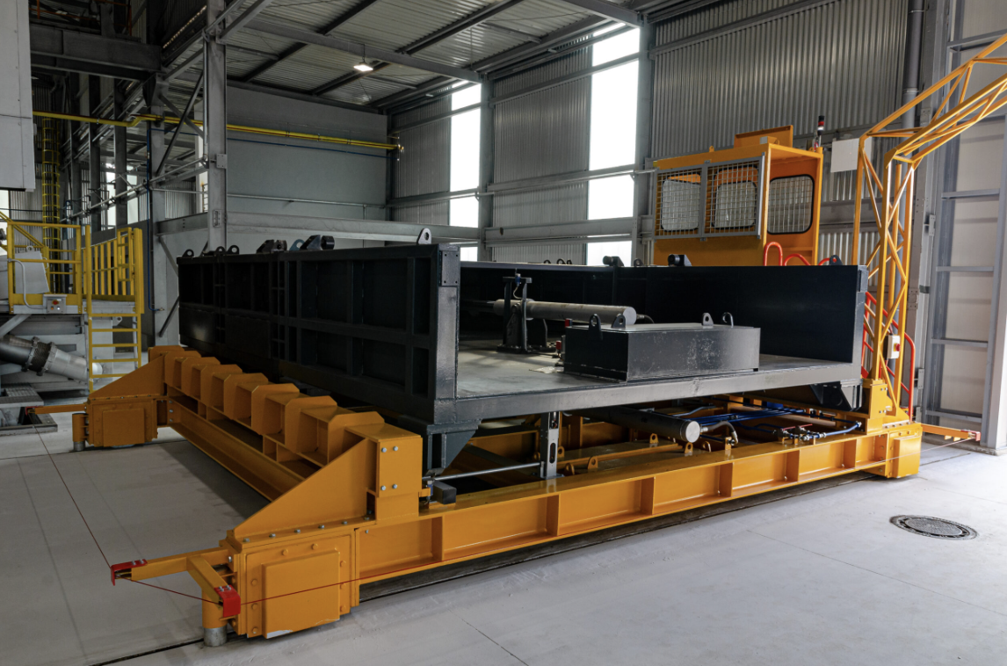
Fig. 12: Example of Charging Machine (reference)
- Charging machine shall be a rail bound Pusher-Type Charging Machine for efficient depositing of scrap, ingots, sows and slightly oily or light VOC containing scrap into the Melting Furnace.
- Charging of charging machine shall be by Front End Loader or Fork Truck Including the following, without limitation to other things:
- Loading platform with integrated weighing system and overhead display
- Rail bound base car for cross travelling between loading platform and melting furnace doors.
- Charging chute (scrap carriage) with pusher shield mounted on base car and designed as an extremely rigid, cast house friendly construction.
- After positioning the charging chute at the furnace door, a furnace grab shall extend and temporarily fasten itself to the furnace door sill.
- After grabbing sequence, the charging chute shall extend into the furnace, over the sill, to the inclined ramp, tilt to close the distance edge of the charging chute to the ramp, afterwhich the scrap pusher shall move forward while the chute tilts up and moves reverse to support a uniform distribution of the scrap inside the furnace.
- All drives shall be electric, switchgear and control system shall be mounted on the side of the charging machine base car
- The charging machine sides shall be equipped with safety scanners / lasers which firstly slows and then stop the machine automatically in case of a possible collision with any object (human, machine, etc.). Precise distances from object when should charging machine slow down and stop will be calculated and defined by Contractor. Slow down speed will be also defined by Contractor.
- The base car shall have a flashing light to warn all pedestrians in its position and direction.
- A guide lock mechanism shall be activated before the start’s movement.
- The guide lock mechanism will be hydraulically driven.
- Side (travel) movement of the machine will be driven by electrical Motors controlled via frequency converter.
- Onboard camera with view into the melting furnace during charging cycle. Camera has to be integrated into Customer overall camera system = coordination during engineering with Customer approval is mandatory.
- Inspection / maintenance access at all moving parts (wheels, gear box, cardan, etc.) and grease points for inspection, manual lubrication etc. has to be ensured.
- Electrical power supply shall be considered via bus bar or or motorized cable reel. with integrated data transfer to ensure safe and uninterupted data transfer/communication for full automatic operation - mounted on the building.
- Inspection / maintenance access at all moving parts (wheels, gear box, cardan, etc.) and grease points for inspection, manual lubrication etc. has to be ensured.
- Integration of control system with data transfer (warnings/alarms, data, status etc.) to furnace control system and central furnace pulpit and indication on HMI.
- Operation:
- Operation should be full automatic from central furnace pulpit for all furnaces. By setting via HMI the command for charging furnace no. x, the cycle should start with travelling of the charging machine to respective furnace. Following by start opening furnace door with start of pushing sequence after furnace door is opened. After cycle is completed, furnace door is start closing the charging machine should travel back to charge position. Any step can be interupted by furnace operation team. Restart of automatic cycle at any stopped moment has to be ensured (via HMI operation).
- „Semi-automatic“ operation via HMI pushbutton as back-up (in case full automatic is not working due to any reason) with step-wise selecting movement as desribed above with consideration of actual position of charging machine and sequence steps.
- Manual operating movement of all movements via push button panel mounted on the charging machine.
Above description of sequence of full automatic / semi-automatic shall be understood as base. During engineering final sequence with all required safety aspects and integration as to be final confirmed.
- Charging machine has to be universal use for all melting furnaces = one design for charging machine for 35 tons as well as for 25 tons melting furnaces. In this way charging machine for 35 tons can support charging on 25 tons furnaces and vice versa. This consideration is valid only if final layout ensures one common rail system for serving all melting furnaces.

      - Rotary Salt Flux Injector (Fixed Injector)
- Base data:
- Maximum gas flow (SLPM) 300
- Nominal treatment gas flow (SLPM) 200
- Grade 99.997 %
- Inlet supply pressure min. 500 kPa / max. 700 kPa
- Inlet supply temperature 10 °C < 50 °C
- Filtration level 10 micron
- Moisture level dew pt – 45 °C

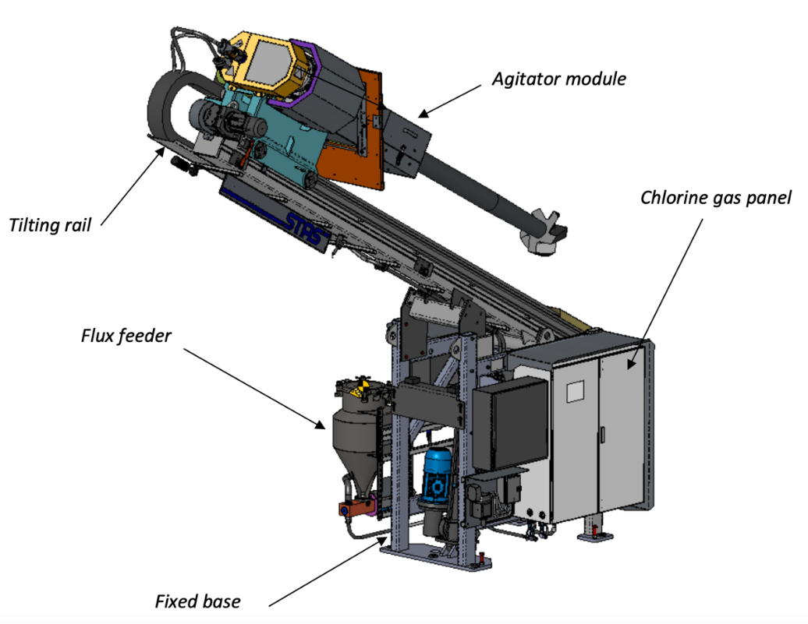
Fig. 13: Example of Rotary Flux Injector (reference)

- The main element the spinning nozzle, rotary injector is a carrier gas (argon) which delivers a fluxing agent (solid salts or chlorine gas) underneath the metal surface.
- The fluxing agent is dispersed through the combined actions of the disperser and the injection of the carrier gas.
- RFI base mounted on a trolley.
The RFI base is a welded assembly with four sturdy wheels that rest on two rails fixed to the floor. A gearmotor with chain drive transmits translation movement to place the RFI at or near the corner of the furnace that must be treated, treating the furnace diagonally. Two positions are allowed, treatment position maintained by 4 stoppers and maintenance position maintained by 2 stoppers.
The RFI will be located on the wall, opposite the burners, adjacent the hydraulic tilting cylinder with the treatment flow (Argon and Salt) oriented toward the diagonal corner, near the burner wall.
- Tilting rail
The tilting rail is composed of a hollow beam with two rails installed on each side of the beam. The linear movement of the injection module along the tilting rail is provided by a gear motor and sprocket drive system. The tilting movement is provided by an optional electric actuator.
- Agitator module
The main frame is a welded assembly holding the flanges bearings for the driving shaft. The graphite rotor is supported by a coupling mounted at the front end of the driving shaft. A rotary joint, through which the gas and flux mix flows, is mounted at the other end of the driving shaft. Grip belt sheaves are used to transmit power from the motor. Also, a blower is installed to avoid the overheating of the front bearing during the operation in the furnace.
- Rotor and Shaft
The graphite impeller is screwed at the end of the graphite shaft. The shape of the blades allows the best mixing performance possible to increase the process efficiency.
The center of the shaft is hollowed, and the gas-flux mix is routed through the rotor into the molten aluminum. The injection shaft is linked to the driving shaft by a rigid coupling for easy replacement.
- Flux Feeder
The flux feeder is made of stainless steel. Its capacity, which is specific for each application, is sufficient for ONE treatment.
The feeding auger is driven by a motor that controls the auger speed via an AC-drive installed in the power & control panel. The feed rate can be adjusted at the human-machine interface (HMI).
- Gas Panel
Two independent gas panels are included: one for the control of the gas flow for the RFI mode and another one for the control of the gas flow for the RGI mode.
They are equipped with pressure gauges, pressure switch, regulators, solenoid valves, flow meter and flow regulators. These components help to detect abnormal pressure or flow in the circuit.
The gas inlet and outlet, located on the panel, connect to the gas source and to the machine itself.
There is also a connecting stand to allows secure chlorine connection/disconnection.
- Rotating Turret Base
When the RFI base is fully retracted, the RFI shall be able to be rotated 90 degree preperatory to treating the adjacent furnace.
- Power and Control Panel
The control panel, installed in the control room, near the equipment or on the equipment (depending on the configuration). Integration of control system with data transfer (warnings/alarms, data, status etc.) to furnace control system and central furnace pulpit and indication on HMI.

      - Automated Dross Skimming Mechanism
- Base data:
- Total Weight 20 tons
- Traveling speed on the floor 0 - 45 m/min
- Skimming Boom in/out speed 10–30 m/min
- Skimming Cycle Time < 10 min
- Overall Machine Length abt. 10 m
- Maximum Noise Level 82 dba
- Skimming of the furnaces to be performed by furnace skimmer.
- Skimming at all melting (35 or 25 tons) furnaces and holding (35 or 25 tons) furnaces.
- Skimmer will have its own dross box for dross collecting.
- Air cooled skimming boom.
- Skimmer machine body is mainly made up of St-52 steel NPI and NPU profiles for extra structural integrity.
- Up/Down movement of the skimming decice will be provided by 2 hydraulic cylinders, back/forward movement driven by Hydraulic motor/pump.
- A guide lock mechanism shall be activated before the starts movement.
- The guide lock mechanism will be hydraulically driven.
- Side movement of the machine will be driven by electrical Motors controlled via frequency converter.
- Movement limits of the skimmer during skimming process, to be defined by sensors to enable smooth and sustainable movements.
- Refractory lining protection by using exact position control as per furnace dimensions required (for each type of melting or holding furnace with respective depth length = information of skimming machine which furnace need to be automatically detected by the control system).
- Auto skimming process and manual movements are controlled by air-conditioned remote-control cabinet or HMI panel which allows operation without human presence near the skimming area.
- Skimming machine shall have a hydraulically activated terminating dross blade which extends from the machine and enters the furnace sill area.
- Skimming machine shall, on the reverse rake motion engage with a terminating dross blade, to compress the dross.
- The dross shall be compressed a maximum of 30 seconds.
- The total dross cycle time shall be less than 10 minutes.
- The compressed dross shall allow 25 % of the entrained metal to drip or drain onto the sill. A molten return of minimum 25 % is expected and has to be demonstrated (by raking with or without dross pressing and comparing the weight deviation).
- Distance between the centerline of rails to be by the Contractor in mm.
- Contractor shall provide a blower for arm cooling.
- Cameras to control skimming processes and auto dross detection system for shortening skimming time.
- Rails of the automated skimmer, connected to a Dross Press to minimize process losses and un-avoidable operator intervention.
- Light barriers / laser scanners and camera systems which surround the car for security.
- The automated functions will all stop and terminate if there is a disruption in the light barriers / laser scanners and camera system.
- Skimmer is expected communicate with all furnaces (melting and holding) as accessable via the bus bar (suitable for data communication).
- Inspection / maintenance access at all moving parts (wheels, gear box, cardan, etc.) and grease points for inspection, manual lubrication etc. has to be ensured.
- Electrical power supply shall be considered via bus bar or or motorized cable reel. with integrated data transfer to ensure safe and uninterupted data transfer/communication for full automatic operation - mounted on the building.
- Inspection / maintenance access at all moving parts (wheels, gear box, cardan, etc.) and grease points for inspection, manual lubrication etc. has to be ensured.
- Integration of control system with data transfer (warnings/alarms, data, status etc.) to furnace control system and central furnace pulpit and indication on HMI.
- Total power to the system < 50 kW.
- 10 pieces quick change skimming rakes.
- Performing rake exchange shall not take longer than 10 minutes. Design shall ensure well protected fixation of the skimming rake to the air cooled boom.
- Name Plate shall be clearly visible.
- Reflective strips attached to all corners.
- Blue LED lights on all four corners, headlights must be operational when actively movement.
- Operation:
- Operation should be full automatic from central furnace pulpit for all furnaces. By setting via HMI the command for skimming furnace no. x, the cycle should start with travelling of the skimming machine to respective furnace. Following by start opening furnace door with start of pushing sequence after furnace door is opened. After skimming is completed, furnace door is start closing the skimming machine should travel back to waiting position. Any step can be interupted by furnace operation team. Restart of automatic cycle at any stopped moment has to be ensured (via HMI operation).
- „Semi-automatic“ operation from central furnace pulpit via push button / joy stick panel as back-up (in case full automatic is not working due to any reason) with step-wise selecting movement as desribed above with consideration of actual position of skimming machine and sequence steps. Skimming itself by using onboard skimming machine camera signal following on monitor by operation via joy stick located on the central furnace pulpit.
- Manual operating movement of all movements via push button / joy stick panel mounted on the skimming machine within a cabin.
Above description of sequence of full automatic / semi-automatic shall be understood as base. During engineering final sequence with all required safety aspects and integration as to be final confirmed.
- Skimming machine has to be universal use for all melting / holding furnaces = one design for skimming machine for 35 tons as well as for 25 tons melting furnaces. In this way skimming machine for 35 tons can support skimming on 25 tons furnaces and vice versa. This consideration is valid only if final layout ensures one common rail system for serving all melting furnaces.

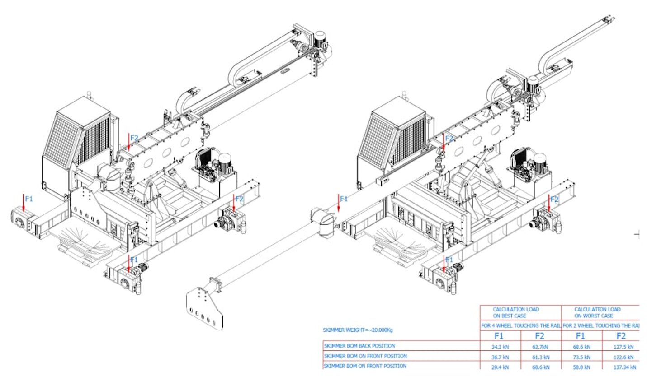
Fig. 14. Example of Automated Dross Skimming Machine (reference)
- HOLDING FURNACE EQUIPMENT
- Intent
The intent of this document shall be to identify the specifications and requirements needed to provide a bidding quote for qty of one (1) tilting holding furnaces. Customer has a 35 MT liquid capacity. Customer prefers Roof Mounted Electrical Resistance Heaters.
This project’s focus and thus funding is based on substantial reduction in green house gasses, consequentially we have chosen Roof Mounted Electrical Resistance Heaters as our heating means. In doing so, insulation at the walls, hearth and roof becomes paramount in that every kW of energy lost thru the walls or structure must be replaced with additional energy to replace the heat which is lost. As a Contractor on this project, we encourage you to choose well respected high alumina materials in contact with the molten aluminium and hyper insulative layers near the steel walls. Eventually, we will be asking for very specific Product Acceptance Tests and Guarantee’s and thus, we ask you to keep this in mind because every kW you keep from escaping to atmosphere will help you meet or exceed our expectations.
Project scope, capacity, layouts, designs, product formula, and process models shall be maintained strictly confidential. Contractor shall not disclose this information at any time.

- Holding Furnace Scope of Supply
This specification, in conjunction with the referenced specifications, codes, and standards, identifies the minimum requirements for the design, manufacture, and supply of the following:
- One (1) - 35 MT Tilting Holding Furnaces (receiving of 35 MT of liquid melt from melting furnace within one melt transfer need to be considered)
- Furnace shell.
- Pouring Spout
- Receiving Spout.
- Main Door and door drive mechanism.
- Provision for Rotary Flux Injector (RFI) Door (for future installation)
- Hydraulic tilting-door opening system.
- Refractory (Materials, installation, dry-out).
- Electrical Heating system.
- Duct system which transmits the fumes to the bag house.
- Over the door hood & fume collection system.
- Walkways and platforms where needed.
- Rotating or guillotine receiving and pouring spout covering doors (Pneumatic or Hydraulic).
- Provision for Air cooled camera (for future installation) – same type as used at melting furnace
- Retractable Thermocouple Device (Gear Motor).
- Molten Metal Capacity, during casting
- Safety guards.
- Transfer Troughing from Holder to Casting unit
- Utility supply piping (T.O.P ~ Furnaces).
- Electrical power & control system.
- Control panels & H.M.I.
- Environmental equipment (TA Luft Guidance)
- CE mark indicating that the manufacturer affirms the goods conformity with European health, safety, and environmental protection standards.
- The Contractor shall be fully responsible for designing and providing a complete system that will meet or exceed the general and performance requirements set forth by this specification.
- The Contractor shall supply prior to installation complete detail design documentation/drawing with Bill of Materials for the furnace identifying all components which are identified in the assembly drawings and manuals which are considered as refractory material / consumables.
- The Contractor shall also provide necessary drawings (Assembly or Manufacturing) which may be needed over the life of the furnace to maintain the refractory lining, the pre-cast shapes, castable and repair the furnaces.
- Any patented or trade secreted items shall be identified in the offer, enabeling Customer to provide due protection of the Contractors rights.

- Reference Standards, and SPI’S
The following is a list of Standards and SPI’s having pertinent information and details for this project. The latest editions of specific codes and standards shall apply.
- Specifications
- Noise DIN 45635 (82 db) and DIN 45641 (8 hr 82 db) (available online).
- Effluents TA Luft 2002 (available online).
- Burner and Flames EN 746, EN 1539 (available online).
- Customer General Equipment Specification (to be provided later).
- Customer Powder and Dust Explosion Hazard Specification (to be provided later).

- Take Off Points (TOP)
- The Contractor is responsible for identifying the TOP (Distance and Conditions) for the following (whatever is applicable):
- Natural Gas
- Oxygen
- Compressed air
- Electricity
- Effluent Isolation ductwork, Temperature and Nm³/min
- Water
- Incinerator exiting ductwork if an incinerator is needed.
- Molten Metal Trough/Joint.
- What ever is needed for operating the furnace.

- General Technical Data
      - Design Criteria
The Contractor shall clearly state the annual rated output for the furnace (TPH) and heating system (MW). The equipment shall be designed for continuous duty, 24 hours per day, and 7 days per week with minimal maintenance. The design criteria are below in Table 7:
Table 7. Holding Furnace Design Criteria
ITEM | PARAMETER | UNITS |  | VALUE |  | COMMENT
1 | TYPE | HOLDER |  | Tilting, DRY HEARTH |  | Hydraulic tilting
2 | BATH CAPACITY | MT |  | 35 |  | receiving of 35 MT of liquid melt from melting furnace within one melt transfer need to be considered.
4 | AVERAGE HOLDING TEMPERATURE | Cº |  | 730
5 | HEATING TYPE |  |  | ELECTRICAL RESISTANCE |  | Contractor to specify
6 | ELECTRICAL ENERGY FOR HOLDING WITH ELECTRICAL HEATING | kWh/t |  | * |  | Contractor to specify
7 | ELECTRICAL ENERGY WHEN INCREASING TEMPERATURE 50 C PER HOUR. | kWh/t |  | * |  | Contractor to specify.
11 | NOMINAL FLAT BATH OVERALL DIMENSIONS | m² |  | * |  | Contractor to specify final dims. Furnace depth to be based on required door width and other parameters.
12 | HEARTH FREEZE PLANE | mm |  | * |  | Refractory to be specified by Contractor
13 | SHELL TEMPERATURE | Cº |  | * |  | Contractor to specify
14 | HEARTH FREEZE PLANE | mm |  | * WITHIN WEAR LAYER OF FURNACE |  | Contractor to provide calculations of freeze planes in floor and sidewalls below melt line
15 | POURING SPOUT ELEVATION ABOVE BATH | mm |  | * |  | Contractor to specify
16 | ELEVATION OF PIVOT POINT ABOVE FLOOR | m |  | * |  | Contractor to specify
17 | PIVOT POINT | mm |  | * |  | Above designed metal level
18 | FURNACE TILT ANGLE (MAX) Empty + 2º | DEG Rotation |  | * |  | Furnace must be designed to be fully emptied
19 | TILTING TIME, EMPTYING | MIN |  | * |  | Adjusted to match Casting Speed
20 | TILTING TIME, DESCENDING (EMPTY) | MIN |  | < 2 |  | Will be controlled manually or remotely from main control system
21 | TILTING MECHANISM |  |  | * |  | To be controlled from Melter Control Panel
22 | MAXIMUM METAL DEPTH | mm |  | * |  | Approximately
23 | FREEBOARD, MIN | mm | 100 |  | On pivot side
24 | Ramp Angle at door | DEG (°) | * 30–35 |  | Sill to bottom of furnace
25 | SILL ANGLE | DEG (°) | 3–5 |  | Sloping down towards ramp
26 | SILL WIDTH | mm | * |  | With sill plate to direct dross to pan. Plates to have expansion gaskets
27 | FURNACE WALL HEIGHT ABOVE METAL | mm | * |  | Contractor to specify final dims.
32 | DOOR SILL TO FLOOR |  | * |  | Contractor to specify final dims.
33 | RAMP ANGLE AT BACK | DEG (°) | * 22–25
34 | FLOOR SLOPE | DEG (°) | 1.5–2
*: Contractor denotes key inputs which are required within theTechnical Offer.

      - Furnace Shells
- The furnace shall be fabricated and assembled in the Contractor’s workshop, as so much reasonably practical, using full penetration welds by welders trained and certified by local authority, prior to delivery.
- Furnace Bottom to be fabricated from structural steel grade S235J2 or equivalent.
- Shell and bottom shall be adequately reinforced against buckling using heavy-duty channel sections.
- The steel shell to be full penetration welded, continuous from 300 mm above metal level to the bottom of the hearth including hearth plates.
- Structural channels to be positioned with flanges facing down so as not to collect dirt.
- Shell structure shall not exceed 50 % of the material yield strength.
- Extra stiffening shall be provided around all doors, tap hole mountings, casting and receiving spouts and exhaust port.
- Contractor shall provide calculations for review after request by Customer.
- The Contractor shall provide a Pouring (Tapping) Spout, opposite the main door. The refractory entrance shall be tapered, with increasing area toward the molten away from the exterior wall.
- The Pouring and the Receiving Spout opening must have a rotating refractory stopper to hydraulically or pneumatically temporarily seal the opening so that during high electrical heat mode, fumes or heat does not escape the furnace chamber.
- The Contractor shall provide a Receiving spout, adjacent the pouring (Tapping) Spout, opposite the main door. The refractory on the bath side shall be tapered with increasing area toward the molten away from the exterior wall.
- The opening jams and top lintels will be constructed from heavy, removable, replaceable cast iron or steel frame constructed in segments to allow for expansion and bolted back to the furnace door surround structure to allow for expansion and bolted back to the furnace door surround structure. Alternately, pre-cast section door jam and lintels may be used providing they have a segmented steel frame construction to allow for expansion and bolted back to the furnace door surround structure. This construction prevents distortion of the doorway face and is foundry duty able to withstand the periodic bumping of equipment during skimming.
- The door sill pre-cast refractories will be protected by a heavy, heat-resisting cast iron apron bolted back to the furnace structure in segments to allow for expansion. These apron segments must have angled deflector plates for dross removal and are specifically developed to resist the high level of mechanical shock which can occur during cleaning, fluxing, and skimming in aluminum foundries (Fig. 15). Actual sill depth should be greater than 1.0 meter and be sloped toward the molten.
Fig. 15: Wide Flange Door Frame
      - Cast steel faceplate
The perimeter of the door opening seal surface shall be covered with ASTM A297 (HK) grade heat-resistant cast steel castings (Faceplate) bolted in place. (No water cooling, No air cooling). The bolt holes shall be counter-sunk drilled to prevent the bolt heads from protruding (Fig. 16). Jam & lintel area to be 2” thick, sill area to be 3” thick with angled skim apron.
Fig. 16: Cast Steel Faceplate
      - Replaceable refractory face plate
Under special conditions, Customer can accept a replaceable refractory face plate in lieu of the ASTM A297 (HK) grade heat-resistant cast steel castings if the refractory face plate is adjacent the poured wall while still being adjustable over time.

      - External guides
Door guides shall have external guides, so the door does not deviate from the guides. The external guides shall be designed to be bolted for easy removal of the doors (Fig. 17). Also, the guides shall be designed to be strong enough not to be damaged or deformed by flames from the door openings.
Fig. 17: Door Guides
      - Skim apron
A skim apron shall be installed at the sidewell sill for dross skimming and shall be designed to be bolted for easy replacement (Fig. 18 and Fig. 19).
Fig. 18: Skim Apron
Fig. 19: Skim Apron (Views)
      - Refractory sill
The front sill refractory will be protected by a heavy, heat-resisting cast iron apron bolted back to the furnace structure in segments to allow for expansion. These apron segments have angled deflector plates for dross removal and are specially developed to resist the high level of mechanical shock which can occur during cleaning, fluxing and skimming in aluminum foundries (Fig. 20). Heavy castings are fitted over the top of the sidewell wall refractories to protect them from erosion and damage during cleaning.
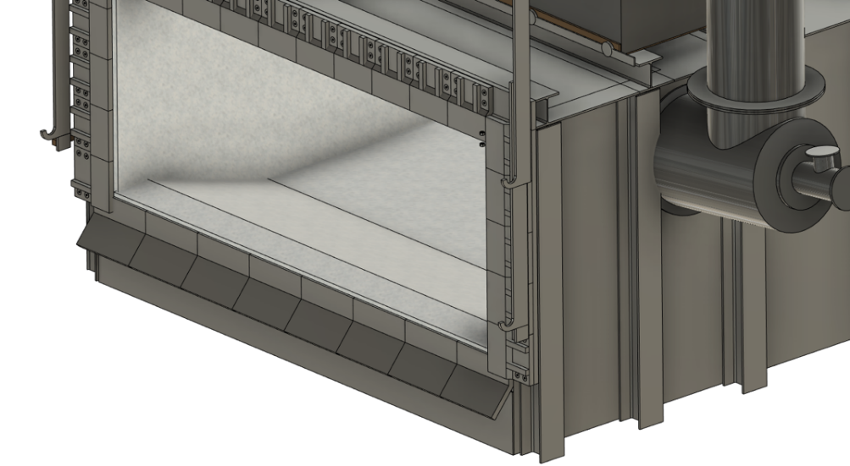
Fig. 20: Refractory Sill with Heavy-Duty Support Apron
- The door sill pre-cast refractories will be protected by a heavy, heat-resisting cast iron apron bolted back to the furnace structure in segments to allow for expansion. These apron segments must have angled deflector plates for dross removal and are specifically developed to resist the high level of mechanical shock which can occur during cleaning, fluxing and skimming in aluminum foundries. Actual sill depth should be greater than 1.0 meter and be sloped toward the molten.

- Furnace exterior temperatures as follows:
- Hearth. 92 °C (MAX). Min. Thickness 500 mm, Hot face 750 °C
- Lower Sidewall 86 °C (MAX). Min. Thickness 450 mm, Hot face 750 °C
- Upper Sidewall 54 °C (MAX). Min. Thickness 450 mm, Hot face 948 °C
- Roof 75 °C (MAX). Min. Thickness 350 mm, Hot face 1100 °C
- Door 65 °C (MAX). Min. Thickness 350 mm, Hot face 950 °C
- Shell to include the following:
- Structural steel, plate, and sheet metal
- Support steel for door lintels, jambs, and sills.
- Door hoisting system
- Trough joint and connection flange.

      - Furnace Doors
- The tilting furnace shall include a single, full width door. The door shall be located across the front of the furnace on the side opposite the furnace pivot / pouring spout. The door seal shall be designed to require no additional cooling except that provided by convective ambient air currents.
- Absolutely no hydraulic lines may be located below metal level in the proximity of the door on the exterior of the furnace.
- Absolutely no electrical lines may be located below metal level in the proximity of the door on the exterior of the furnace.
- There shall be no services fastened to or attached to the concrete flooring or inside furnace basement wall below the furnace door.
- The furnace door mechanism to lift vertically and shall provide the following design features:
- Opening and closing rate shall be approximately 5 m/min.
- Door at up-position to safely clear lintel to facilitate its change.
- Guiding arrangement shall provide sealing of the doors to the door jambs (Guide and Lock).
- Mechanism shall be designed/setup for “easy” door removal and replacement for maintenance purposes.
- Lift mechanism shall be complete with electric motor or hydraulically driven hoist and chains.
- Wires and hydraulic lines shall be located behind a forward-facing radiant panel shield and be protected from heat when the door is open.
- Four Safety chains shall be provided on each door to prevent the door from falling in the event of failure of the main hoisting chain.
- Horizontal clamp mechanism shall be provided for positive door closure when door is in closed position (Fig. 21).

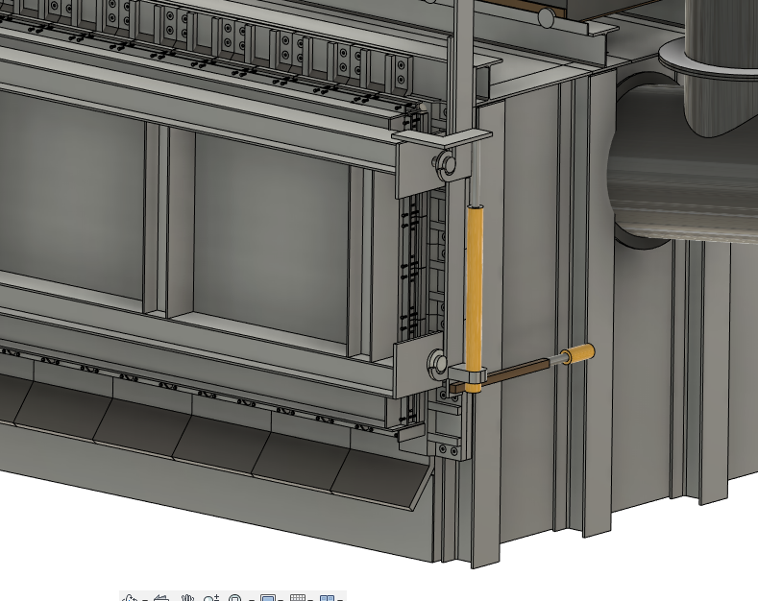
Fig. 21: Horizontal Door Clamp
- This horizontal clamp mechanism shall also be provided to separate the door seal from the door sill and lintel structure.
- Motor drive for hoist shall be in a position away from direct heat impingement generated by the furnace.
- Furnaces to have a minimum 1.4-meter clear opening vertically and width as per furnace dimension.
- Doors for holding furnace must be identical for spare part minimization and for universal usage of furnace charging machine(s) at all furnaces (25 / 35 ton melting and holding furnaces) within the overall project.
- Furnace to have a radiant shield, facing the door when the door is in the elevated or open position.
- The furnace door jamb may in lieu of the horizontal clamping, contain an angled steel guide and stop on each end to utilize the weight of the door to seal against the furnace. Additional chain length is to be provided for door to rest on cast house floor to support during maintenance.
- A counterweighted door is preferred to reduce electrical motor size.
- All components of the door lift mechanism shall be adequately protected from heat exposure of the furnace.
- It shall be the responsibility of the Contractor to provide a door that will maintain the seal with the furnace throughout its useful life with reasonable maintenance.
- Complete details of the proposed door drive, arrangement, slope angle and materials of construction shall be provided for approval by Customer.
- The door open/close functions shall be by a pushbutton located near the door for maintenance purpose or operation usage. Main operation via control system as per automatic sequence for skimming controlled via central furnace pulpit.
- The door shall raise in less than 20 seconds and lower in less than 15 seconds.
- The open/proximity switches shall also ensure the furnace is operating on low fire or on pilot whenever the door is off the closed position. Cabling / route should be protected from dirt and transient radiative heat.
- Each furnace door shall provide access for automatic charging, skimming, dross removal, and for access to clean furnace walls and hearth.
- Bottom of the door opening shall be located 50 mm above the maximum metal line in the hearth. The hearth shall be sloped upwards at the door to facilitate dross removal.
- Door shall be designed with folded blanket and block fiber refractory lining.
- All outer edges on the inside of the door will be short cast iron seal housings bolted around the doors to form a surrounding frame to accommodate a compressible fiber seal that presses against the door jambs and lintel when in the down clamped position. These seal castings can be adjusted while the furnace is hot to ensure a good tight seal against the furnace frame (Fig. 22).

Fig. 22: Door Seal

- Water cooling of the door is not acceptable.
- Minimum door width 5.0 m.
- To be fabricated from A515M alloy steel plates of thickness to ensure a structurally sound door for the application intended.

      - Furnace Exhaust
- A hood shall be provided for fume capture over the door opening on the furnace to capture fumes generated during de-skimming or cleaning operations when required.
- Under special conditions the Contractor may introduce an internal plenum in the hood. If this is the case, the Contractor must be able to show their flow calculations inorder to gain the Customer approval.
- The velocities for designing the hoods and the fume collection duct system shall be as below:
- Minimum Face velocity below hoods 1 m/s
- Minimum Velocity in fume/dust ducts 20 m/s.
- The hood casing shall be made of 5 mm thick St – 37 steel sheet reinforced as needed by NPU or steel structures for rigidity. The steel exterior and interior shall be coated with paint and the interior surfaces with a high temperature paint, See Customer Painting Guidelines.
- The furnace shall be equipped with a discharge flue to remove any fumes or offgassing which occurs during tilting-casting.
- The baghouse fan (scope of others), shall be sized to accept all combustion gas flows and all fume exhaust source points, synchronized so the bag house is not oversized.
- The Contractor scope shall include all hardware, gasketing and lining materials, all ducts for discharge flow shall be swivel or pivoting type to minimize any fugitive emissions.
- The Contractor shall, specify flue discharge flow and temperature after the pneumatic/automated furnace pressure control damper so that an appropriate bag house may be designed.
- The flue shall be lined with reinforced refractory to limit steel temperatures.
- The emergency stack (scope of others) height approximately 30 meters, as directed by the Contractor.

      - Refractory Lining
This project’s focus and thus funding is based on substantial reduction in green house gasses, consequentially we have chosen Roof Mounted Electrical Resistance Heaters as our heating means. In doing so, insulation at the walls, hearth and roof becomes paramount in that every kW of energy lost thru the walls or structure must be replaced with additional energy to replace the heat which is lost. As a Contractor on this project, we encourage you to choose well respected high alumina materials in contact with the molten aluminium and hyper insulative layers near the steel walls. Eventually, we will be asking for very specific Product Acceptance Tests and Guarantee’s and thus, we ask you to keep this in mind because every kW you keep from escaping to atmosphere will help you meet or exceed our expectations.
Each offer shall include your heat transfer calculations for the following six (6) * points. Each calculation shall show, the anticipated hot face temperature which below molten shall be 750 °C, on the roof 1100 °C and on the upper wall, 950 °C. Exterior furnace temperatures will be a key variable for analysis along with your anticipated heat loss thru each section and the freeze plane 660 °C.
All metal exposed surfaces with corresponding build up layers in the holding furnace as below listed up except for the door are expected to be a cast in place monolygh.
With this information you must include the Technical Data Sheet for each product anticipated in the lining and your local source point.
- Ramp
- Minimum 300 mm Working Lining, 68 % AL₂O₃, 22 % SiO₂ castable. Barium containing additive preferred.
- 65 mm Back-up Castable 49 % Al2O3, 39 % SiO2
- 115 G-26 Insulating Firebrick
- 10 mm 80% AL2O3 1100 ℃ Underlaying Refractory Board
- 10 mm Rigid Fiber Board Panel 1000 ℃
- Hearth *
- Minimum 300 mm Working Lining, 68 % AL₂O₃, 22 % SiO₂ castable. Barium containing additive preferred.
- 65 mm Back-up Castable 49 % AL₂O 3, 39 % SiO₂
- 115 G-26 Insulating Firebrick
- 10 mm 80% AL2O3 1100 ℃ Underlaying Refractory Board
- 10 mm Rigid Fiber Board Panel 1000 ℃ Grade 607/85
- Lower Sidewall *
- Minimum 300 mm Working Lining, 68 % AL₂O₃, 22 % SiO₂ castable. Barium containing additive preferred.
- 115 mm thick of Dense Brick (40 – 42 % AL₂O₃)
- 40 G-26 Insulating Firebrick
- 20 mm Rigid Fiber Board Panel 1000 ℃ Grade 607/85
- Barium containing additive preferred.
- Upper Sidewall *
- 285 mm Working Lining, 42 % AL₂O₃, 52 % SiO₂ castable.
- 115 mm thick of Dense Brick (40 – 42 % AL₂O₃)
- 75 mm Rigid Fiber Board Panel 1000 ℃ Grade 607/85
- 25 mm Insulating Hard Board (ISO-Al grade)
- Barium containing additive preferred.
- Door *
- 230 mm minimum hot face thickness
- 230 mm with folded blanket or block fiber refractory lining.
- Alkaline resistant up to 1400 °C
- Roof *
- 250 mm 42 % AL₂O₃, 52 % SiO₂
- 100 mm 30 % AL₂O₃, 37 % SiO₂
- 50 mm Blanket
- Alkaline resistant up to 1400 °C
- Refractory-supporting steel structure shall be parallel to lintels or opposite orientation to the tilting axis designed and installed with an increased supporting weight-load of 25 %.
- The refractory specifications in this section are minimum requirements. The refractory manufacturer will be by Contractor unless otherwise specified. The Contractor may choose any refractory or manufacturer of proven quality, to be approved by Customer if the intended material and performance properties are met. Contractor is responsible for the final refractory design and shall warrantee the refractory for five (5) years after furnace start-up.
- Furnace floor shall be sloped to a point at the drain out tap block which may be needed to drain the furnace in the unfortunate event of a prolonged power outage.
- The Contractor shall provide refractory materials of construction and basic construction details for the following to be approved by Customer:
- Lower sidewalls to 300 mm above metal line
- 30–35° Door Ramp
- Ramp Sill.
- 22–25° Back Wall Ramp.
- Upper Sidewalls
- Upper Sidewall Cap
- Furnace Door Arches
- Furnace Door Jamb
- Furnace Door Jambs
- Furnace Door Sill
- Furnace Door
- Pouring and Receiving Spouts
- The hearth must withstand regular skimming operation by mechanical means. Contractor shall take this into account with the design and material of the furnace liner.
- All hangars and other refractory fastening hardware shall be 316 Stainless, unless othwersise agreed in advance of installation.
- All fiber blanket and paper shall have appropriate cut outs, so the refractory blanket terminates 10 mm away from the hanger or hardware.
- The refractory shall be designed to minimize heat loss. Heat transfer calculations shall be provided with final offer as total kW lost. The basis for this calculation shall be: m²(area) x w\m².
- Contractor is to provide the dimension from the freeze plane to the hot face of the brick.
- Cold face steel temperatures shall not exceed the following at steady state heating when the ambient temperature is 25 ºC. It is to be understood by the Contractor that, heat loss thru the furnace lining indicates an excess GHG to overcome this loss.
- Lintels, jambs, and sills shall be provided with metallic inserts for handling and affixing to the steel shell.
- The sills shall be easily replaceable and shall resist damage during charging and skimming.
- The door jambs shall be easily replaceable and shall be flush with the sidewalls of the refractory lining to facilitate furnace cleaning and preclude damage to the lining or jamb.
- Expected operating life of furnace lining is 5 calendar years minimum with 5 to 7 charges per day; this shall be incorporated into the design criteria of the furnace lining.
- Furnace sill shall not exceed 1.5 meter from mill floor for scrap charging purposes.
- Weep Holes shall be provided in the furnace shell and bottom to allow water vapor from the refractory to escape during furnace dry out. Weep Holes need to be threaded for M12 bolts. The Weep Holes should not be more than 1 m apart.
- The Contractor shall provide within engineering (detail design including manufacturing drawings / bill of material lists) also an alternative refractory/lining concept with only pre-cast shape/block linings (all hot faces) and provide to the Customer within documenation hand over full.

- Required documentation
- General
- The Contractor shall provide all revised or new drawings and documentation required for installation and maintaining the equipment in editable format. Where applicable, these shall include, but are not limited to, the following: Functional Description, Assembly and Disassembly Procedure Description, Process & Instrumentation Diagrams (P&I), General Arrangement & Equipment Layout Drawings, Assembly Drawings, Foundation Drawings, Structural Drawings, Piping Drawings, Plan, Section & Detail Drawings, Conduit and Cable Schedules, Single Line Drawings, Equipment Grounding Drawings, Exposed Raceway Drawings, Transition Drawings, Junction Box / Termination Panel Details, Interconnection Drawings, Control Drawings, Elementary Drawings, Communication & Interface Drawings, Level I & Level II Logic Documents, Operation & Maintenance Manuals, and Training Manuals & Visual Aids.
- Safety instructions,
- Risk analysis,
- Technical protocol (specifying name of equipment, type of equipment, serial nr., weight, main dimensions),
- Guidlines for a inspection and checks (on daily, weekly, monthly, yearly basis),
- List of spare parts for mechanics, hydraulics, pneumatics and electrical systems with a cataloque nr., for minimum 2 years,
- Basic list of alarms with a help instruction,
- Initional revision, tests protocol, certificates for electro cabinets ets.,
- For Automation, the Contractor shall provide PLC Configuration, Hardware and Software Specifications, and technical & schematic wiring diagram. (including existing panel) PLC control software in editable and open form
- The Contractor shall provide, in one master document, a listing of all parameter settings for electrical, mechanical, and hydraulic equipment.
- The Contractor is required to notify the Customer’s Purchasing representative of any impact on cost or schedule resulting from Customer’s requested changes, whether the request was made verbally, written or in review comments on drawings. The said changes shall only be executed upon authorization by Customer’s purchasing.
- The Contractor shall provide the “As Built / As Commissioned” editable, electronic drawings and documentation, with one hard copy, no later than 3 weeks after completion of the project. The Contractor shall provide detailed fabrication drawings of all non-commercial parts utilized in the fabrication and installation of equipment within the Contractor’s scope of supply. All standard commercial parts are to be specified on respective assembly drawings, and in O & M manuals in sufficient detail to permit direct purchase from third party contractors.
- Any components currently covered by patents must be identified and appropriate patent # must be listed.
- The Contractor shall provide one editable copy of all computer-generated documents on USB disk or external hard drive.
- All documentation provided to Customer shall be in Czech and English
- On the operational panel will be possible to choice a language Czech or English.
- The Contractor shall provide Customer with a limited use Right to Copy said documentation for the explicit use by Customer in maintaining, training and operating the equipment.
- The Contractor shall provide Customer with the Material Safety Data Sheets (MSDS) for any used chemical.
- Instead of CD use external hard drive.
- Technical documentation of the machine (layout of the system, sets of machining drawing, hydraulic schema, pneumatic schema, lubrication instruction),
- All documentation is delivered in 3 copies in paper format and 1 copy on USB disk (pdf format).

- Drawings
- All design drawings must be done in Metric Form in the latest AutoCad version and provided in addition in *.dwg and *.pdf format. Other preferred formats are *.step, *.igs, *.mi, *.pkg, *.dxf.
- The design and installation drawings shall be submitted for Customer’s review. To expedite Customer’s review, drawings shall be transmitted electronically.
- Comments on drawings by Customer do not relieve the Contractor of his responsibility for the system design, operation and safety. Drawings returned by Customer with comments, shall be resubmitted for record purposes.
- EPLAN is the preferred software for electrical documentation.
- Manuals
- Contractor shall provide a full and complete Bill of Material (BoM) for all delivered parts. Documentation in SAP Materials Management Module is preferred.
- Operation and maintenance manuals shall be submitted in editable, electronic format.

- Documents for construction readiness
- Machine layout and basic data output data
- Side views
- Basic information for compressed air system, cooling water, hydraulic system, other required media
- Final of load data
- Conduits/channels for media/electric dimensions – connected to civil works as needed for general designer for building engineering
- Emissions arising from the technology (if relevant) - characteristics, amount, location of the chimney (exhaust), height and diameter of the chimney (exhaust), amount of air, operating hours
- Noise – sources, amount of emissions (technical data), proposal of a possible method of limitation

- Documents for Basic engineering
- Machine layout with connection points and all utility output data
- Side views with connection points
- Foundation plan with load data (static and dynamic) including the Machine ground connection
- Anchor plans of the equipment
- Drawings and requirements for compressed air system – power, flow, pressure, connection dimensions, piping plans etc.
- Drawings and requirements for cooling water – power, flow, pressure, connection dimensions, piping plans etc.
- Drawings and requirements for hydraulic system – power, flow, pressure, piping plans etc.
- Drawings and requirements for air extraction (if you consider) -power, flow, connection dimensions, piping plans etc.
- Emissions arising from the technology (if relevant) - characteristics, amount, removal method – cleaning, location of the chimney (exhaust), height and diameter of the chimney (exhaust), amount of air, operating hours
- Documents for Electrical Equipment containing
- Electric switchboard dimensions
- Electric design drawings
- The required cable routes
- Drawings and requirements for other required media – power, flow, pressure, connection dimensions, piping plans, etc.
- Noise – sources, amount of emissions (technical data), proposal of a possible method of limitation
- 3D model of the device for the possibility of creating an overall model in the hall and thereby eliminating the crossing of distribution lines
- Technology requirements for other professions – lifting equipment, platforms, camera systems, special lighting, etc.

- Documents for installation of the Equipment
- engineering and design documentation containing the Detail Design documentation elaborated in details necessary for performance of the subject matter of the Contract;
- all documentation needed for proper construction, installation, erection, commissioning, operation, maintenance and repairs of the Equipment;
- detailed assembly, installation, erection, commissioning, operation and maintenance manuals for each appropriate unit of the Equipment;
- implementation documentation to the extent necessary for the needs of the tender procedure under the Subsidy Program (including measuring technology, preparations for assembly, requirements for measurement accuracy, etc.) and assembly.

- Final Documentation
- mechanical drawing documents for parts, sub-assemblies and assemblies, in PDF and DWG format,
- electronic drawing documents in E-Plan format, version 2.9 or later and in PDF format
- pneumatic line diagram in PDF and DWG format,
- hydraulic line diagram in PDF and DWG format
- operation and maintenance manual, hard copy (3x) and digital form, in Czech and English,
- BOM for spare parts in PDF and XLS format (indicating the type identification, ordering number, manufacturer, standard, dimension, lead time, etc.),
- BOM for wear parts in PDF and XLS format (indicating the name, ordering number, manufacturer, standard, dimension, lead time, etc.),
- maintenance, inspection and revision plan in Czech – based on the government resolution No. 378/2001 Coll. Section 2
- calibration sheets and recommended calibration intervals
- leak test reports for compressed air, gas and industrial water
- safety circuit function verification report
- electrical equipment verification test report pursuant to Czech national standard ČSN EN 60204-1 ED.3 (initial inspection of electrical parts)
- certificates, CE declaration of conformity
- risk analysis according to ČSN EN ISO 12100
- data sheets and certificates for the materials used
- installation logbook
- SW backup (source codes must be supplied for the PLC control system, visualisation e.g. WinCC, control of frequency converters, hydraulics, etc.), source codes must be in English
- other documents necessary for the operation of the line
- list of necessary workshop equipment for mold preparation and cleaning
- Version of AutoCAD (DWG) and EPLAN must be confirmed by Customer at start of project.

- Others
- 3D model documents of the line, in STEP format – due date as per the Contractor’s suggestion, however not later than 8 months since the order date
- preliminary operation and maintenance manual, hard copy (3x) and digital form, in Czech – due date before the operation and maintenance operator training
- all units, dimensions and weights must be given in SI (metric) units.

- Mechanical
- General
- The equipment shall be configured for maximum availability, reliability and maintainability. Maintainability shall include, but not be limited to, the following:
- Ease of maintenance and reduction of time required to change components and parts:
- Duplication of components and connected spare devices where practical
- All valves and all components requiring lubrication or adjustment shall be serviceable from accessible positions, without endangering operating or maintenance personnel.
- All rotating equipment shall be statically balanced.
- All pipe threads (coupling nut) to be Metric ISO standard. No alternative is allowed. (Usage: Assembly of plant or equipment piping, and connections or direction changes between rigid pipe. It is not the same as port fittings into cylinders.)
- All threaded fasteners to be Metric ISO standard. No alternative is allowed. (Usage: Bolts, screws, nuts, machine assembly)
- Bearing shall be precision ball or roller type.
- Guards shall be provided for all power movable parts and rotating drive components for personnel and equipment protection. Access to moving parts may be restricted by handrail and/or mesh guards to prevent operators or maintenance technicians from accidentally reaching the moving part. Refer to ISO 13857:2008 for Safety distances to prevent hazard zones being reached by upper and lower limbs.
- Locking mechanism, manually actuated, shall be furnished to lock moving parts during maintenance. Locking mechanisms shall follow LoTo requirements.
- Lifting facilities shall be provided on all major items of equipment to allow movement by crane.
- Leveling screws shall be provided on all main bases to facilitate installation.
- Vibrating system parts shall be equipped with effective damping to avoid transmission of vibrations to buildings, steel structures, other machinery parts, and piping.
- Structural supports, platforms, stairways, handrails, floor plate, etc. required for operation and on-line maintenance shall be provided by the Contractor. Dimple plate shall be provided on other than concrete walking surfaces.
- Design shall minimize the need for foundation pits and trenches.

- Lubrication
- Customer is responsible for the first fill as par Contractror detail engeneering specification
- A means to lubricate all bearings shall be provided. All rolling contact bearings shall meet or exceed 44,000 hrs. of equipment operation.
- As far as technically possible, maintenance/lubrication free equipment shall be used, based upon a minimum design life of 44,000 hr. of operation.
- The state of lubrication upon delivery shall be documented and identified. (i.e. is it a basic lubrication or lubrication ready for operation)
- If possible, facility for lubrication while the equipment is running shall be installed, i.e. lubrication nipples, oil level gauges and fill points shall be moved outside the machine guarding for easy access and reasonably centralized and labeled.

- Pneumatics and Hydraulics
      - General
- Customer is responsible for the first fill as par Contractor detail engeneering specification
- The Hydraulic system offered with all equipment include small hydraulic power packs and are being procured along with the individual equipment as a package and the same will conform to the standard / good engineering practice adopted for Hydraulic power packages. These packages will include all necessary electrics, pipework, instrumentation and controls.
- The hydraulic systems in general will include tank units, pump motor units, filtration unit, plate type heat exchanger cooling unit, valve stands, piping, hoses, instrumentation, controls, accumulator stands as required for a complete functional system.
- The system shall be designed such that the components are not allowed to be over-pressurized by the maximum discharge pressure of the pumps (i.e. the design pressure of every component in the system is higher than the maximum discharge pressure of the system pumps). This includes all cylinders, hoses, fittings, piping, gauges, etc. Pressure relief valves may be allowed to protect the hydraulic components, provided they are discharged directly back to the reservoir.
- Relief pressure plus any relieving backpressure to the reservoir shall not exceed the design pressure of the protected component(s). Use of pressure relief valves to protect components will only be allowed with written approval from Customer on a case-by-case basis
- Complete skid mounted hydraulic power packs shall be provided to meet any equipment hydraulic power requirements. Equipment shall be designed for use with “Water based and fireproof hydraulic fluid. The skid shall have a containment or drip pan with a capacity to hold the entire volume of oil in the system.
- Hydraulic tank(s) and piping (onboard as well intermediate piping up to end position) shall be of stainless steel. Pump-tank level interlocks shall have safety switches and analog for measuring/monitoring temperature shall be provided.
- Necessary test kit for proportional and servo valves will be provided as per the relevant system.
- Each hydraulic system shall be provided with electrical control panel. Audible and visible alarms shall be provided in the control panel as well as in HMI for indicating malfunctioning of any component.
- Supply of one (1) no. mobile filling pump-motor-filter unit (one unit for all hydraulic packs within Contractors scope) complete with 15 m long suction and delivery hoses, electrical control cabinet, 15 m long cable and power plug. The filter will be of adequate capacity and 5 micron fineness for hydraulic systems for unloading fresh hydraulic oil from barrels/tanker to the tank of each hydraulic system.
- Supply of one (1) no. mobile nitrogen booster complete (one unit for all hydraulic packs within Contractors scope) with electric motor, control cabinet, 15 m long each suction and delivery hoses, 15 m long cable and power plug for initial charging of accumulators with nitrogen.
- Hydraulic filter in any respective line (circulation, feed, pressure, return line) need to be double type (switch over between working and standby filter during operation without system stoppage is ensured) with differential pressure switch (signal to automation system with local mechanical inspection display) monitoring.
- For each type of pump (circulation, feeding, pressure pump) one hot stand by pump has to be considered.
- The pumps shall be mounted relatively close to the reservoir to ensure pump suction is always flooded.
- Manual, lockable isolation valves with electrical monitoring signal to control system shall be provided on pump suction and discharge sides of each pump to allow isolation for maintenance or repair without disruption of the system. In addition, pressure gauges with isolation valves shall be provided in between pump discharge and the discharge isolation valve.
- Selection or change of operating pump during operation has to be possible via control system HMI without stoppage of the hydraulic system. Monitoring of running motor hours with possible reset in case change of motor or pump has to be considered via control system HMI.
- Pumps shall be pressure compensated variable displacement type and shall be sized to handle the maximum flow for the system. Pumps shall be arranged in parallel using common suction and discharge headers. Pumps shall be identical.
- Pressure transducer measurement with isolation valves at each pump shall be provided.
- All pressure transducer measurements with isolation valves need to be analog type with 4-20 mA signal to control system with local display.
- All hydraulic cylinders need to be equipped with 2 pressure transducer measurements with isolution valves for measuring A and B side of respective cylinder. Analog type with 4-20 mA signal to automation system with local display. In addition, fittings located at each cylinder A and B side shall be provided for temporary installation of pressure gauges for maintenance and diagnostic directly at site.
- Any kind of servo / proportional valve need to be onboad electronic type (no external hardware card) and directly controlled by automation system with position feedback signal to automation system (preferred 4-20 mA).
- All lines feeding any kind of hydraulic drive (motor, cylinder, etc.) located close to high temperature area have to be equipped with differential pressure measurement (4-20 mA signal to automation system with local display) to detect hose or line breakage and respective line have to be equipped with shut off valve to ensure immediate stoppage of hydraulic fluid to respective hydraulic drive (motor, cylinder, etc.).
- Pneumatic equipment shall be specified for 10.5 bar maximum pressure. Actual pressure shall not exceed 6 bar (5-6 bar is the air pressure in the plant air pipelines). Contractor shall provide lockable shutoff supply valve, regulator and filter/lubricator for pneumatic devices. Contractor shall specify and supply, specify air-receiving tanks for large air volume using equipment or safety – critical equipment.
- Hydraulic piping connections on cylinders, power units and valves shall be 4-bolt SAE flanges.
- Each hydraulic / pneumatic circuit / cylinder shall be provided with lockable isolation valves on supply and return piping. In addition, each circuit / cylinder shall have a lockable drain valve to relieve circuit pressure prior to maintenance.
- Cylinders shall be designed with an operating pressure of 100 bar and a Proof pressure of 200 bar. Cylinders shall be designed to withstand twice the operating pressure according to the relation of the cross sections. Cylinder tubing to be seamless grade 55 steel tubing, piston rod plated with minimum 0.038 mm C45 hard chromium. Guide Bushings to be RG7 Red Brass, or equivalent. Connections to be SAE O-ring Flanges.
- Hydraulic equipment shall be mill duty type. In the melting and casting area, the hydraulic fluid shall be a suitable water based Polyol Ester.
- System components and piping shall be designed for 200 bar max for cylinder systems, 500 bar for hydraulic motor drive systems.
- Hydraulic tubing, fittings and ports.
- All hydraulic tubing to be Metric ISO standard. No alternative is allowed. (Usage: Tubing which may be bent or formed with hand tools or automatic tubing bender. Used for connections between valves, cylinders, etc that are within a machine, panel, HPU. Typically heavy gauge stainless steel.)
- All hydraulic tube fittings must be approved by Customer Engineers. (Usage: Fittings used to connect SS tubing to other tubing or devices, these fittings rely on compression to form a seal between the tube and the fitting)
- All hydraulic valve & cylinder ports to be BSPP standard. Exceptions must be approved by Customer Engineers (Usage: Connection ports between pipe, tubing, or hoses and a valve, cylinder, or other hydraulic device)
- All hydraulic hose fittings to be Metric ISO 24°. Exceptions must be approved by Customer Engineers (Usage: Connection between tubing, pipe, or hydraulic device and a flexible hose).
- On valves stands, tables function block diagram has to be mounted by using stainless steel plate – engraved. In addition, fittings located at each function served from the valve stand/table shall be provided for temporary installation of pressure gauges for maintenance and diagnostic directly at site.
- At all components (pumps, valves, instruments etc.) stainless steel plate (engraved) has to be mounted displaying reference code on respective installed steel frames, table, stands etc.
- Electrical signal (LED or diode) at soleniod valve connectors or any other kind of electric powered devices indicating power or switching status.

      - Furnace specific
- Each furnace pair (= One (1) melting and one (1) holding furnace) to include one (1) hydraulic power unit (HPU).
- Door functions shall be driven by a smaller pump (1 working + 1 stand by pump).

      - Melting furnace specific
- Furnace tilting (once during one melting cycle) with the following functions.
- Rapid tilt-back - This must be a normally open solenoid valve which dumps tilt cylinder hydraulic oil to tank. Solenoid must be energized for tilt-up functions. This solenoid valve also functions as the emergency tilt-back in the event of a power interruption while transferring molten to the holder. Should tilt from max tilt to ground level in 2 minutes or less.
- Slow tilt-back – This function shall be designed to automatically lower while maintaining molten metal level during transfer to the holder.
- Rapid tilt-up - This function is used for prepositioning of the melter prior to molten metal transfer to the holder. Valve to include manual flow rate adjustments.
- Slow tilt-up - Used during the molten metal transfer for trough metal level control. Proportional valve sized appropriately for good control of trough level for the duration of the transfer (20 minutes). Proportioning valve to take into consideration the reduction in molten metal area towards the end of the transfer.
- Tilting cylinders shall raise the furnace to an elevation where all the molten may be drained into the trough or an adjacent dump bin.
- Hydraulic system shall have a capability to pull the furnace door tight should a hydraulic pull cylinder at the door be used.
- The hydraulic system shall have a manually activated valve to lower the furnace in the event of a power outage, or an emergency accumulator shall be provided.
- The hydraulic system shall have the provision to be lowered „Rapid tilt-back“ via contral pulpit operation emergency pushbutton „Furnace lowering“ (must be powered via UPS to ensure operation in case of power outage) OR with a hand valve (without electrical power), located next to the furnace on a safe protected place.
- Hydraulic tilting rate shall be configured to be controlled by the operator in the operator control room at the HMI.
- Melt transfer to be controlled either from local control panel (also used for maintenance purpose) next to furnace or via remote via control pulpit.
- Energy saving control has to be considered using state of art technology – for example frequency converter with separate set of pressure pumps for tilting only or similar to ensure lowest electrical power consumption in case no tilting ongoing = stopping pumps after tilting is completed and furnace is back in 0-position.

      - Holding furnace specific
- Furnace tilting (continuous process during ongoing casting) with the following functions.
- Rapid tilt-back- This must be a normally open solenoid valve which dumps tilt cylinder hydraulic oil to tank. Solenoid must be energized for tilt-up functions. This solenoid valve also functions as the emergency tilt-back in the event of a power disruption and thus must be hard-wired through all emergency stop and cast abort pushbuttons. Should tilt from max tilt to ground level in 2 minutes or less.
- Slow tilt-back – This function shall be designed to automatically lower while maintaining molten metal level during casting while simultaneously receiving metal from the melter.
- Rapid tilt-up - This function is used for prepositioning of the holder prior to casting and may also be used to rapidly fill the trough at the start of the cast. Valve to include manual flow rate adjustments.
- Slow tilt-up - Used during the cast to control furnace tilt-rate for trough metal level control. Proportional valve sized appropriately for good control of trough level for the duration of casting (cast will take approximately 6-8 hours), considering the changing surface area of the bath as a function of tilt angle.
- Tilting cylinders shall raise the furnace to an elevation where all the molten may be drained into the trough or an adjacent dump bin.
- Hydraulic system shall have a capability to pull the furnace door tight should a hydraulic pull cylinder at the door be used.
- The hydraulic system shall have a manually activated valve to lower the furnace in the event of a power outage, or an emergency accumulator shall be provided.
- The hydraulic system shall have the provision to be lowered „Rapid tilt-back“ via contral pulpit operation emergency pushbutton „Furnace lowering“ (must be powered via UPS to ensure operation in case of power outage) OR with a hand valve (without electrical power), located next to the furnace on a safe protected place.
- Melt transfer to be controlled either from local control panel (also used for maintenance purpose) next to furnace or via remote via control pulpit.
- Hydraulic tilting rate shall be configured to be controlled by the operator in the central pulpit at the HMI with closed loop of melt level in thought at TOP to downstream casting line.
- The hydraulic proportioning valve, which controls the tilt up rate shall be purchased with fine calibration spring to ensure precice molten metal control in the trough to +/- 1.5 mm.
- Energy saving control has to be considered using state of art technology – for example frequency converter or separate set of pressure pumps for tilting only or similar to ensure lowest electrical power consumption in case no tilting ongoing.

- Pneumatic tubing, hoses, fittings and ports.
- All pneumatic tubing and hoses to be Metric ISO standard. No alternative is allowed. (Usage: Tubing, hoses which may be bent or formed with hand tools or automatic tubing bender. Used for connections between valves, cylinders, etc., that are within a machine, panel, HPU. Tubing typically lighter gauge stainless steel.)
- All pneumatic tube fittings must be approved by Customer’s Engineers. (Usage: Fittings used to connect SS tubing to other tubing or devices, these fittings rely on compression to form a seal between the tube and the fitting)
- All pneumatic valve & cylinder ports to be BSPP standard. Exceptions must be approved by Customer’s Engineers (Usage: Connection ports between pipe, tubing, or hoses and a valve, cylinder, or other pneumatic device.
- All pneumatic hose fittings to be approved by Customer’s Engineers (Usage: Connection between tubing, pipe, or pneumatic device and a flexible hose) Hydraulic directional control valves shall be 3-position valves; center position shall vent ports A & B to T with a pilot operated check valve. Pneumatic directional control valves shall be 3-position with blocked center. Loss of power will cause the valve to center in order to prevent movement when power is restored. Solenoid actuated valves shall have indicator lights and manual overrides.

- Piping
- All utilities serving the furnace shall have lockable shutoff valves upstream of all operating valves and/or components to provide “zero energy state” immediately downstream.
- All machine assemblies shall be pre-piped to the machine boundary with single point connections.
- Contractor drawings shall clearly show tie-in points, connection size and type for all connections to plant piping systems (i.e. utility connections). Drawings shall also indicate tie-in points for interconnecting piping between Contractor provided components.
- All Hydraulic lines or pipes shall be stainless.
- Absolutely no hydraulic or electrical lines may be located below metal level on the furnace shell in the proximity of the walled in molten receiving window, RFI door or pouring spout.
- There shall be no services fastened to or attached to the concrete flooring or inside furnace basement wall in the proximity of the walled in molten receiving window, RFI door or pouring spout.
- Pipes should be sized to minimize pressure drops.
- Flow velocity shall be determined based upon an analysis between capital and operating costs. The connection of the equipment with the supply, production and waste lines should be as short as possible. If direction changes or branch offs are required, they shall be designed to allow optimal flow rates and minimize pressure drops. With limited space available optimization between routing and flow rates must be found.
- All piping shall be clearly arranged to facilitate inspection for damage/leakage. All piping shall be color-coded and labelled in compliance with ANSI 13.1.
- Pipe routing and location of valves, sensors etc. shall respect ergonomic ease for servicing and replacement.
- Hoses shall be resistant to ambient heat, commercial lubricants, hydraulic fluids and cleaning detergents. Metallic hoses shall be used in areas where molten aluminum spill hazard exists.
- Hoses shall be installed in such a way that they can neither be pinched nor worn through.
- All machine assemblies shall be pre-piped to the machine boundary with single point connections.

- Walkways, Platforms and Ladders
- Platforms shall be installed in all locations where inspection and maintenance are required.
- Stairs shall be installed for all elevated areas that require access. Ship ladders are acceptable.
- All handrails shall be 1.2 meters high and have 100 mm high toe guards installed.
- All walkways, platforms and stairs shall be made using checkered plates, or grating as necessary for fire prevention.

- Electric and Instrumentation
- General
This chapter specifies the documentation of electrical and instrumentation systems that is necessary to meet the requirements of a new industrial facility.
The documentation level requirements for each part are set out in the scope of work.
The intention is to design modern equipment in accordance with the needs of the entire project, including electrical and instrumentation systems.
When selecting the size and type of electrical cabinets, transformers, motors, drives, etc., standardized types and ratings must be preferred to maximize interchangeability and minimize maintenance needs.
TOP (Take over point):
- 400 V power supply for low voltage equipment – TOP is input terminal in MCC or, respective electric cabinet.
- Contractor shall provide the preliminary SLD and automation configuration diagram with his offer document.

- Ambient conditions
The proposed instrumentation will be suitable for operation in the following ambient conditions:
- Outdoor temperature max. 40 °C
min. -30 °C
- Indoor temperature max. 50 °C
min. 10 °C
- level above sea to 1000 m

The Contractor acknowledges that the above information is a guide to the general design. However, the maximum temperatures to be considered will depend on the location of the equipment, which is the responsibility of the Contractor.
- MCC / distribution room 15-35 °C
Relative humidity 70 % (air-conditioned)
- Control room / PLC room 15-25 °C
Relative humidity 55 ± 5 % (air- conditioned)
- Cable tunnel / cable cellar Ventilated
Relative humidity 95 %

- Voltage and power supply conditions
- Voltage system
Medium voltage: nn kV (will be defined during engineering)
Low voltage: 0.4 kV TN-C 3+PEN, TN-C 3+PE+N
- Frequency 50 Hz
- Voltage fluctuations ± 10%
- Frequency fluctuations ± 0.5%
- Operation of air circuit breakers, AC contactor coils
auxiliary relays etc. 230 VAC, 1 phase, 50 Hz
- Digital input and output card,
Auxiliary relays, control voltage, solenoid / control (magnetic) valves
LED indication lights 24 V DC
- Analogue input and output card 4-20 mA (prefered) or 0 - 10 V

- Other conditions
The equipment shall be designed in accordance with the latest technological developments. It shall also be designed to allow easy interconnection with other systems. It must ensure that all parts of the process are equipped with all necessary safety features such as emergency stop buttons, limit switches, etc.
The motors and controls must conform with the main mechanical equipment and process control requirements. Drives requiring speed control, positioning and coordinated operation shall be equipped with AC motors powered by a variable speed drive system. In the case of AC motor control by a frequency converter, insulated bearings shall be used. All other drives not requiring speed control, such as pumps, blowers, etc., shall be equipped with constant speed AC motors and controlled from motor control centres. The control features shall be designed for easy interfacing with other control systems that are separately supplied by other contractors.
All LEDs must be the clustered LED type indicator lights.
Identification numbers shall be provided for all devices in the circuit breaker panels, control panel, motor control center, drive panel, control panel/column, etc., and all terminals on the various control devices shall be interlocked terminals with engraved numbers.
A non-magnetic gland shall be provided in the electrical cabinet for termination of single core power cables.

Power for all Level 1 and Level 2 automation equipment, process AC drives and all communication/electronic/microprocessor equipment and field devices (instruments, sensors, etc.) for whole Contractor and its Sub-Contractor scope (= it is not allowed to install several UPS as per Contractors scope split) shall be provided from an uninterruptible power supply (UPS) system with a minimum 30 minute battery backup provided by the Contractor.

The basic level automation system (Level 1) required for interlocking, sequencing, switching, safety, etc., shall be designed using programmable logic controllers (PLCs) and PCs as specified in the section for the Level 1 automation system.
The degree of protection by the enclosure for equipment located internally and externally shall be as follows:
- Electrical cabinet/MCC IP4X (indicative, according to the required standard)
- Control panel/pulpit IP3X (indicative, according to the required standard)
- Motors (internal) IP54 (indicative, according to the required standard)
- Motors (external and pump motor) IP55 (indicative, according to the required standard)
- Local push-button station IP65 (indicative, according to the required standard)
- Junction box etc. IP65 (indicative, according to the required standard)
The design of mechanical equipment shall take into account and provide features to facilitate the maintenance of electrical equipment including motors, brakes, circuit breakers, switches, junction boxes, etc.
The following must be ensured:
- Sufficient space around each machine
- Easy access (maintenance) to each machine
Layout of electrical equipment
- Location of Low voltage panels, MCC(s), frequency converters, PLC panels, UPS for steel shop shall be as per Contractor disposition of the equipment. Locations for the above need to be indicated in the layout.
- As mentioned earlier, one central control room for centralized operation is envisaged in the shop control room building.

During engineering Risk assessment study shall be elaborated according to requirements of norm ČSN EN ISO 12100. Study shall define requirements to ‘Safety Integrity Level’ (ČSN EN ISO 13849-1) and ‘Performance Levels’ (ČSN EN 62061).
Salient technical features of equipment and system
- Contractor in his design shall include the technical features of equipment and system as mentioned in the following section.

- Main technical features of the furnaces
In their proposal the Contractor must include the following technical features of the furnaces as they are listed below.
- Medium voltage electrical cabinets
- Medium voltage electrical cabinets are within the scope of the Customer. Monitoring and remote control of this electrical cabinet to the indoor substation will be the responsibility of the Customer.
- The Contractor will only be responsible for monitoring (status of disconnector, circuit breaker, consumption, etc.) of this electrical cabinet for local maintenance purposes. The Customer shall provide the Contractor with the bus interface. Monitoring will be designed using a simple schematic in a level 1 system accessible on the control panel (HMI)
- Medium/low voltage transformers (or, potentially, another transformer – Customer scope)
- Transformers must be the dry-type tranformers
- Transformers will be naturally ventilated
- IP rating IP2X
- Low voltage electrical cabinet
The scope of engineering work under this tender will include basic data for the low voltage electrical cabinet, but detailed engineering is required for integration into the control system.
Below are the technical properties of the 400 V electrical cabinets (or, potentially, other low voltage cabinets):
- The preferred type is the standard fixed cabinet type.
- Each transformer MV/0,42kV (Customer scope) or shall be connected to the independent power distribution switchboards.
- For back up purpose will be incoming section of power distribution switchboards interlocked with another power distribution switchboard (with automatic coupling section). The switchboard shall be provided with automatic incoming feeder transfer in case of breakout of main feeder from transformer.
- Each medium/low voltage transformer (Customer scope) must be connected to independent electrical cabinets.
- The short circuit current level is 50 kA for 1 second.
- IP rating to be IP4X (indicative, must comply with the required standard). The design must take into account the external influence assessment.
- Electrical cabinets shall include one spare section for future needs.
- The input and output status of all power supplies must be monitored. It is necessary to provide a Remote IO connection to the PLC (using auxiliary contacts for the power supplies) and to indicate it on level 1 of the HMI.
- A device measuring voltage, current, power consumption etc. is installed on the input part - connected via a bus system to the PLC and indicated on level 1 of the HMI.
- All feeders will be equipped with a pull-out circuit breaker and motor charging and will also have remote control (PLC) capability from a Level 1 HMI.
- Busbar material shall be made of copper.
- The internal wiring of the electrical cabinet will be marked and all electrical cabinet equipment will be tagged.
- The Contractor must bear in mind that it is not possible to connect several auxiliary contacts for power supplies, contactors and similar items in series to the respective PLC/Remote IO digital inputs. Each auxiliary contact must have a separate PLC/Remote IO digital input.
- Number of outgoing feeders shall be as per requirement.
- All feeders shall ensure safety and galvanic outage with possibilities lock in outage status for example by fuse disconnector or lock on circuit breaker. Equipment has to meet safety norm of Customer.
- AC motors and control units
- The asynchronous motor with cage shall be designed, manufactured and tested according to IEC 60034.
- A motor with an output of less than 350 kW must be supplied from a low-voltage grid and a motor with an output of 350 kW or more must be supplied from a medium-voltage grid. The motors shall be continuous duty, totally enclosed, fan cooled (TEFC), IP54 rated (IP55 for a pump motor), Class F insulated with temperature rise limited to Class B at 100 % load.
- If necessary, an electro-hydraulic brake with low-voltage three-phase motors and a limit switch to release the brake to be used, e.g. for tilting furnace drives, etc.
- All accessories, such as digital tacho/pulse encoder, brakes, etc., as required, shall be supplied. Adequate motor ventilation with air-to-air heat exchanger shall be provided along with the required monitoring equipment. Motor cooling at low speed and rated power shall be provided. Motor cooling in the IC number shall be clearly indicated. The number of motor frame sizes shall be standardised and kept to a minimum as far as possible.
- Built-in Pt100 temperature sensors are considered for all motors with an output of 20 kW and above that require speed control, and the signals shall be interfaced to the automation system for central parameter monitoring in addition to the standard alarm and shutdown functions implemented in the drive system.
- Motor shall be energy efficient type. The motors must comply with EU Regulation 640/2009 as amended by EU Regulation 4/2014, EU Directive 2009/125/EC and EN (IEC) 60034 or later applicable standards. All motors shall comply with IE4 efficiency, but at least IE3 according to EN60034-30.
- Anti-condensation heaters shall be provided for motors located outdoor.
- Medium voltage motors and other motors where applicable shall be equipped with a bearing temperature and vibration monitoring system at the end of the drive and beyond, anti-condensation heaters, in addition to duplicate resistive temperature detectors (PTC) for each phase winding. This also applies to all fan IDs (primary/secondary) regardless of voltage level.
- Also phase segregated power terminal box and separate control terminal box with brass cable glands for termination of anti-condensation heaters and winding RTDs.
- For variable speed applications the motors must be inverter type.
- Any additional motor mounted equipment required for the process must be available.
- Motor Control Centers (MCC)
The MCCs shall be equipped for the control of low voltage motors as well as for the supply and control of feeders for downstream equipment with all necessary arrangements for interfacing via Remote IO with PLCs and Level 1 controllers. Technical properties of the low voltage MCCs are specified below:
- A standard fixed (preferred smart type with bus communication to PLC to ensure full diagnostic and data exchange) MCC type is preferred.
- The short circuit current level is 50 kA for 1 second.
- IP rating: IP4X (indicative, must comply with the required standard). The design must take into account the external influence assessment.
- A contactor and electronic overload relay must be provided for motors rated 7.5 kW and above, and a motor protection circuit breaker (MPCB) must be provided for motors rated less than 7.5 kW. For motors rated 90 kW and above up to 350 kW, a YD (star-delta) starter shall be provided.
- One section shall remain free as a spare for future needs.
- All feeders shall provide safety and galvanic failure with the possibility of interlocking in a fault condition, for example by a fuse disconnector or circuit breaker interlock.
- The status of all input and output feeders must be monitored. The necessary connection to the Remote IO with the PLC (auxiliary contacts for the power supplies) must be provided and indicated on level 1 - HMI.
- A device measuring voltage, current, power consumption etc. shall be installed on the input part - connected via a bus system to the PLC and indicated on the HMI level 1.
- All feeders will be equipped with a pull-out circuit breaker and motor charging and will also have remote control (PLC) capability from a Level 1 HMI.
- Motor output feeders of 15 kW and above must have an ammeter.
- Output feeders with directly controlled switching elements/contacts must be controlled and connected via the bus system to the PLC and indicated on the level 1 HMI.
- Busbar material shall be made of copper.
- The internal wiring of the electrical cabinet will be marked (tagged) and all electrical cabinet equipment will be tagged.
- The Contractor must bear in mind that it is not possible to connect several auxiliary contacts for power supplies, contactors and similar items in series to the respective PLC/Remote IO digital inputs. Each auxiliary contact must have a separate PLC/Remote IO digital input.
- Variable speed drive
- For a variable speed drive, the AC induction motor must be powered by an IGBT (insulated gate bipolar transistor) type inverter with a fully digital microprocessor based control system. Individual variable speed drives shall be provided for individual motors requiring speed and torque control.
- The enclosure of the drive must have a minimum IP31 rating.
- If necessary, the active front end must be mains regenerative (no braking resistance).
- The VVVF drives shall generally be sensor less vector controlled and shall have provision for hardwired as well as bus interface with PLC of level-1 automation system.
- Cast resin insulated converter transformer shall be provided for VVVF drive where is necessary.
- VVVF will have necessary input and output filters or reactor for prevention against influence to the electric net.
- Control station
- The main control console in the control room must accommodate HMI terminals. The control console to be equipped with all necessary control switches, buttons, signal lamps, joysticks, etc. As required for control of the entire line, it must be of the fully enclosed floor mounted type, dust and pest proof, with vertical sides and sloped tops. The top of the control console shall be stainless steel plate.
- The controls and instruments to be located on the various control consoles shall be grouped for convenient operation and shall include those items necessary to meet the ultimately established control and operating philosophy.
- Local control pulpits shall be provided for convenient operation and maintenance, in addition to remote control from the control room.
- Wherever more than one control console is provided to control a common machine, the necessary control switches will be provided, along with indicator lamps for switching control from one console to another, with a confirmation function.
- For all drives, a local control/pushbutton station (LPBS) shall be provided and shall be located in the vicinity of the relevant equipment. LPBSs for non-reversible drives that are controlled via a Level 1 automation system shall be equipped with 'Start', 'Stop' and 'Emergency Stop' buttons along with an indicator light showing 'Locally Selected', while LPBSs for reversible drives shall additionally be equipped with 'Forward/Open/Up' and Backward/Close/Down' buttons and a 'Start' button is not required. However, for drives not controlled by a Level 1 automation system, a "Local/Remote" switch shall be provided on the appropriate LPBS instead of the "Locally Selected" indicator. The 'Emergency Stop' buttons shall have a mushroom-shaped head and be of the 'press to lock and key to release' type.
- The IP rating of the control console shall be IP4X and the local control pulpits IP65 (indicative, must comply with the required standard). The enclosure for the local control pulpits must be sheet steel. The top of the control console shall also be made of stainless steel. The design must take into account the external influence assessment.

- Junction box
The required number of local junction boxes shall be provided. The junction box rating will be IP65. The enclosure for the local junction box to be made of sheet steel. The design must take into account the external influence assessment.
- Uninterruptable power supply (UPS)
Power for all Level 1 and Level 2 automation equipment, process AC drives and all communication/electronic/microprocessor equipment and field devices (instruments, sensors, etc.) for whole Contractor and its Sub-Contractor scope (= it is not allowed to install several UPS as per Contractors scope split) shall be provided from an uninterruptible power supply (UPS) system with a minimum 30 minute battery backup provided by the Contractor.
- UPS shall be fed from 400 V switch board
- The UPS unit shall comprise but not be limited to the following,
        - Incoming circuit breaker
        - Isolation transformer
        - UPS modules considering parallel redundant load sharing arrangement
        - Ni-cd battery for 30 min.
        - 230 V distribution for power distribution to various loads
- Technical parameters
Rating | : | To suit requirement and + 30 % spare capacity for future loads (to be supported with calculation)
Input voltage | : | 400 VAC ± 10 %, 3phase, TN-C 3+PEN, TN-C 3+PE+N
Output voltage | : | 230 VAC± 1 %, single phase
Output frequency | : | 50 Hz ± 0.1 %

- Each UPS distribution circuit breaker need to be monitored (auxiliary contact as PLC input / Remote IO). Contractor to note that no serial connection of several auxiliary contacts for feeders, contactors and similar items to respective PLC / Remote IO digital inputs are to be considered. Each auxiliary contact needs to have separate PLC / Remote IO digital input.
- UPS unit shall be connected via bus communication for monitoring to respective PLC.
- Power and control cables and installation material

All electrical devices must be designed to withstand the environment in which they are to be used. Temperature is of particular concern, especially for those devices which are mounted above or near molten metal or near furnaces.
Cable sizes shall be designed and standardized during the design phase, taking into account the following properties:
- Single or multi-core armoured cables with PVC insulation, dimensions 500, 400, 300, 240, 150 and 95 mm².
- Class 1.1 kV, single or multi-core, PVC insulated and PVC sheathed copper cables with dimensions ranging from 1.5 to 500 mm² and to be standardised during the design phase.
- Class 1.1 kV, multi-core, PVC insulated and PVC sheathed copper control cables with the following dimensions and core numbers:
Core number Dimensions, mm²
2, 4, 7, 10, 16, 24, 48 1.5 (for control, indication
PLC input/output)
- When there are three or four cores in a cable, one core must be spare and when more than four cores are used, there must be 20 % of spare cores.
- Special signal cables including shielded twisted pairs and shielded control cables required for signal transmission shall be provided. A fibre optic cable shall be provided for data transmission.
- The hot zone (for example around furnace(s), launders, casting area) must have heat resistant power and control cables according to the ambient conditions at the workplace.
- Different cable trays/ducts must be used for different voltage levels.
- Mixing voltage levels on the cable is not allowed.
- Any cables used for data transmission (regardless of the system) must be installed in isolation from other cable types.
- All bus and network cables are to be measured and an inspection protocol is to be provided.
- Exposed conduit shall be rigid zinc conduit.
- All conduit, grounding and piping shall be routed to avoid likely molten metal spill and heat release areas such as around doors, throughs, etc.
- Floor penetrations and pits shall be curbed to prevent metal spills from damaging conduit and piping systems or from entering pits.
- Where trenched utility chases are required, the trench is to be filled with sand or other protective material if in close proximity to potential molten metal spills.
- Common equipment ground to be provided for all electrical components via conduit or separate conductor.
- Low level signal instrumentation wiring shall be Teflon insulated (150 °C to 200 °C).
- Thermocouple extension wire shall be type PLTC, PVC / PVC with overall shield, type KX.
- Thermocouple extension wire for high temperature areas shall be type FEP / TEP insulated cable.
- Fiber Optics Cable:
- Multimode fiber optic cable (50/125) for general short haul application internal to any single infrastructure – cable color: Orange.
- Single-mode fiber optic cable (9/125) for long haul fiber optic runs, typically by carriers that have implementations over several miles providing connectivity between two facilities – cable color: Yellow.
- All communication or networking cable, if utilized near or around high temperatures shall be plenum rated.
- If Contractor is responsible for equipment installation, then the Contractor shall be responsible for purchasing and installing all equipment grounds and ensuring that all equipment is properly grounded. Contractor shall be responsible for tying in equipment grounds to the existing plant ground grid. Connection to grid shall be via Exothermic Weld using 4/0 copper cable (or equivalent), green & yellow colored jacket required were exposed.
- Identification:
    - All cables shall be identified by cable tagging at both ends, identifying the cable and the individual wires by color and wire number. The tagging shall indicate the purpose, source and destination of the cable.
    - Each wire shall be identified by wire number on both ends. Wire labels shall be pre-labeled tubular type.
    - Devices located in electrical panels, terminal boxes, or mounted on stands, shall be labeled with a device tag identifying the device. The tag shall be permanently attached to the component. If the component is mounted on a mounting plate, the plate shall also include the identity of the device.
- Grounding
- Complete earthing system design shall be provided for the total earth resistance value for the new buildings must be within respective norm (Information for BD purpose)
- The dimensions of the grounding conductors and their installation must be in accordance with the applicable standards.
- A separate electronic grounding system shall be provided for the various units covered by this specification for AC drives, PLC, Level 1 and Level 2 automation system, instrumentation system etc. The total electronic grounding resistance values per device shall not exceed 0.5 to 1 Ohm
- All non-current-carrying metal parts of various electrical equipment as well as cable fittings, trays etc. must be properly grounded.
- Protection against lightning (section for BD purpose)
Lightning protection must be provided wherever necessary. The separate grounding system for lightning protection shall be complete with grounding electrodes, grounding conductors and accessories as required by the standard.
- Illumination system (section for BD purpose)
Illumination system shall be in Contractor scope for all building which in scope of turnkey. It means especially:
- Indoor lighting
- Outdoor lighting
- Emergency lighting
Number of lamp and intensity of lighting shall be according norm for concrete space. LED type of lamp will be preferably used.
- Maintenance socket distribution (section for BD purpose)
For new buildings and equipment will be installed socket box 400 VAC with one socket 63 A, one socked 32 A and four socked 16 A.
Number of sockets will such that it can be without problem make maintenance and repair of all installed equipment, piping, building, infrastructure etc.
- Fire signalization (section for BD purpose)
To the new building with dispatch center will be installed new central exchange. Number and location of fire signalization sensors will be implemented according norm and fire brigade.
- Telecommunication and data distribution (section for BD purpose)
For new buildings and equipment will be installed new IP telecommunications and data distribution systems, especially to the pulpits, dispatch centers, maintenance rooms, operation rooms, electrics rooms, social building, and offices.
- Intercommunication System (section for BD purpose)
An intercommunication system will be provided for the whole plant with a sufficient number of communication units in the production areas, electric rooms, hydraulic stations, civil rooms/buildings, at each gate, at local control boxes etc.
- Painting of Equipment
For all electrical, instrumentation and automation equipment necessary steps shall be taken in treating all enclosures, plates, frames, fixtures etc. to prevent any rusting, corrosion or any other physical damage to the equipment or the components thereof.
Shade agreed during finalization of tender for finish coat to be applied for equipment installed indoor. All equipment to be installed in the control room shall generally have paint shade RAL 7032.
- Electrical cabinet base requirements
- Self-Standing floor mounted type, Front/Rear access door (
rear door if required).
- Protections: IP 20 without doors by standing in separate PLC room / IP54 or better as standalone by standing in production hall or other non-electrical rooms.
- Dimensions
- Height: 2000 mm
- Width: 800 mm (minimuim, as per final design)
- Depth: 600 mm
- Socket: 200 mm (no socket required in rooms with raised floor)
- Cooling units if necessary
- Color: RAL7032
- Cable entry: Bottom
- Cabinet lighting
- Power outlet for computer etc.
- Power supply for low-voltage main distribution board
- 400 VAC 3 Phase UPS power supply.
- Separate 230 VAC for socket, lightning without UPS power supply.
- Over voltage protection
- Electrical cabinet door locks
All supplied electrical cabinets, control pulpits, junction boxes etc. shall have the same door lock design.
Door lock type for "2bit 5 mm key" - Select which one
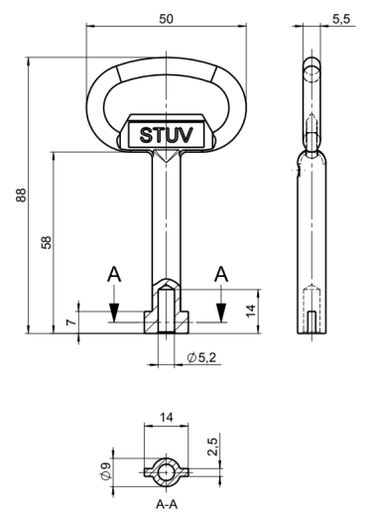

Door lock type for "8 mm triangle key" - Select which one
- Type of electric devices (frequency converter, MCC, PLC / Remote IO, circuit breakers, etc.) to be standardized – including sub-contractor packages / package units!
- Drawings to be handed over in editable form (DWG for layout drawings, EPLAN for circuit diagram drawings) and as PDF.
- Emergency power back up
As mentioned in one of the earlier emergency power back up shall be provided for ‘black out’ type of situation. Contractor is requested to include this into respective Contractor’s low voltage distribution and automatic switching elements.

- Automation Instrumentation Equipment
- For general, standards, battery limit, scope of work, installation, testing and commissioning, design basis, voltage and power supply conditions, layout of equipment, painting shall follow the guidelines mentioned in the electrical part.

- General equipment specification
- The design of the instrumentation system must be based on the latest technology and spare parts and service support must be available. Contractor provided instrumentation shall be calibrated prior to shipment to meet contractor’s published accuracy.
- All transmitter output signals shall be isolated 4-20 mA DC. Transmitters shall be suitable for the environment in which they are to be located and shall meet all applicable codes.
- Flow measurement elements shall be differential pressure devices (orifice plate, pilot tube, etc.) or integrated mass flow control.
- Water flow measurements shall be based on electro-magnetic principe.
- Gas and Electric energy metering shall be accurate to 0.5 % unless otherwise specified in the specific equipment specification.
- For any fan, continuous vibration measurement at minimum four points using acceleration type sensors with locally mounted transmitters for 4-20 mA DC signal outputs for PLC based system.
- Signals having different voltage levels shall not be mixed-up in same cable or same tray.
- Fan speed measurement shall use encoders.
- Noncontact type proximity switches shall be considered to suit the process requirement.
- Control valves shall generally be of the electric or pneumatic type, but for the gas handling area the control valve shall be of the pneumatic type with smart positioner.
- All Contractors provided instrumentation shall be calibrated prior to shipment to meet Contractors published accuracy.
- All valves, dampers, flow actuators or other final control elements shall be suitable for the installation environment and designed for a 4-20 mA DC input control signal.
- The body of the control and shut-off valves shall be stainless steel.
- An electro-pneumatic actuator shall be used to open and close the valves. Open and close limit switches shall be included to monitor valve position.
- Field mounted gauges shall be phenolic or stainless steel construction and have 100 mm diameter dial. Remote seal gauges shall include stainless steel diaphragm and suitable fill fluid for the application. Fluorocarbons or flammable fill fluids will not be permitted.
- All impulse lines, instrument air lines and fittings and accessories shall be of stainless steel. Impulse lines/instrument air lines shall have 2 mm thickness
- All control valves (pneumatic, hydraulic, …) need to send back actual position for movement / position monitoring.
- Local gauges like those for temperature, pressure, differential pressure etc. shall be provided.
- All local temperature gauges shall be bi-metallic type.
- All transmitters must have an integrated type divider.
- The leakage class of all safety shut-off valves shall be Class VI.
- All control and shut-off valves shall have a handwheel for emergency operation.
- All impulse lines and fittings and accessories shall be of stainless steel. Impulse lines/instrument air lines shall have 2 mm thickness.
- Hydraulic tank level interlocks shall have safety switches as per norm needed and analog level / temperature measurement (4-20 mA) for monitoring and respective alarm level adjustment via L1-HMI.
- Hydraulic pressure measurement shall be analogue (4-20 mA) with local display.
- Hydraulic filter (differential pressure) monitoring shall be analogue (4-20 mA) with local display.
- Lubrication tanks shall be equipped with minimum following level switches and option shall be provided for analog type (4-20 mA) level monitoring:
- Max
- Min
- Min min (shall be mandatorily safety switch)
- Lubrication line pressure switches and pressure switches for other systems shall be analogue (4-20 mA) with local display.
- Water or any kind of media (compressed air etc.) filter (differential pressure) monitoring shall be analogue (4-20 mA) with local display.
- Control, proportional, servo valves (for any kind of media and) to have 4-20 mA position feedback signal
- Control, proportional, servo valves (for any kind of media and) to have 4-20 mA position command signal – Except special type valve with different command signal (bus communication).
- Mounting hardware for measurement and control devices, actuators etc. must be designed to minimize vibration. Necessary modifications to mounting hardware due to vibration are at the expense of the Contractor.
- All powered throttling valves shall have integrally mounted feedback positioners.
- Any on/off control elements shall be mounted with necessary solenoids or pilots.
- All on/off control elements shall be equipped with the position sensing limit switches to signal both fully open and fully closed.
- All actuators shall be capable of local manual override operation.
- Totalizers shall be calibrated in liters, Nm3 or kilograms of consumption and shall be installed so they can be reset (to 0) by remote contact closure.
- Natural gas/totalizing meters shall be equipped with a contact closure for each 10 or 100 normal cubic meters (Nm3) of gas.
- Contractor shall provide a CE approved flame detection devices to provide safe operation of equipment. Flame protection relays shall be provided to match the detection devices. The flame protection system shall be capable of independent operation separate from the control system. However, all events/alarms to be monitored by the PLC system.

- Melting furnace specific
- Air cooled camera-video system with cooling pipe to monitor scrap drying, de-coating, de-lacquering and melt process.
- Camera shall be positioned, and mounted between the burners and shall have a continuous temperature measuring device (connected to control system) to help automatic retract the camera should an overtemperature occur. A mechanical flap shall close / isolate the channel between the furnace and the camera in overtemperature situation (after camera is retracted).
- Molten Metal Level and Weight
- Furnace shall be equipped with a Radar Sensor System for Measuring the Molten Metal Height.
- Furnace shall be equipped with hydraulic pressure/load position sensor transducers or encoder based sensor or magnetic linear position indicators which are calibrated to present a furnace weight to give the operator a weight indication during tilting-transfer.
- Furnace shall include a trough molten metal laser sensor prior to the TOP as feedback to the hydraulic tilting loop.
- Molten trough metal level shall be +/- 3 mm during molten transfer.

- Holding furnace specific
- Furnace shall include a trough molten metal laser sensor prior to the TOP as feedback to the hydraulic tilting loop – signal to be transfered to casting machine control system.
- Molten trough metal level shall be +/- 3 mm while casting.
- Provision for future easy / fast installation of an Air cooled camera-video system has to be considered in the furnace design.
- Molten Metal Level and Weight
- Provision for future easy / fast installlation of a Radar Sensor System for Measuring the Molten Metal Height.
- Furnace shall be equipped with hydraulic pressure/load position sensor transducers or encoder based sensor or magnetic linear position indicators which are calibrated to present a furnace weight to give the operator a weight indication during tilting-transfer

- Control System and Automation
- General
This chapter specifies the documentation of control and automation systems that is necessary to meet the requirements of a new industrial facility.
The documentation level requirements for each part are set out in the scope of work.
The intention is to design modern equipment in accordance with the needs of the entire project, including control and automation systems.
The control system used to manage the individual processes will be designed to ensure that all processes operate and communicate reliably. The system will control and monitor all processes and measured variables. The status of the process units and the measured quantities will be displayed on the control console and on the PC monitor in the control room. Inputs and permissions to the individual program levels will be accessible according to the rights defined by CUSTOMER.
The furnace control system need to communicate (full data exchange via suitable bus communication system) with downstream connected casting lines, all process required systems like fume exhaust system, electrical distribution system, Water treatment plant and other auxiliary plant overall plant systems as well as building related systems (HVAC, etc.). Implementation of general overview information (status, main data, alarm/warning) at Contractors HMI system (at central pulpit) has to be considered and implemented by the Contractor. Details to be defined during engineering phase.
Interface to other Customer systems like:
- Laboratory
- MES
- Others if applicable
have to be considered by the Contractor. Details to be defined during engineering phase.
The system will be equipped with acoustic and light fault signalling. The system will store all technical-technological data and this data can be recalled, printed and further processed at any time. The control system will allow:
- ongoing monitoring of blocking conditions
- monitoring and control of the whole process
- monitoring and automatic testing of the control automaton, including sensors and actuators
- signalling of deviation of operating parameters from the set values
- back check of set limits
- continuous monitoring of instantaneous power consumption
- controlled process visualization
- the control system will allow and be equipped for remote connection
- the furnace control system will be ready for connection to the data collection system
The delivery includes the supply of cables and cable routes to individual machine units.
A central HMI / SCADA has to be provided by the Contractor combining all 35 MT and 25 MT melting- and holding furnaces with all related / connected systems (charging / skimming machines, refining units, stirrer, hydraulic units etc.) for full operation with monitoring of all signals available (set points, actual values, alarms/warning/events etc.) at Customers central pulpit.

- Level 1 automation system
      - General
The Level 1 automation system shall monitor and control all significant variables in accordance with process requirements, providing all operational requirements and necessary sequencing, interlocking and safety functions including alarms for abnormal conditions. The Level 1 automation system shall be designed as an integrated system for drives, controllers and automation of the entire line.
- The furnace specifications for the Level 1 automation system include, but are not limited to, the following:
- All PLC systems shall be of the same make and the same series.
- Each PLC must have a power supply module and a CPU communication module.
- Safety circuits shall be designed using the SAFETY PLC.
- Each bus system must be designed as "circular" (circular closed topology). A bus system within a single electrical box does not need to have a closed topology.
- Active online bus diagnostics must be maintained. Each station/device connected to the relevant bus system must be visible with the maximum possible online diagnostic information (status/fault message or warning code).
- At frequency converters full bus communication data (commands, set points, actual values, status/fault or warning code) has to be visible on HMI.
- Remote input/output units connecting inputs/outputs in different areas of the casting line.
- Input/output modules must have active online diagnostics.
- For signals from field devices (sensors, instruments etc.) online hardware diagnostic (wire breakage detection, etc.) has to be installed (usage of respektive DI/DO/AI/AO card).
- Data bus connecting the PLC and HMI units and remote I/O units to the PLC.
- Two (2) Nos. portable laptop type programming terminal for the PLCs mentioned above, with all required system software packages and accessories (cables etc.).
- Monitor for servers and HMI/SCADA operator stations (located in pulpit etc.), etc. must have a 27" widescreen (state-of-the-art); minimum screen resolution of 1920 x 1200. In case of touchscreen monitors for local operator stations/panels size should be selected by the Contractor, but Contractor shall inform Customer before ordering regarding size and location. Target shall be max. possible size to ensure information required for process are displayed in sufficient size and quality.
- The Web Remote HMI client system will be accessible from the "Customer's" network. The Customer will hand over the user access list to the Contractor during the project processing.
- Production views, diagnostic views, maintenance views, trend views and historical data must be accessible on Web Remote clients.
- The operating system for PC-based HMI units must be Windows-based. The system shall be equipped with standard software packages such as multi-program executive routines, protocol formats, compilers, assemblers, editors and utility packages. The required application software licences shall be included.
- Additional software, e.g. antivirus, communication, MS office etc., necessary for the implementation of the functions and completeness of the system must be included.
- The HMI/SCADA screens must be in Czech and English.
- The programming language must be in English.
- Separate grounding of electronic devices and grounding of the electrical cabinet.
- Online diagnostics of field devices (measurement, valves etc.), where is applicable (bus communication etc.).
- The Ethernet switch must be of the manageable type and the required number of optical ports must be taken into account. Type to be agreed with Customer during basic engineering.
- Each network component must have a fixed IP address (without DHCP).
- Establishment of links / communications and required integration into L1 automation system as well as necessary hardware and software amongst the following systems:
- BUYER’s automation system like dedusting system, water treatment plant, substation, building related automation equipment.
- There must be 3 independent Ethernet levels.
- PLC network (communication between PLC and Level 1 + 2 "warm backup" servers)
- Level 1 network (communication between level 1 server and level 1 clients = workstations)
- Level 2 network (communication between level 2 server and level 2 clients = workstations)
- All computers, servers, client stations must be equipped with the maximum state-of-the-art RAM and hard drives available at the time of project implementation/delivery.
- All monitors must be of the same type/manufacturer to ensure interchangeability between different clients and different levels (level 1 or 2).
- All software licenses shall have unlimited validity. In special cases where unlimited validity is not possible, the maximum validity by mutual agreement will be taken into account.
- Sub contractor packages need to be connected via respektive bus communication system (= stand alone system with just status OK / Not OK communication is allowed). Sub contractor package can have its own HMI system, but full integration to overall furnace plant HMI/SCADA system has to be considered = full communication and integration of status / alarm / values to overall PLC / HMI / SCADA to ensure central monitoring.
- Level 1 automation shall have features to enable and predict proactive preventive maintenance requirements. Such as the view of operating hours of engines, pumps, fatigue cycles (e.g. for cylinder movement, valve operation, ...) etc., coupled with warning messages (e.g. for preventive inspection, seal replacement, lubrication, oil check, ...).
- The Contractor must bear in mind that it is unacceptable to connect several auxiliary contacts for power supplies, contactors and similar items in series to the respective PLC/Remote IO digital inputs. Each auxiliary contact must have a separate PLC/Remote IO digital input.
- There must be full access to the source code. The know-how protection area must be clear specified and listed up with transmittal of the bid.
- Ethernet switches must be supplied by a reputable manufacturer (e.g. CISCO, HP, etc.).
- Ethernet network panels for Servers / client stations with related required equipment like network switch / FO patch panels / other required network accessories / UPS circuit breakers with front and back side doors to be placed in respective rooms. Connection from network panels to respective working place / desk shall be done with respective cable connection (for example KVM or similar). Inside of each network panel has to be space reserve for minimum 2 additional computers for Customer purpose. At control room one complete empty network panel shall be available with respective power sockets and network accessories.
- Working place / desk shall be “cable-free”.
- Each individual control desk shall be equipped with CCTV, Intercom, telephone.
- Keyboard in Czech and English layout for all computers (level 1 / 2 and maintenance).
- IP address and password/user access definition to be fixed in cooperation with Customers IT-department during basic engineering stage.

- The Level 1 automation system shall provide both process control and drive control/interlock functions for the complete casting line (from furnace TOP up to packing equipment), including operation and status monitoring of all drives, pumps, fans, valves, etc.
- PLC programming: Instruction List (IL) programming shall be avoided. Ladder programming is the preferred language, but programming may be done in CFC (Continuous Function Chart) or in FBD (Function Block Diagram). If Instruction List programming is necessary due to system requirements, then it shall be commented in detail (each line). The IL code shall be separated into networks according to functionality and the networks shall be commented in detail.
- The configuration of the automation system must be designed to achieve the following operating modes:
- Computer control mode
- Automatic control mode
- Remote-manual mode
- Local mode
- Failure/unavailability of the Level 2 system shall not impede the operation of the Level 1 system or affect normal production.
- For critical parameters, an audio-visual message with "CONFIRMATION" and "RESET" function should be considered.
- Various alarm levels on Level 1 - HMI
- Critical (= process stopping alarm)
- Alarm (= immediate operator's intervention required)
- Warning (= advance warning for an impending alarm situation)
- Event, information (= any kind of motion monitoring, process run/stop status, any kind of operator intervention from local panel or remote screen or level 1 HMI screen).
Everything must be recorded in the level 1 historical archive – HMI / SCADA.
- A Level 1 HMI / SCADA system shall provide the following functions and features(In detail for the Contractors scope = from charging machine up to downstream connected caster TOP AND overall information of the downstream caster equipment as well as connected Customer equipment (such as substation, water treatment plant etc.):
- Furnace operation and monitoring of the whole process displaying all installed sensors, measurements, signals from sub-units, drives etc.
- List up of all preconditions/interlocks for any kind of control (automatic, semi-automatic sequence etc.) or operation etc. to ensure easy and fast (without necessary checking of PLC program) respective condition.
- Recipe management (read only by operation team, write/read by technology engineers).
- System configuration and PLC programming.
- Dynamic interactive graphic displays group displays loop (PI) displays.
- PI drawing of all related medias (water, compressed air, argon, hydraulic, etc.) as per project scope with all PLC connected devices.
- Real-time trends and historical trends.
- Process alarm and event monitoring.
- Diagnostic alarms and event monitoring.
- Real-time alarms / events and historical alarm archive.
- Ability to filter alarms by device / alarm level / area.
- Data logging and online configurable report generation.
- Multilevel password.
- Real-time server database.
- Possibility of remote Internet access for troubleshooting, software upgrade, data analysis.
- Diagnostic screens for maintenance diagnostics - The HMI/SCADA must display, among other things:
- Frequency converter / MCC (status/control expression/required values/actual values according to bus communication with online mode).
- Safety logic (E-Stop, E-Limit switches etc. - blocking a particular function/process etc.).
- Single line diagram with status of all available signals from circuit breakers etc.
- UPS diagnostic
- Hardware configuration with complete network diagnostics (Ethernet/any installed bus system).
- Active online bus diagnostics must be maintained. Each station/device connected to the relevant bus system must be visible with the maximum possible online diagnostic information (status/fault message or warning code). Respective alarming information to be available as alarm message in alarm system / archive.
- IOs (Digital / Analogue / Counters / etc. modules) arranged as per PLC / remote IO configuration (arranged as per PLC Hardware configuration; status of respective DI / DO (0 or 1) or AI / AO (analogue rough value) or Counter module (counter value) to be available on respective IO point.
- Analog measurement with alarm level setting (HH-very high, H-high, L-low, LL-very low), gross value display, simulation option (for testing software functions), alarm enable function, different colors for different alarm levels.
- Alarm level setting.
- All feeders to the control cabinets are monitored (analogue voltage value), all 24 VDC power supplies are monitored (analogue voltage value).
- Operating hour counters for motors, pumps etc. (with counter reset function).
- Preventive maintenance information system (equipment status, preventive inspection information, ...).
- Full data model scope for realizing full access of SCADA system for process control, process and system diagnosis, parameter settings, regulator / quality analysis.
- Various password levels for:
- Administrator
- Maintenance
- Process Engineer
- Operator
- All metering and control of utilities, gases and energy systems must be implemented in the PLC system of the respective area.
- Large displays (if required) for displaying temperature etc. shall be seven-segment LED type, 100 mm in size for each area, with suitable IP rating (IP54).
- All digital displays on the control panels must be suitably connected to the PLC via a bus connection.
- Automation system acceptance criteria:

a) | Level 1 automation system availability | ≥ 99.9 %
b) | HMI screen refresh time | ≤ 1 s
c) | I/O scanning time, data update time | ≤ 20 ms for analogue signals  ≤ 20 ms for digital signals  Data requiring higher scanning speeds are processed as a priority.
d) | Network bandwidth usage (average 5 minutes)  Measured continuously for 8 hours | < 10 %
e) | Available free memory capacity  (for system, server and PC, DCS/PLC controller) | ≥ 50 % (after commissioning)
f) | Spare I/O capacity of each type at each location, spare base bus modules | ≥ 20 % (after commissioning)
g) | CPU load (average) | ≤ 50 % (after commissioning)
h) | CPU cycle time | Max. up to 50 ms for a normal cycle  Average 30 ms for a normal cycle
i) | Data backup | i. Historical data shall be available at the HMI operator station for at least 180 working days  ii. Availability of historical data for a minimum of 2 years on an external storage device
j) | Maximum response time for full screen update (background and foreground) | ≤ 2 s. (the 2 s refer to the time from the function request to the end of the display)
k) | Ethernet switch | Minimum of 40 % free (unused) ports per Ethernet switch (after commissioning)
l. | L1-HMI tag licenses | Minimum 50 % free available tag license (after commissioning).
m. | L1-HMI historical data base tag licenses | Minimum 50 % free available tag license (after commissioning).
n. | IBA for fast data recording with | ≤ 5 ms scanning rate

- Melting furnace specific
Below points should be understood as a minimum – final as per Contractors engineering and needs.
      - Control
- Furnace Process count down process simulator and operator clock, to help monitor overall process connections with the caster.
- Display, setting the targeted process time.
- Operation of the furnace combustion system shall be from a touch screen-based Human-Machine Interface (HMI) system will be located near the equipment for each furnace to be fully independent from the other furnaces – this should be used as a back-up and for maintenance purpose. Main operation has to be considered from Customers central pulpit.
- HMI system control development shall be included. It shall be the furnace Contractors responsibility to provide the necessary means to ensure input and output data is easily transferred from the furnace PLC to the HMI system control.
- The furnace control system shall include all programming of the PLC to control all furnace functions including, but not limited to, air mass flow, natural gas mass flow, temperature, air/fuel ratio, furnace pressure control.
- The PLC program shall also provide monitoring and alarm functions for all direct connected furnace control equipment.
- The Contractor shall provide hardwired local control pushbuttons, indicating lights, etc. The devices shall function as redundant to the touch screen-based HMIs.
- There shall be appropriate hardwired components to permit safe and orderly shutdown following completion of process cycle in the event of touch screen failure.
- Hardwired emergency stop shall provide for a safe and orderly shutdown of the combustion control system.
- Hardwired components to be: E-stop Pushbuttons, Master Relay / Control Power Reset, PLC Fail Light, roof over temperature (roof temperature above 1175 ºC), burner safety controls and Alarm Acknowledgment Pushbutton. Controls are to be labeled in Czech.
- Except for the furnace over temperature alarm controller and the burner safety controls (both to be hardwired to stand-alone controller), all furnace control shall reside in the PLC.
- The Contractor shall program the PLC to control air and fuel flow to each burner, if more than one, as well as provide the capability of turning individual burners on, off or pilot, as required by furnace energy demand.

      - Bath And Roof Temperature Control / Equipment
- Bath and roof cascade temperature control system shall be provided which will maintain maximum melting rate while still protecting the furnace and roof refractory.
- The bath temperature thermocouple shall be installed thru the furnace shell and shall be protected by a cast iron tube.
- The bath temperature thermocouple shall be retractable, with pneumatic or electrical motor to retrieve the thermocouple from the hot inner chamber and molten bath when not in use. Thermocouple retraction orientation shall be as vertical as possible.
- Two (2) thermocouples shall also be provided in the flue breeching to monitor exhaust gas temperature, control by one, second as a redundant/back up.
- The roof thermocouple shall be installed 25 mm from the hot face of the refractory.
- Refractory hot face temperature shall not exceed 1260 °C.
- A Hi-limit thermocouple shall be strategically placed in the furnace and solely connected to a hi-limit with manual reset for hi-temperature furnace protection.
- All temperature measurement shall be accomplished through type K and/or type R thermocouples contained in a suitable sheath with appropriate immersion length.
- Thermocouples shall be provided on the roof, flue and bath areas. Thermocouple mounting shall provide a firm positioning of the sensing junction within the furnace.
- All thermocouple lead wires attached to the furnace shall be protected by high temperature glass braid (armor, Teflon sheathe optional).
- Thermocouple extension wire for cool areas shall be type PLTC, PVC / PVC with overall shield, types KX and RX as required.
- Thermocouple extension wire for high temperature areas shall be type FEP/TEP insulated cable.

      - Specific application software
- Recipes (for all important set parameters) for all alloys with base setting installed by Contractor. CUSTOMER shall be able to update / tune and add alloys as per future needs - as per Contractors definition if part of Level 1 or Level 2 (in case of Level 2 it has to be covered by Contractor).
- Tilting rate control
- Roof Over-Temperature Control (hardwired).
- Flue Temperature Control
- Bath Temperature Control
- Cold Combustion Air Flow Control-Each Burner
- Furnace Pressure Control
- Fuel / Air Ratio Control
- Flame Safety System Monitoring (hardwired).
- Pilot Gas Control
- Safety Limits Monitoring
- Burner Control.
- Main Hearth Oxygen Control.
- Total Fuel Flow – Instantaneous and Totalized
- Trough Metal Level.
- Molten Metal Capacity, during alloying and transfer.
- Process model (as per Contractors definition if part of Level 1 or Level 2 - in case of Level 2 it has to be covered by Contractor)
Charge melt cycle and overall process connections with connected down stream caster with following minium:
- Charge mix input material (Prim Al, Scrap as per quality groups) and respective weight
- Melting model as per final alloy (chemistry / temperature) – split into respective phases (charging, melting, skimming, alloying, refining, settling, transfer)
- Correction possibility
- Self learning tool
- Simulation tool of for new charge mix / alloy for technologist.
- Display, setting the targeted process time
- The furnace combustion system will automatically go into low fire under the following conditions, but not limited to (abnormal conditions shall be annunciated in the control room).
- The door is opened.
- The furnace roof or flue gas temperatures exceed the preset limits.
- Temperatures more than limit set-points (or field failure of temperature sensing devices).
- Hi-Limit temperature/process settings are exceeded.
- The furnace shall not go into high/control fire unless the furnace door is closed, and no abnormal conditions exist.
- Contractor shall submit a description of the operation control sequence and proposed instrumentation Contractors. Contractor shall provide complete and detailed functional description of operation including, but not limited to, sequence of operation, interlocking requirements, and input / output devices.
- Intergration of main data/information down stream connected casting line into furnace HMI.

- Holding furnace specific
Below points should be understood as a minimum – final as per Contractors engineering and needs.
      - Control
- Furnace Process count down process simulator and operator clock, to help monitor overall process connections with the caster.
- Display, setting the targeted process time.
- Operation of the furnace combustion system shall be from a touch screen-based Human-Machine Interface (HMI) system will be located near the equipment for each furnace to be fully independent from the other furnaces – this should be used as a back-up and for maintenance purpose. Main operation has to be considered from Customers central pulpit.
- HMI system control development shall be included. It shall be the Contractor’s responsibility to provide the necessary means to ensure input and output data is easily transferred from the furnace PLC to the HMI system control.
- The furnace control system shall include all programming of the PLC to control all furnace functions including, but not limited to, temperature.
- The PLC program shall also provide monitoring and alarm functions for all direct connected furnace control equipment.
- The Contractor shall provide hardwired local control pushbuttons, indicating lights, etc. The devices shall function as redundant to the touch screen-based HMIs.
- There shall be appropriate hardwired components to permit safe and orderly shutdown following completion of process cycle in the event of touch screen failure.
- Hardwired emergency stop shall provide for a safe and orderly shutdown of the combustion control system.
- Hardwired components to be: E-stop Pushbuttons, Master Relay / Control Power Reset, PLC Fail Light, roof over temperature (roof temperature above 1175 ºC), heater safety controls and Alarm Acknowledgment Pushbutton. Controls are to be labeled in Czech.
- Except for the furnace over temperature alarm controller and the heater safety controls (both to be hardwired to stand-alone controller), all furnace control shall reside in the PLC.
- The Contractor shall program the PLC to control heater as required by furnace energy demand.

      - Bath And Roof And Metal Temperature Control / Equipment
- Bath and roof cascade temperature control system shall be provided which will maintain maximum heating rate while still protecting the furnace and roof refractory.
- The Electrical Heating system shall be displaced or offset the roof a Contractor recommended distance from the roof, without recessed or partially exposed silicon carbide glow tubes to maximize radiant heat transfer to the molten bath. (as per chapter 2.4.5.10. - Roof)
- Refractory hot face temperature shall not exceed 1260°C.
- The bath temperature thermocouple shall be installed thru the furnace shell and shall be protected by a cast iron tube.
- The bath temperature thermocouple shall be retractable, with pneumatic or electrical motor to retrieve the thermocouple from the hot inner chamber and molten bath when not in use. Thermocouple retraction orientation shall be as vertical as possible.
- A Hi-limit thermocouple shall be strategically placed in the furnace and solely connected to a hi-limit with manual reset for hi-temperature furnace protection.
- All temperature measurement shall be accomplished through type K and/or type R thermocouples contained in a suitable sheath with appropriate immersion length.
- Thermocouples shall be provided on the roof, flue and bath areas. Thermocouple mounting shall provide a firm positioning of the sensing junction within the furnace.
- All thermocouple lead wires attached to the furnace shall be protected by high temperature glass braid (armor, Teflon sheathe optional).
- Thermocouple extension wire for cool areas shall be type PLTC, PVC / PVC with overall shield, types KX and RX as required.
- Thermocouple extension wire for high temperature areas shall be type FEP/TEP insulated cable.
- The trough thermocouple shall control the metal temperature in the furnace during casting.
- The heating system shall be controlled via the PLC and the molten metal temperature shall be + 2 / - 5 °C.
- We accept that many horizontal caster installations have a wider temperature range, relying on the degasser heating system to normalize the low metal temperature conditions, - 5 °C.
- We cannot accept a +5 C conditions as these thermals are difficult to manage, necessitating the addition of scrap to the launder or cooling pipes. The Contractor must deliver the heating logic in the holder to control the overshoot conditions to + 2 °C during heating or as the upper refractory and roof cool, rejecting the heat energy to the molten metal.

      - Specific application software
- Roof Over-Temperature Control (hardwired).
- Safety Limits Monitoring System.
- Trough Metal Level Control
- Molten Metal Capacity.
- The furnace heating system will automatically go into low under the following conditions, but not limited to (abnormal conditions shall be annunciated in the control room).
- The door is opened.
- Hi-Limit temperature/process settings are exceeded.
- Contractor shall submit a description of the operation control sequence and proposed instrumentation Contractors. Contractor shall provide complete and detailed functional description of operation including, but not limited to, sequence of operation, interlocking requirements, and input / output devices.

- Level 2 automation system
The complete Level 2 automation system is the responsibility of the Customer. CUSTOMER will hand over the system parameters - SW/HW configuration to the Contractor during the project.
The Contractor must equip the level 1 control system with an OPC interface to enable communication with the OPC server and the "Customer's" MES system.
The standard is the OPC UA variant, which must be used by the Contractor.
- Others
- Requirement for the network address range
Before implementing the industrial systems, it is necessary to compile and approve the draft network address range and its individual features which will be used by the Contractor for communication with the control system, MES, ERP and other communication layers. The approval of the draft network address range must be made by the Customer before the implementation of the industrial systems.
- Requirement for the network isolation
To ensure safe and continuous operation, it is necessary to strictly isolate parts of the production network from the administrative network and from other networks of individual processes. This isolation is aimed at restricting the risk of attack or malfunction propagation to one individual part of the network while keeping the other parts safe and maintaining the continuity of the operation.
In the event that the production network needs to be interconnected with other surrounding networks, the individual destinations, including the IPv4 source, IPv4 target and ports, must be clearly defined in accordance with the safety standards and the Customer’s requirements.
The network interconnection with other networks must be approved by the Customer and secured so as not to endanger the production network safety.
- Remote access
For the purpose of remote administration and service interventions the remote connection is subject to the prior approval and discretion of the Customer via the pre-arranged HW and SW features.
If the Contractor uses his own HW devices for remote connection, the Customer’s approval must be sought. The final technical design of this access must be properly documented, including the identification of the network connection point.
The Contractor is required to arrange for the following:
- Update and maximum possible securing of all the devices within the Customer’s network that are used for remote access.
- Default passwords preset by the device manufacturers must not be used. Passwords must have at least 12 characters.
- Adherence to the current safety standards, including regular update of the operation system, functional and updated antivirus software and/or use of two-factor authentication.
- Ensuring that the users connected to the Customer’s network have no administrative rights in their local computers.
- Every use of the remote access must be properly documented and must comply with the pre-arranged conditions and safety requirements.
- OT (Operational technology) documentation
Detailed documentation for the OT area will be developed during the project implementation. This documentation should include:
- Control system communication diagrams
- Allocated addresses of features
- Methods of communication among individual features
- Feature configuration back up method, including a description of their creation and restoring
- Inventory of HW/SW computer equipment, such as servers and stations
- Authorisation information for each purpose of the system
- Change management
Change management must be maintained during implementation and operation. Any change in the configuration or topology of the system must be recorded at least to the extent of:
- The person who made the change
- Time of the change
- Extent of the change
- Reason for the change
- Responsible person
- Support and service
The level of support and service, including response time and availability of technical support, must be specified for each feature. It shall be determined how system updates and repairs will be provided. It should be clear in advance how long the company wants to support the systems and to what extent = taking into account costs and consequences.
- Monitoring a logging
If the Contractor does not implement his own monitoring and logging system, it is necessary to ensure that all the active elements are monitored at least by ICMP to secure the elementary availability from a particular address within the OT network supplied by the Customer. The Contractor should make available the diagnostics information through the SNMP protocol if present on the particular device, feature or system.
If the system cannot arrange for logging itself, it is necessary that the systems where authentication/verification of users take place are able to send the SYSLOG messages to the address designated by the operator, with the following information:
- Person performing the action.
- Time of the action.
- System where the action takes place.
- Description of the change or event.
- Disaster recovery a continuity plan
As part of the implementation, plans will be developed to restore the operation of the given device in the event of an attack/damage to the system. This plan should include the following:
- Definition of the individual recovery steps, including:
- Identification of critical processes and systems for recovery
- Procedures for data and application recovery
- Procedures for hardware and software feature recovery
- Plans for communication with the internal and external stakeholders during the recovery
- Matrix of responsibilities, including:
- Identification of persons responsible for individual recovery steps.
- Clearly defined roles and responsibilities within the disaster recovery
The Contractor is required to ensure that the disaster recovery plan complies with the latest procedures and best practices in the field of disaster planning and recovery.
- Requirement for endpoint and server security
As part of the protection against the introduction of malicious code, security of end stations and servers must be secured by the following means:
- Periodic update of the system, at least in the area of critical vulnerabilities
- Physical security of active features and network distribution
- Operation of basic antivirus protection
- UAC activation
- Not using administrator accounts for regular user operation.
- Adherence to generally applicable rules for the security of operation systems and accounts with a view to Mitre ATT&CK, SIEM Security Configuration Assessment.
- Disabled use of USB flash disks, cameras and other portable media.
All essential control and operation systems for the operation of the production facility / set shall have an available backup in accordance with 3-2-1 Rule, which means a backup on at least three different media, with at least two locations and one backup outside the operation site. This conception must be designed and implemented in cooperation with the Customer.
The Contractor should ensure that all the safety measures are implemented and observed in accordance with the latest safety standards and the Customer’s requirements.
- Disaster recovery plan
As part of the implementation, plans will be developed to restore the operation of the given process in the event of an attack/damage to the system. This should include the definition of the individual recovery steps, the matrix of responsibilities and their contacts, the location of backups, the recovery process (method and procedure) of the system.

- Standardization
Components of all the devices must be designed, assembled and tested in accordance with the applicable Czech and EU standards, as appropriate, to reflect all the specific aspects in the environment of the Czech Republic.
All the items of the equipment must comply with the regulations and provisions of the relevant statutory bodies of the Czech government as long as applicable. If required by the regulations, the Contractor must obtain the necessary permits from the statutory bodies and other relevant authorities.
All products delivered from the non-EU countries must be furnished with the CE certificate (Conformité Européenne) / Conformance to European Norms).
Electrical equipment must also correspond to the latest Czech electro-technical regulations in terms of safety, grounding and other basic provisions set out for the installation and operation of electrical devices and facilities.

- Scope of work
The Contractor’s activities include: design, engineering, delivery and supervision over the installation, testing, commissioning within the limits and tolerances defined herein. The scope of the Contractor’s work must generally comply with the following:
- Structures – mechanical, electrical, instrumentation and automation
- Engineering includes designing the devices, technological structures, electrical installation, instrumentation and automation, water supply system, utility lines, hydraulic, lubrication and pneumatic systems, auxiliary and ancillary equipment. Drawings and documents must include the general arrangement, assembly, arrangement drawings, pipeline arrangement drawings with supporting details, technological diagrams, pipeline and instrumentation diagrams, one-line power-management diagram, block diagrams, list of motors with calculated power, management philosophy, functional description, test certificates, technical and installation drawings etc. Designs of all the devices/systems/items, as mentioned in this specification and set out for proper functioning/operation of the system.
- The Contractor shall be responsible for supplying the necessary data relating to the scope of work which will be used by the Customer as a background material for acquiring all statutory permits such as the zoning plan, building permit etc., on request by the Customer by an agreed date.
- Providing the basic data / technical data for all the units/items not stated in this document however necessary for the completeness of the system is the basic responsibility of the Contractor.
- In the course of designing the machinery within the competence of the Contractor, it is necessary to take account of the interface with the devices of other Contractors (such as furnace systems, power supply etc.) which are not within the scope of this specification.
- Designing the pipeline/lines, fittings, valves and other accessories for the utility lines and water supply system within the faucets, including the pipe supports.

- Designing – constructional and structural
- Load data for all the machines and accessories designed by the Contractor for the necessary construction project of the Customer. This includes the data concerning the load of the necessary foundations, supports, structures, buildings, rooms, local stations which are required by the Contractor’s machines/system.
- Format and parts of the load data must be agreed on between the Customer and the Contractor at the designing stage, based on the applicable European regulations and standards.
- Structural design of the entire line/system supplied by the winning Contractor, as stated in various parts of this specification. This includes the structural design, necessary supports and anchors for the line/system as required by the line/system of the Contractor.

- Delivery
The scope of the delivery includes: engineering, delivery of the equipment, technological structures, electrical, instrumentation and automation, water supply system, utility lines, hydraulic, lubrication and pneumatic systems, auxiliary and ancillary equipment within the premises of the Contractor. Supervision of mechanical, piping and electric equipment installation (erection within CUSTOMER scope). Supervision of cold/hot commissioning. Refractory material as well installation is within Contractors scope.

- Spare parts
Contractor to submit a list of Preliminary Recommended Spare Parts based on historical Mean Time Between Failures (MTBF) data along with ABC ranking and criticality ranking. The quote proposal shall include:
- List of individual normal Wear items for two years of operation;
- List of Capital Spare Parts (Longer durability items)
Both lists shall be understood as recommended with included normal expected life time, recommended quantity at CUSTOMER stock level, standard delivery time and most favorable pricing.
Final lists as per detail engineering with exact type and specification has to be transmitted with detail engineering to ensure sufficient time for ordering by CUSTOMER.
- The list shall include (minimum and as per Contractor additions):
- Furnace doors
- Steel casters for door & door opening.
- Furnace pressure dampers with actuators
- Regenerative burner beds
- Regenerative burner media balls
- Burner tiles & burner nozzles
- Pilot burners
- Regenerative burner instrumentations, valves (fuel, air, exhaust)
- Flame sensors, ignition trans, spark plugs with cable.
- Min. 2 pieces of each sensor / transmitter installed.
- Solenoid valves, motorized valves, regulating valves, filters.
- Control motors, actuators.
- Hydraulic components (pump, motor, valves, sensors, instrumentations)
- Hydraulic cylinders
- Pressure switches & gauges, thermometers, thermocouples.
- Transmitters (temperature, flow, pressure, differential pressure), flow meters
- Door drive reducers with motors
- HMI stations (computers, monitor, etc.)
- Control system components (for each PLC / Remote IO component at least one piece, power units, etc.)
- Network equipment (router, switch, couplers, etc.)
- UPS equipment
- Limit switches & sensors.
- If – during the commissioning – the Contractor uses the spare parts delivered under the delivery contract, the Contractor will be obliged to replenish these spare parts / to deliver them to CUSTOMER free of charge.
- The Contractor will provide technical specification of the spare parts for their purchase in the future. Where applicable, detailed and production drawings must be prepared so that CUSTOMER may produce/order from several sources/markets as needed.
- The Contractor will clearly specify the list of spare parts where detailed technical drawings / production drawings cannot be shared. The main idea is to be informed beforehand about the spare parts where CUSTOMER is “dependent on” the Contractor.

- Supervision over installation, testing and commissioning
- The Contractor’s area of competence includes: supervision and necessary technical assistance during installation, testing, commissioning of the line and putting into operation, including performance tests of all the devices, machines and equipment, i.e. cables, pipes etc., which the Contractor has delivered, as well as those acquired/produced by any other parties based on the Contractor’s drawings and specifications.
- The Contractor’s area of competence includes but is not limited to:
- Supervision over the assembly staff, assistance and instructions given to the same for proper interpretation and use of project specifications, drawings, specific technical documents for the installation company within the competences of the Contractor.
- Preparation of project specifications, procedures and supervision of the performance of dimensional checks, adjustment checks, welding procedures, non-destructive tests, pressure tests, leakage tests, corrosion-proof treatment etc.
- Planning, supervision and technical assistance for cold and hot tests, commissioning and testing of guaranteed power parameters.
- Within its bid, the Contractor is obliged to mention the following information concerning the equipment delivered.
- Size of roofed area necessary for storage (in m²)
- Size of free area necessary for storage (in m²)
- Size of free area necessary for installation/production, outside the area intended for the machinery itself (in m²).

- Work progress report
The Contractor is responsible for preparation of weekly and monthly work progress reports during the engineering activity.

- Drawings and documents – General
- The Contractor is responsible for providing and submitting the drawings and documents, including BOM’s and technical catalogues, standard operation and maintenance procedures, calculations of productivity and dimensioning.
- The Contractor is responsible for providing a detailed time schedule for the engineering stage, indicating the deadlines for drawings and documents to be submitted.
- Delivery of detailed technical drawings/documents for spare parts and wear parts is included in the scope of the Contractor’s delivery.
- 3D model documents must be submitted for the line, depicting the as-built status in which it was handed over to the Customer. In its bid, the Contractor should state which kind of 3D software is planned to be used for this project. This information is important for the Contracting Authority so that it is able to obtain compatible software which it will use for loading the 3D models submitted by the Contractor.
- Isometric drawings of pipelines, with indicated dimensions, must be submitted.
- The Contractor’s scope of activities must include preparation and submission of drawings of the line depicting the as-built status in which it was handed over to the Contracting Authority.
- Contractor to submit recommended spares list based on mean time between failure information from Contractor’s database.
- All spare parts to be quoted individually at system design prices, stating delivery time and quantity in use.
- Spares will be ordered separately at Customer’s discretion, after receipt of complete recommended spare parts list. Recommended spare parts lists, with prices, shall be submitted no later than 6 weeks after the completion of engineering. All parts shall be identified by original manufacturer’s part number and full description.
- Contractor shall be responsible for providing and staging all spare parts required for system start-up and commissioning. These parts are to be provided at no expense to Customer.

- Specification of public procurement for installation work
The Contractor’s scope of activities includes preparation of tender documentation concerning the installation of the line as designed by the Contractor.
The specification applies to all mechanical, electrical, instrumentation and automation equipment. The specification must reasonably describe the use of special tools and instruments, preventive measures, binding and fixing equipment for transfer and positioning of the line sub-assemblies.

- Governing language
- All drawings and documents must be submitted in the Czech and English language.
- All HMI’s must be submitted in the Czech and English language.
- During engineering, the Contractor must have at least one member of the team who is able to speak and write in English or Czech.

- Others
The Contractor’s activities include provision of training for various operation and maintenance works.
Design of special tools and instruments that are necessary for effective operation and maintenance of the line/system projected by the Contractor falls in the competence of the Contractor.

- Specific provisions
- Assembly and testing at the Contractor’s site
The CUSTOMER will be authorized to check the quality and quantity of mechanical and electrical parts of the specified line at the Contractor’s site or at the sites of the latter’s subcontractors.
Prior to sending the line and machines to the Customer’s site, they must be completely assembled to the maximum extent and tested by the Contractor at its site. The Customer’s representatives must be given access to the assembly and testing. None of the machines delivered by the Contractor according to this specification may be sent to the Customer’s site until the tests are fully approved by the Customer’s representatives. The Customer requests the tests be announced at least fourteen (14) days in advance.

- Preparation for transport
The line may only be disassembled to the minimum necessary extent for the transport, all parts must be carefully packed and labelled. All conductors should be left in their channels, bare wires should be wound and packed so as to be protected during the transport. All conductors and cables must be properly labelled for the ease of identification.

- Lock-out & Tag-out (LOTO)
The Contractor must compile a Lock-out & Tag-out procedure for its line.
The system must ensure that all dangerous parts of the machine are properly switched off and cannot be switched on before the maintenance or service is finished.
The Contractor will prepare the task lists for four (4) points of Lock-out and Tag-out. These points are as follows: identification of power source, disconnection of power source, securing and identifying the power source and proof of the disconnection effectiveness.
The procedure for disconnection and identification (lock-out and tag-out) must be discussed with and approved by Customer.

- Delivery to the Customer’s site
The Contractor will take into account the width and height of the production hall gate. Gate dimensions are as follows: 5.0 x 5.0 m.
The delivery of the line, machines and other related consumables to the Customer’s site must be coordinated with and approved by the Customer in advance.
Customer
- Technical media interface
The Customer will arrange for and provide the following technical media in the place of installation.
- Natural gas
- Pressure in supply line: 25 or 100 kPa
- Temperature: Ambient temperature
- Heating value 30,4 – 38,4 MJ/m³
- Cooling water (plant wide open circuit with cooling towers)
- Temperature in supply line: 10 - 25 °C
- Delta temperature (between supply and return line): 5 – 8 °C
- Pressure in supply line: 0,59 – 0,70 MPa
- Flow rate: 250 m³/h (at 0,6 MPa)
- Chemical composition will be communicated during engineering
- pH value 7,6 – 8,0
- Compressed air
- Pressure in supply line: 0,5 - 0,6 MPa
- Temperature: 15 - 25 °C
- Quality class: 1 according to ISO 8573-1
- Relative humidity: 0 %
- Argon
- Pressure in supply line: 1,1 MPa, max. 1.6 MPa
- Temperature: Ambient temperature
- Quality class: 5.0 / 99,999

Contractor to define with transmittal of offer all required media (water, technical gases) with base definition (temperature, pressure, flow rate etc. and acceptable range).

- Sub Floor or Floor Technical Room
- The Contractor shall provide the Furnace Hydraulic Power Unit, the Combustion Fans and other services in a Sub Floor Technical Room (room is part of Customers civil scope, but equipment related to the melting/holding furnace is part of Contractors scope. Pipe connections as part of the combustion system within Contractors scope. Hydraulic piping up to machine attached piping or valve stand/table next to furnace equipment within Customers scope).
- This Sub Floor Technical Room may be connected to the Furnace Sub Floor area which contains the Molten Metal Stirring equipment.
- This room, shall be accessed from a staircase, with a access or egress door entering the room and a similar door entering the Furnace Sub Floor / Floor area.
- These doors shall have a 90 minute fire rating, according to ASTM E119.
- The doors shall be normally closed, power open with an electromagnet wired to the fire Alarm System keeping the door open with power on so when the fire alarm is active, the doors close.
- Each door shall be equipped with an EN 1125 approved panic exit door handle.
- The Contractor shall provide a list of the equipment which should fit in this room with corresponding rough dimensions and weights 60 days (with the fundation drawings) from acceptance of the contract so that the room can be designed in conjunction with the Furnace Sub Floor area.
- The Contractor shall provide lifting points on all equipment anticipated for this room.
- Removable opening at the roof of the Sub Floor technical room for equipment manipulation (exchange in case of need) via overhead has to be considered in the design.
- Roof (including removable opening) of this Sub Floor Technical Room shall support light duty forktruck traffic.
- Safety requirements
- General
The Contractor is obliged to address and/or implement the criteria for the safety device design.
The Contractor is obliged to reasonably reduce the risks, propose the necessary protective measures for those who may be exposed to risks due to dangerous situations.
Dangerous situations may be caused by the following:
- Failures or failure statuses in electrical devices which may result in electric shock or fire of electric origin.
- Failures or failure statuses in control circuits (or components and devices connected to these circuits) which result in malfunctioning of the line/machine.
- Failures or power outages as well as failures and failure statuses in power circuits which result in malfunctioning of the line/machine.
- Loss of integrity in circuits dependent on the sliding or rolling contacts, which results in impaired safety function.
- Electrical interference, e.g. electromagnetic, electrostatic generated either outside or inside the electrical devices, which results in malfunctioning of the line/machine as a whole.
- Release of accumulated power (electric or mechanic) which results in electric shock or unexpected motion which may cause injury.
- Surface temperatures which may cause injury.
Safety measures must combine the measures introduced at the design stage (this is the Contractor’s responsibility; whereas the measures which are to be introduced by the user are the responsibility of the Customer).
Safety shall be a primary consideration in the design of this equipment. Guards, protective devices and Lockout and Tag-out and Zero Energy procedures shall conform to applicable Customers standards and shall minimize potential hazards to operating and maintenance personnel. Contractor shall obtain all approvals of equipment and components prior to delivery and commissioning.
As part of the CE certification the Contractor shall collaborate with Customer’s Personnel in executing a risk analysis. The machinery and equipment must be designed and built by taking into account the results of the risk analysis. Risks from hazardous substances, biological hazards, fire and explosion hazards, thermal, physical, physical risks are incorporated into the risk analysis.
The Contractor shall design and furnish all necessary machine guarding and fall protection incorporated within machine assemblies.
All elevated platforms > 1.0 m (with regard to an adjacent floor, ground or other working/walking surface) shall be equipped with a hand rail and a mid rail (local regulations that require railings be installed at a lower height shall be met). A toe board is required when there is the potential for tools and/or materials to be kicked off the elevated work platform and onto personnel below.
The Contractor shall provide a zoned LOTO (Lock Out Tag Out) according to maintenance requirements on the equipment.
The Contractor shall design equipment such that cleaning, adjustments, threading and/or maintenance of such equipment shall minimize “Confined Space” entry by operating or maintenance personnel. If entry is unavoidable, design of the confined space shall permit rescue and provide means of extraction of an unconscious individual, weighing up to 130 kg.
The equipment shall be designed with a noise level having an upper exposure action value equal to 85 dB and a lower exposure action value equal to 80 dB.
The Contractor shall provide periodic safety reviews with Customer’s representatives during equipment design, installation, commissioning and start-up.
The Contractor shall calculate the distributed load of platforms etc. (kg/m²) and show the sufficiency of the support.
Equipment shall be designed such as minimizing / controlling the risk of spills and emissions in compliance with local regulations.
Special attention should be placed on the inherent explosion hazards associated with molten aluminium, the best reference being the “Guidelines for Handling Molten Aluminum.

- Requirements for mechanical safety
Mechanical safety covers the protection of users against risks related to moving parts, mechanical forces, falling objects or any other mechanical risks.
- Protective covers and guards
The line must be equipped with fixed protective covers which protect the users against access to moving parts of the line or any other risks. The covers must be designed so that they are difficult to circumvent or removed without tools.
- Protective fencing
Protective fencing is another form of protection which prevents access to dangerous parts of the line and the line must be fitted with the same. This fencing should be reasonably rigid and resistant to withstand external influences and to enable clear view of the machine interior for the purpose of inspection and maintenance.
- Safety switches and sensors
The use of safety switches and sensors may prevent the operation of the line if the protective elements have been removed or in case of a dangerous situation. These elements may include: emergency switches which stop the line in case of touching or vicinity switches.
- Protective brakes and emergency stop
The machines should be equipped with safety brakes or emergency stop systems which can quickly stop the movement of the machine in case of danger or whenever instant stop is required.
- Distance from dangerous parts
The design of the line must minimize the risk of injury by keeping the safe distance between the user and dangerous parts of the machine, such as rotating or moving parts.
- Protection against falling objects
The machinery should be designed so as to minimize the risk of fall of dangerous objects from the working platform which could lead to personal injury of the user.
- Rigidity and stabilization
The machinery must be stable and firmly fixed on the floor in order to minimize the risk of tilting or any other accidents related to the machinery instability.
- Appropriate marking and indication
Dangerous parts of machines should be marked in accordance with the applicable standards so that the users are informed of potential risks.

- Requirements for electrical safety
- Electric shock protection
The machinery must be designed so as to minimize the risk of electric shock. This includes the use of insulation materials, grounding, protective elements such as fuses, circuit breakers and protective switches.
- Protection against electric discharge
Electrical components of the machinery must be placed and insulated so as to minimize the risk of occurrence of electric discharge which would endanger the user or damage the line/machine.
- Safety insulation
The machinery must be fitted with sufficient insulation to protect the user against touching or approaching dangerous electrical parts.
- Ensuring safe voltage
The voltage used in the machinery must comply with the applicable standards and must be designed to minimize the risk of injury.
- Protection against overload and short-circuit
The machinery must be fitted with protective elements, such as fuses, circuit breakers etc. which protect against overload and short-circuit that may lead to fire or injuries.
- Safety grounding
Electrical devices must be grounded in order to minimize the risk of electric discharge and to ensure safe excess current drainage.
- Protection against humidity and dust
The line must be designed so that it is resistant against ingress of moisture and dust which could lead to damage of electrical components and increased risk of injury.
- Protection against electromagnetic interference
Electrical devices must be designed so that they minimize the interference from electromagnetic fields which may influence the functioning of the machine or any other machinery in its vicinity.
- Safety marking and indication
Dangerous electrical parts of the machinery must be marked in accordance with the applicable standards so that the users are informed of potential risks.
- Regular inspection and maintenance
Electrical devices must be regularly checked and maintained in order to detect potential problems which may endanger safety.

- Service and maintenance
The bid will include a draft service level agreement covering the machinery. The Customer wishes the agreement to include annual service checks. If a higher frequency of these checks is necessary, the agreement should set out their interval.
Troubleshooting
- Failure condition addressed via remote connection: response time within 4 hours of the announcement.
- Failure condition addressed personally by a technician: response time within 24 hours of the announcement.
The draft service level agreement should also incorporate a price quotation for regular service and urgent service, with price validity of 5 years. Price for regular service means 1 on-site service check.

- Reliability
Customer’s prefers items that would lead to reliable physical assets and reliable processes to be implemented as early as in the design phase. Some of these items are listed below:
- An asset care / maintenance program shall be provided. The preferable asset care strategy shall be condition based maintenance rather than time based maintenance.
- The Contractor shall consider maintainability in the design (e.g. lifting devices, quick releases) operability, (i.e. layout and location of control pulpits, analysis of operator movements, visual management for inspection and recognition of equipment condition), testability, (e.g. sample points for oil), accessibility, (e.g. room for maintenance workers and tools, platforms etc.), time saving methods, standardization, and mistake proofing in the design.
- The Contractor shall base equipment selection decisions on Life Cycle Cost, incl. energy cost, maintenance costs, operating costs, buying cost, material cost.
- The Contractor shall deliver standard procedures for installation, start-up, commissioning, (incl. detailed plans, required times & resources, tolerances, alignment, start-up sequencing, check of performance indicators).
- Any special tools required for removal, assembly and maintenance of any system or component shall be included with the equipment.
- Where practical and cost effective, the Contractor shall implement redundancy of critical components, for instance so that maintenance work can be performed without causing downtime.
- The Contractor shall be willing to participate with at least one representative in a risk analysis event if asked to. They shall also provide a limited amount of reliability reviews with Customer’s representatives during equipment design, installation, commissioning and start-up.
- Contractor shall provide all preventive maintenace (PM) procedures necessary to properly maintain the equipment. Each PM shall include the recommended frequency and work / motor hours required to complete maintenance item. Frequency and work / motor hours shall be monitored as much as possible / applicable on control system.

- Energy
- General
- The equipment and components shall be selected to ensure the lowest life cycle cost and meet all energy efficiency requirements in the Břidličná facility.
- The Contractor will provide means to meter and to monitor each energy source (electricity, gas) and fluids (compressed air, nitrogen, argon, etc. ) at each process unit and also for each significant single user (est. yearly cost > $100K ) with an accuracy of 0.5%.
- The following data shall be provided for the equipment: Power installed (all in kW), energy efficiency class /standard, and power used for nominal output and 50% nominal output, specific energy consumption (in kWh - using upper calorific value) per output unit (e.g. Tons) and energy consumption for the key process steps (e.g. consumption during holding time).
- The electrical equipment and components shall follow the state of art energy efficiency rules.
- All AC motors shall meet the “IE3 “ or “NEMA Premium ” efficiency standards. IE2 motors are only acceptable if the yearly use is less than 2000 h.
- Direct coupling with “state of the art” alignment. If a belt must be used, the selection of the belt will target the highest friction.
- The selection of distribution transformers will target the lowest life cycle cost (class I efficiency transformers or NEMA premium, efficiency > 98 %).
- All electrical appliances shall meet the A or B or “EU Eco Label” (Directive 2009/125/EC) or “Energy Star” efficiency ratings.
- The lighting provided with the equipment should be of high energy efficiency and a good color rendering (>70) (fluorescent T5 with electronic ballast are preferred).
- The selection of compressed air energy source for driving / moving / cleaning / cooling is only allowed only if no alternative with a lower life cycle cost is available or it is required for specific safety, regulation, or process reasons. The compressed air equipment design and working pressure set point should target the minimum life cycle cost.
- Energy conservation will be fully integrated in the design and control of the equipment by providing systems which automatically switch off the energy consumers or reduce their energy consumption in a controlled and safe way according to the standards and regulations during idle time or downtimes. The MMI systems will allow an easy manual switch off of the equipment.
- Adapt the energy use to the real demand: The equipment shall be designed and sized to optimize the real energy use according to the real demand. In the case of a fixed demand, the equipment should be designed to target the optimal equipment efficiency. In case of a variable demand, the equipment should be equipped with variable output systems. (number of motors running by a cascade control, variable speed drives, variable flow pumps, heating control, level control etc.)

- Heat management:
- State of art high efficiency burners shall be selected based on a life cycle cost analysis. The combustion air temperature and furnace door opening time shall be monitored. The oxygen content in flue gas and furnace pressure control will be optimized to ensure the highest energy efficiency.
- The insulation (piping, tanks, furnaces, boilers etc.) will be designed to minimize the energy losses and will target the lowest life cycle cost.
- Natural convective cooling is preferred, where applicable.
- Simultaneous cooling and heating shall be avoided.
- The heat recovery solutions are preferred over solutions that require any additional energy use.

- Hydraulics:
- The use of variable flow pumps with an integrated proportional valve for pressure control combined with a variable speed drive on the motor (main pump and filtration pump) is recommended. The pressure set point will be adjusted to the purpose for each cycle step. The use of low friction oil is also recommended.

- Training
Staff training will be provided by the Contractor FREE OF CHARGE within the delivery of the line.
The training will be divided into three levels, based on the proficiency and complexity of the line/machine:
- Operators
- Maintenance
- Technologist
The training will take place in a minimum of four blocks, at the Customer’s site, in English. The blocks are necessary due to various working shifts of the operators and expert staff.
Theoretical training will take place in the Contractor’s classroom, duration: 3 (three) days. The purpose of the theoretical training is to give general information of the line technology.
On site training (duration: 5 (five) days) as per during cold and hot commissioning.
All training documents to be provided in PDF format and hand over in electronic form (USB or CD).
Detailed training schedule will be agreed on at the appropriate time during the project implementation.
To this end, the Customer will arrange for an adequate number of interpreters at the appropriate time.
Each training will be documented; an attendance list will be made according to the Customer’s internal regulations.
- Operators
The Contractor will compile the training documents (in Czech and English) for the operators, and will train the staff in safety measures and simple maintenance interventions.
The training will cover the following topics:
- Process and procedure
- Tools and changeover
- Maintenance (daily maintenance within the operators’ competence)

- Maintenance
This training applies to expert staff, such as electricians, mechanics, tool makers, PLC programmers, process engineers, metallurgists and management.
The Contractor will provide general and specialized expertise of the operation as well as experience through this training which will also include recommendations concerning the process technology, working procedures with special oral/written operation and testing specifications, as well as information about specific performance data based on the practice.
The Contractor will prepare the training documents (in Czech and English) for the expert staff.
The training will cover at least the following topics:
- Safety systems at the machinery
- Functional description of electric, pneumatic, hydraulic control (flow chart)
- Maintenance planning and performance
- Troubleshooting, breakdowns. Basic structure of the programmed management process To this end, practical hardware and software training must be provided.
- Setting the technological parameters and effect of their changes.
- Review of available documentation including drawings, instruction manuals, bill of material and spare parts.
- Review of system operation, control, interlocks, sequencing, maintenance and safety via operation and maintenance manuals and drawings.
- Provide suggestions of other pertinent topics related to operating and maintaining the new equipment.

- Painting
- General
- The Contractor shall comply with the Customer Plant Appearance Standards, which shall be final confirmed and agreed during engineering.
- The Contractor shall comply with DIN 2403 (Identification of pipelines according to fluid conveyed) and DIN 12792 (Ventilation for buildings – symbols, terminology and graphical symbols) in regard to the identification of pipelines according to the fluid conveyed. The below table is a quick reference for the information within DIN 2403 and is specific to the Customer facility.

Pipe/Media/  Machine parts | Color Code | Color
Stacionary machine parts | RAL 5022 night blue | Blue
Movable machine parts | RAL 1021 | Yellow
Machine parts above 80 °C | RAL 9007 | Grey
Natural Gas | RAL 1003 | Yellow
Hydraulic | RAL 8023 | Orange Brown
Cooling Water | RAL 6032 with shield / insulation | Yellow Green
Fresh Water | RAL 6032 with shield / insulation | Yellow Green
De-ionized Water | Stainless steel Grade 1.4571 [316Ti] with shield
Hot Water | RAL 6032 with shield / insulation
Compressed Air | RAL 5015 | Blue
Acid | RAL 2003 with shield | Pastel Orange
Thermal Oil | RAL 8023 with shield / insulation | Orange Brown
Argon | Stainless steel Grade 1.4571 [316Ti] with shield / insulation
Chlorine | Stainless steel Grade 1.4571 [316Ti] with shield / insulation

- Primer and finish coats of a suitable aluminum explosion prevention coating (min. 2 layers) shall be applied to all equipment near the furnace including duct system exposed to molten metal, heat per manufactures instructions.
- Area’s not to be painted include:
- Machined surfaces
- Electrical connection points
- Bearings, liners, gears, wheel contact surfaces
- All chemical solvents and paints shall be used in accordance with manufacturer’s instructions and Customer standard practices.
- All chemicals and paints shall be approved by submission of a Material Safety Data Sheet as well as any manufacturers supplied information and or instructions to the Customer project manager prior to delivery onto Customer site.
- A Material Safety Data Sheet shall be in the immediate vicinity of all chemical and paints when located on Customer’s site.
- At end of installation, the Contractor shall touch-up / paint to cover unpainted, field-welded or scratched / damaged surfaces. Any paint waste products shall be removed and disposed of properly and legally by the Contractor at no additional cost to Customer.

