Contents
Contract Subject: 3
Internal analysis: 4
0.0 Solution description: 6
0.1 Logical solution scheme 6
0.2 Logical scheme of Module interactions 7
0.3 Platform 7
0.4 GUI (graphical user interface) requirements 9
0.4.1 Web GUI 9
0.4.2 Maps 10
0.4.3 Module reporting 10
0.4.4 App for crew tablet computers 10
1.0 Electronic Registration Module: 12
1.1 Contract 12
1.2 Order 13
1.3 Service prices 13
1.4 Add-on Services (Supplementary Services) 13
1.5 Containers (Bins) 14
1.6 Electronic delivery note 17
1.7 Container stand 18
1.8 Collection site 18
1.9 (AKU) End user address 19
1.10 Staff 19
1.11 Crew 19
1.12 Zone 20
1.13 Vehicle 20
1.14 Collection schedule 20
1.15 Collection 20
1.16 Collection plan 21
1.17 Container inventory system 22
1.18 Stock-taking and passportisation 24
1.19 Stickers printing 24
1.20 Change and lifecycle log 25
2.0 Fleet Management Module 26
2.1 General technical requirements regarding the Fleet Management Module: 31
2.2 Technical specification of the monitoring units: 32
2.3 Specific requirements regarding Module functionality: 35
3.0 Collection Planning Module 36
Part 1. Creating plans 36
Part 2. Waste collection evaluation 37
3.1 Further requirements for the Planning Module: 40
3.2 “Rebeka” Planning Regime 40
3.3 Planning regimes supply/takeaway/exchange of containers 42
3.4 Planning Regime for OLO Taxi 44
3.5 Skip containers (VKK) Planning Regime 44
3.6 “Freestyle” Planning Regime 44
4.0 Integration interfaces 45
4.1 Noris 45
4.2 Softip 47
4.3 Protank 47
4.4 Passport App / Delivery Takeaway Exchange 48
4.5 App to takeover container stands and quality control 49
4.6 eSTAS 50
4.7 Ron 50
4.8 MS Sharepoint 50
4.9 Venzeo 50
4.10 CRM 50
4.11 Fleet maintenance system 50
4.12 Hemak Scalis – Automated vehicle weighing system 50
4.13 MS Power BI 50
4.14 “Waze” 52
4.15 Plus Codes 52
4.16 Infopanels 52
4.17 Handheld Chainway RFID UHF 2D Sled - Android APP BT Integration 52
4.18 XStation 52
4.19 Google maps 52
4.20 Mapy.CZ 52
4.21 ArcGIS 52
4.22 Samsung Galaxy Tab Android 10“ Tablet 53

Contract Subject:
- Contract title: “Digitalisation of a fleet of 200 vehicles + Collection planning system + System of electronic waste registration and confirmation of container emptying“
- Type of contract: Service
- Agreement on the provision of IT Solution Services will be entered into with the preferred bidder for the contract subject.

Internal analysis:

It is expected that the introduction of the digitalisation of the vehicles and the planning system will enable efficient planning using state-of-the-art tools for collection and evaluation of data. The solution consists of 2 main areas.
a. Hardware – equipment that will be installed onto the collection vehicles and will serve to gather data and send it to the central system for processing (“Monitoring Unit”). The aim of OLO is to collect data from the vehicles, and the Provider is expected to supply and operate the equipment by way of IaaS (Infrastructure as a Service), meaning that the solution Provider will operate the equipment for the purpose of collecting data from the vehicles and sending the collected data to the System for further processing.
b. System – software platform that will be used to collect data from the vehicles and other data that affect the evaluation, planning, and optimisation of the waste collection activities. This system also supplies one of the 4 inputs necessary to achieve electronic STAS. As part of the envisaged system change to “Pay as You Throw”, this system is key for creating unambiguous records of emptying recognition, which will serve as a basis for billing (“Platform”).

Solution objectives include:
In terms of the company management
- increasing collection efficiency
- cutting fleet operation costs
- targeted maintenance planning based on actual vehicle use
- meeting the targets set by the shareholder
- data input for BI and management
In terms of the staff and processes
- speedy access to relevant data
- continuing collection and processing of data for planning purposes
- KPIs for driver evaluation
- monitoring fuel consumption of vehicles
- choosing suitable technology (CNG/Diesel) depending on consumption at a specific Section/Zone
- refuelling comparison – fuel station and vehicle fuel tank
- preventing fuel leaks
- digitalising vehicle logbooks
- synchronising data with OLO systems
- streamlining outputs
In terms of system work
- processing data on container pickup in one place
- processing data from vehicles in one place
- processing the waste collection plan in one place

0.0 Solution description:

The Contracting Entity expects the delivery of a comprehensive solution using a combined service model IaaS – PaaS (Infrastructure as a Service and Platform as a Service).

Logical solution scheme
The scheme does not list all the inputs, as they are specified in more detail in the technical specification. A complete breakdown of the inputs is provided in Paragraph 4.0 of this document below.

0.2 Logical scheme of Module interactions

0.3 Platform

General description:

For the purpose of procuring the technical solution, “Platform” means a unit consisting of Modules and Functionalities. The Platform will use a modular system The Contracting Esntity expects the Platform to be delivered as one software unit. Data from the individual modules described herein will be managed in one central database with a unique database model using the principles of big data technologies, AI, machine learning, Business Intelligence, data modeling, data lake, AWS cloud computing, Data Bricks, MS Power BI (the Contracting Entity lists these technologies as an example and it is not important for the Contracting Entity which specific technology the Provider will use to safeguard the Platform Functionality). The Contracting Entity expects the delivery of a Platform the structure of which ensures an average response time to database queries of 2 seconds.

General requirements regarding PaaS (Platform as a Service):

- Providing for initial set-up and system training.
- Opportunity to export collected and processed data from all the described Modules and sub-modules in XLS, CSV, or PDF.
- Platform consists of a central database (big data) accessible by all the individual Modules; each of the Module processes its own data and the individual Modules can process data from the central database independently.
Platform must meet the minimum security standards set by the ISO/IEC 27000 family
As part of PaaS, the Contracting Entity requires that the Provider define the access of users to the program. The Contracting Entity expects the Platform to have no restrictions when it comes to the number of user access or licences. The estimated number of administrative users of the Platform is 50. The estimated number of executive users (drivers, waste collector, crew, delivery, takeaway of containers...) is 200.

As part of the Platform, the Contracting Entity requires the creation of the following types of access authorisations. Administrative staff are required to have a Single Sign On for the OLO Active Directory. It is possible to provide for LDAP/AD Sync with respect to OLO. For all other staff, local authentication is required within the Platform.
    - Administrator
- can create users and assign authorisations
- can assign authorisations for individual users to use each Functionality of the Platform and the individual Modules independently
- can create and edit user groups for individual organisation units (all users within a group have the same authorisations)
    - Superuser
- authorisation includes access to each function and system administration
    - User
- can create and browse reports and statistics, view data
    - Planner
- Authorisations include creation and evaluation of plans, data administration, use of all Modules and Functionalities
    - Driver
- includes field work and registration of field work related data for follow-up evaluation.
    - Foreman
- Includes management, inspection and evaluation of the work of Drivers and crews
    - Crew delivery-takeaway-passport
- Includes keeping records of delivery, pickup and passportisation of waste containers in the field using a mobile app

Example of accessing the Functionalities by the individual Contracting Entity departments

Department | Main Functionality Use
Planning | Registration and Planning
Foreman collection ZKO and TZ | Registration and Fleet management
Transport Department | Fleet management
Skip (VKK) Department | Skip (VKK) Planning
Delivery Takeaway | Planning Delivery, Takeaway, Taxi
Customer Services | Registration, Reports

0.4 GUI (graphical user interface) requirements

0.4.1 Web GUI
It is required that the proposed system contain a web GUI with responsive design. The GUI needs to be intuitive, clear (the functions need to be accessible through icons arranged in a streamlined menu) with localisation to Slovak. Alternatively, a solution based on a stand-alone client app using Windows OS is admissible.

The Contracting Entity requires that as part of their tender, the tenderer made accessible the basic draft of the interface. The GUI will be evaluated by a committee organised by the Contracting Entity.

Working with data by way of forms and parameter editors (described in detail for the individual Functionalities) for the individual types of processes data by module, functionality, type.
The user interface shall contain maps – in the form of layers to show the locations of the collection points and the specific address points of containers and location of vehicles in real time with max. error of 5m (see description in Paragraph 0.4.2.)
It needs to offer the option to track objects on miscellaneous types of maps (in the form of layers), and the option to switch to Street View.
At the same time, we require that apart from these data, one of the map layers contains traffic situation data for the routes within Slovakia, covering no more than the last 10-15 min. Within Bratislava, the traffic data from apps such as Google, Sygic, or Waze are used for the routes. We accept an equivalent solution.
Further requirements:
- User functions of the information system accessible through a secure web gateway (SSL certificate).
- User authentication through Single Sign On to LDAP/AD domain of the Contracting Entity
- Real time overview (on-line) of the location of vehicles or vehicle groups on the map including additional vehicle information (vehicle registration number, type, time, location, mileage, speed, direction, altitude and fuel tank status for lorries, input consisting of work carried out by the superextensions of the lorries) accessible from any computer connected to the Internet (including in printed form), or through a mobile app with automatic location refresh.
- Showing the exact route on the map including a graphic indication of the speed and direction using maps (Google Maps, mapy.cz, or other) including the payment of licence fees for using the maps (road network, satellite view), displaying individual rides by sections (for passenger vehicles and lorries), including complete updates throughout the entire time of using the monitoring system in the scope of the necessary licence.

0.4.2 Maps
- WEB GUI needs to have an option to choose from among map layers Google Maps, Mapy.cz, Bratislava GIS – Cadastral map ...), location of the waste containers, collection points, current location of vehicles.
- There needs to be an option to display each of the individual layers separately and merged together, including the option to set opacity level for each layer individually at a scale from 0% (not transparent at all) to 100% (completely transparent).
- The Modules should contain an option to browse the maps based on related parameters (address, plot number, owner name, etc.)
- Linking the parameters to the geo position on the map through the database of the Contracting Entity (customer + address + GPS) or though the integration described in Paragraph 4.0, such as Cadastral portal (owners + plot number + GPS)

0.4.3 Module reporting
Tool for generating reports. Full integration into PowerBI. This means that all data processed in the Platform and the individual Modules will be available for visualisation and follow-up processing in PowerBI. Integration through MS SQL Data gateway. As part of the initial solution supplied, the Provider shall provide 5 reports for each Module.

Examples of report types:
- Alerts from vehicles
- Costs of vehicle operation
- Evaluation of container pick
- Evaluation of fuel consumption
- Evaluation of vehicles operation
- Mandatory vehicle breaks
- Displaying weight statements and weights
- Collection of waste by
  - Container picks
  - Worktime fund
- Error data report
- Vehicle usage
- Work statement
- Defects
- Inspections

0.4.4 App for crew tablet computers
The Contracting Entity requires that the delivered solution to be installed on the existing tablets of the Contracting Entity. The application will allow the crew to access functionalities across the platform modules.
- Displaying the plan, route and picks of bins (containers) on the map
- Displaying the course of the route on the map
- Displaying the performance of the plan in figures
- Navigation
- Option to choose Collection (1.15) by the crew in tablet
- Option to display detailed info by clicking on the address points
- Option for manual input of warnings, traffic restrictions, obstacles to Collection site (1.8) from drivers
- Displaying alerts and notifications (additional picks of bin , new container stand (1.7) or container (1.5))
- Displaying tasks for the crew as assigned by the foreman/planner
- Display of eSTAS in the tablet and recording (manual input) of parameters by the driver, e.g. vehicle inspection and technical problem
- Crew competition, displaying top 5 performances on the tablet (most efficient consumption, number of pickups, time)
- Total ranking
- Online information from the Foreman
- Pac Man
- Online data - collected from online platforms, used by the collection vehicle crew on the respective date of collection, on the planned route, displaying alerts and recommendations on the tablet.
  - Traffic density (historical data, online data)
  - Predictions regarding traffic volume based on historical data
  - Restrictions
  - Weather conditions
  - Weather impact on mobility

1.0 Electronic Registration Module:
Database system designed to process a large number of static and dynamic data from numerous sources (for a specification of the sources see section Integration). The system needs to respond during data processing, for one when data from the electronic registration are used by the other Platform Modules and also during manual work with the data by the user. The System needs to be automatically scalable depending on the number of data, irrespective of the maximum capacity of the electronic registration.

The data will be processed in a relational structured form, unstructured heterogenous form and in combinations thereof.

The registered data need to enable links between the individual logical units within the Platform
In way that enabling bulk editing of the selected data set in a manner that ensures that detailed parameters including context (solution parameters described in this specification) are available for bulk processing, editing and displaying. Bulk editing examples: for a set of containers, for containers that share the same stand, for containers belonging to one customer, etc. Regarding scheduled activities, the Provider shall prepare data maps based on which the links will be made.
Such as, a container is covered by the Contract, Stand, Zone, Collection Point, etc. at the same time.

Working with the Module must be simple, intuitive and fast for the user. It should provide the possibility of unique identification of the container(s)/station/removal point in a maximum of 3 steps (clicks). The current data record has the following structure: Contract (1.1)->Customer->Container Stand(1.7.)-> Collection site (1.8)->Containers (1.5)->Frequency->Collection day.

The processing of a large number of heterogeneous data is expected mainly in the modules Collection Planning (3.0) and Waste Collection Evaluation (3.0 Part 2.), which will process vehicle data (vehicle parameters, GPS movement, speed, consumption, engine revolutions, engine temperature, outside temperature, RFID sensors), traffic data, seasonal data, weather information, manually fed field data – i.e. data described in detail in section “Fleet Management”.

The basic prerequisite of the data structure is that the entity parameters automatically apply to the set into which they uploaded.

Below are the groups of registered data or Functionalities that are arranged logically, they group related parameters and are linked in terms of databases and function (relations). Visualisation and user editing of the parameters in the individual groups of registered data or Functionalities must be enabled. The individual groups will use data from the software integrated into the Platform as per Paragraph 4.0 of this document.

List of groups of recorded data:

Contract
Upon signing the contract at the tax department (OMDPaL) of the Town Council of Bratislava or OLO Sales department – Softip, the waste collection obligation as per the applicable generally binding regulation comes into effect.
The group of registered data shall contain in particular the following data. First registration is made in the NORIS/Softip app where individuals are registered as customers and they sign a contract (a unique contract number is assigned), the following data are recorded with regard to the contract:

- Customer identification
- Customer contact info
- Contract parameters
  - Contract reference number
  - Contract status
  - Contract change log
  - Contract term (from - to)
  - Contract source (Noris, Softip)
  - Name and surname of customer
  - Type of customer
  - Address of customer/borough/ZIP Code (there can be several addresses, e.g. grocery stores of one grocery chain)
  - Phone number/email/
  - Commodity
  - Logical container
  - Type of container
  - Container capacity
  - Average weight per volume/type of container per each month of the year in the respective borough, parameters may be uploaded manually and automatically calculated based on the data from the respective collection (collection weight / number of picked up containers per individual type)
  - Collection cycle (interval)
  - Collection site
- Container (several containers may be assigned to one contract) – logical entity based on OMDPaL (department of the capital of Bratislava), which contains the contract parameters – container type and collection cycle + parameters of the individual of the container
- Unique container identifier – common UID Town Coucil + OLO
- Container stand
- Collection site
- Add-on Services (1.4) – to Bin (1.5) or to Collection site (1.8)
  - Unlocking, stairs, towing in meters divided into standard and add-on services (paid, unpaid) information can be automatically downloaded from the App to takeover container stands and quality control (4.5) with possibility to edit this data
  - disinfection service

The contract data will be shared through integration into CRM and ERP.

Order

Registration of data from orders created by customers or OLO Sales department/ OLO Customer Service department through the mobile app, CRM or the web portal and the integration into Softip orders.

Service prices

Prices of the services that customers can order through the mobile app, CRM or the web portal and the integration into the approved Softip price list.

Add-on Services (Supplementary Services)

Services that the customers may or are required to order in addition to their contracts by way of their order. Supplementary services may include container pulling, making the container accessible, key service, stairs.
Information about supplementary services shall be linked to a specific container; the scope of the supplementary services depends on the main cycle(frequency) indicated on the container/container stand. Based on a calculation of the number of pickups, the system will process the total value of the order.

By way of integration into Softip, the information is transferred to billing.

Containers (Bins)

Upon initially registering a contract, a so-called “logical container” is created.

Once a contract becomes effective, a logical entity is created in Noris/Softip and once the data are transferred, a physical container is created and assigned paraments such as RFID, GPS, container stand address, etc.
One container (1.5) can only have one contract (1.1), one stand (location)= (1.7). A direct data link between the customer and the container (not the customer and the property address) is required.
Simultaneously, other important data originate in the database.
- Zone (zone is manually assigned by the department in charge, one Bin(Container) can belong to more Zones)
- Type of waste
  - Biodegradable waste (BRO)
  - oils
  - household biodegradable waste (KBRO)
  - street sweeping waste
  - healthcare waste
  - paper
  - plastic
  - glass
  - mixed waste
- Container volume
  - 0l (bags)
  - 20l
  - 110l
  - 120l
  - 240l
  - 500l
  - 700l
  - 1000l
  - 1100l
  - 1200l (collecting bell)
  - 1800l (collecting bell)
  - 3000l (simi-underground waste containers)
  - 5000l (simi-underground waste containers)

- Container status (container status manually set up)
  - future
  - new
  - for delivery
  - delivered
  - active / current
  - for takeaway
  - taken away
  - past
  - for exchange
  - exchanged
  - suspended
  - repaired
- Container ID (serial number)
- Original container ID (historical parameter)
- RFID (passportisation ID number)
- BAR
- UID Mag. OLO – contract number
- Department of contract entity (department/officer in charge to whom respective collection is assigned)
- Container material
  - plastic
  - metal
- Container stand number (stand ID)
- Container stand name (ID + stand address)
- End user name
- End user email
- End user phone
- End user municipality
- End user borough
- End user district
- End user street
- End user descriptive number
- End user orientation number
- End user ZIP Code
- Customer (name and surname)
- Customer – address (customer address)
- Container code
  - 10 (110l Mixed municipal waste)
  - 101 (5000l Semi-underground container for paper)
  - 102 (2500l Container for glass)
  - 105 (5000l Semi-underground container for plastic)
  - 17 (120l Mixed municipal waste)
  - 18 (240l Mixed municipal waste)
  - 20 (1100l Mixed municipal waste)
  - 201 (500l Composter)
  - 202 (700l Composter)
  - 203 (1000l Composter)
  - 204 (120l Biodegradable waste)
  - 205 (240l Biodegradable waste)
  - 25 (5000l Semi-underground container for mixed municipal waste)
  - 3000 (3000l Semi-underground container for mixed municipal waste)
  - 3001 (3000l Semi-underground container for paper)
  - 3002 (3000l Semi-underground container for glass)
  - 3005 (3000l Semi-underground container for plastic)
  - 31 (120l for healthcare waste and infectious waste)
  - 32 (240l for healthcare waste and infectious waste)
  - 33 (1100l for healthcare waste and infectious waste)
  - 5000 (5000l Semi-underground container for mixed municipal waste)
  - 5001 (5000l Semi-underground container for paper)
  - 5005 (5000l Semi-underground container for plastic)
  - 51 (120l paper)
  - 52 (120l glass)
  - 55 (120l plastic)
  - 61 (240l paper)
  - 62 (240l glass)
  - 65 (240l plastic)
  - 71 (1100l paper)
  - 72 (1100l glass)
  - 75 (1100l plastic)
  - 82 (1200l-bell-type container for glass)
  - 92 (1800l-bell-type container for glass)
  - V51 (bags for paper)
  - V55 (bags for plastic)
- Price categories (single-family house, business, invoice, flat, collection site, school, owner, public transport stop)
- Number of containers (1 at all times)
- Attachments – photos from bin delivery or other douments in .jpg, .png, .pdf format
- Validity from (date)
- Validity through (date)
- Collection cycle – customer request for collection frequency per unit of time (1x/week, 1x/4 weeks, etc.)
- Collection date – tool for registering frequency request (T = weeks, 103[24,24] = zone 103 collection on Tuesday and Thursdays)
  - T1 - [1-7]
  - T2 - [1-7]
  - T3 - [1-7]
  - T4 - [1-7]
    - In this way, it is possible to define any collection frequency - any collection days / any collection week / the possibility to define collection directly on a specific calendar day / for each container separately in an unlimited spectrum of possible combinations (any combination of n-times the number of collection frequencies with a continuous collection area in an unlimited the number of time intervals for an unlimited period in advance). At the same time, the history of all collection time intervals is also preserved. During the year, it is possible that ad hoc requirements also arise for the "Seasonal" type of collection, the parameters of which are defined operationally, according to the nature of the given collection.
    - Categorization of ad hoc terms of Collection such as Exceptional and Substitutional
- Note for drivers
- Site description
- Created by (name of employee who created the entry)
- Date and time of creation (date and time stamp)
- Changed by (name of employee who changed the entry)
- Date and time of change (date and time stamp)

It is required that the data from the Noris/Softip app be synchronised with the central database through the integration API. Container Stands/Contracts/Collection requirements taken over from Noris/Softip need to be proposed by the automatic planning system to be assigned to specific zones, collections, and to container stands. The proposal will be checked, adjusted and uploaded into the database by an OLO staff.

Electronic delivery note
This object is a consolidated summary of system entries from NORIS and Softip, contains data necessary for the required service (such as delivery, collection, container exchange). This is to be interpreted as an electronic service application.
This object is linked to the logical and physical container.
In addition to the container parameters, the delivery note contains GPS coordinates of the place of delivery, photo documentation of the container, place of delivery, container stand and collection site.
Activities related to this Module require a desktop/web and mobile interface.

Delivery note/Delivery | Delivery note/Takeaway | Delivery note/Exchange
Detail | Detail | Detail
Delivery note number | Delivery note number | Delivery note number
Ref. number of contract | Ref. number of contract | Ref. number of contract
Type | Type | Type
Status | Status | Status
Customer name | Customer name | Customer name
Date of execution | Date of execution | Date of execution
Realised | Realised | Realised
Basket and bags
Customer Info | Customer Info | Customer Info
Name | Name | Name
Street | Street | Street
Borough | Borough | Borough
 | Municipality | Municipality
ZIP Code | ZIP Code | ZIP Code
email | email | email
Phone number | Phone number | Phone number
Collection yard | Waste container stand | Waste container stand
Borough | Borough | Borough
District | District | District
Container to be delivered | Original container | Original container
Container ID | Container ID | Container ID
RFID | RFID | RFID
Waste type | Waste type | Waste type
Container type | Container type | Container type
 | Other than original container | Other than original container
 | Container not found in system - Checkbox | Container not found in system - Checkbox
 | Container ID + Search | Container ID + Search
 | RFID + Scan & Search | RFID + Scan & Search
 | Waste type | Waste type
 | Container volume | Container volume
 |  | Container for exchange
 |  | Container ID
 |  | RFID + Scan
 |  | Waste type
 |  | Container type
Consent/confirmation of acceptance | Consent/confirmation of acceptance | Consent/confirmation of acceptance
Consent checkbox | Consent checkbox | Consent checkbox

Container stand
A container means the physical location where a container is located as per the generally binding regulation VZN BA 6/2020
- Address
- GPS
- Plus Codes or Open Location Codes = https://plus.codes/
- Only in Planning Module
- Link to system – app for takeover of stands (4.5) (*) and Softip
  - Parameters as in the takeaway system (size and capacity of container stand, meters, stairs, keys, passability, lighting, principles of work safety and health (BOZP), paid services)
  - parameter for the hydraulic arm
  - Option of future refitting to PPK (semi-underground container stands)
- Administrators for container stand
- Attachments – photos from bin delivery or other documents in .jpg, .png, .pdf format

It is also necessary to define Temporary Joint Stand (DSS): a point determined by OLO/MAG where customers are required to put their containers for pickup. Unless the customer made their container available at the specified time, collection will not be made.

A single joint stand may have several addresses assigned, such as container stand Sadová 1 = Sadová 1 + Vajnorská 29 27 31 + Mestská 2 4 6 + Tehelná 1

(*) Integration into the Application to takeover stands is required. The app will access the central database for the purpose of working with the data or adding data. The app that is used to takeover newly created stands or stand that have not been taken over in the form of an approval process for the takeover of a stand. Changes and edits need to be stored in the central database.

Collection site
Collection site means any physical location accessible by the waste collection vehicle, where the contained is emptied into the vehicle.

- Recorded data:
- Address
- GPS
- Plus Codes
- Accessibility by collection vehicles
- Incline
- Road width
- Paved/unpaved road
- Drive-through height
- Seasonal parameters
- Suitable for vehicle type
- Time parameters/restrictions
- Hospital
- School
- Drive-through restrictions
- Noise restrictions (such as glass collection)
- Alert from drivers regarding temporary issues/restriction
- Road work
- Landslide

(AKU) End user address
Set of one or several entrances to residential buildings to which a container is assigned. They are usually referred to by the number of the first and last entrance. Such as Stavbárska 1-7 (entrances 1,3,5,7). There can be n-property managers per one end user address.
Where the households agree, there may be several end user addresses per container stand.
With some of type of properties, one end user address may be assigned to several container stands.
The end user address is used when contacting the customer department of OLO and the administrators. It is an information referring to the location and the background information necessary to resolve conflicting statuses or orders for a new product.

Staff
- Specific person – personal number
- Work position (driver, waste collector, substitute)
- Personal parameters
- Worktime fund, days off, medical leave
- Parameters of maximum physical strain (the system automatically counts and monitors the number of services and the total strain per person and displays alerts of excess strain)
- Age = maximum allowed strain
- One-off weight of load
- Weight of load daily strain (meter)
- Km driven
- Time measurement – taking a safety break
- Specific parameters for calculation will be specified in the scope of implementation
- Monthly evaluation of measured values per employee for sake of correct employee assignment.
- Higher age means assigning to work involving less strain
- Health condition/injury assigning to work involving less strain
- Measurement for the purpose of accidents for health and workplace safety (BOZP) report to demonstrate the absence of work overload

- Knowledge of zones or boroughs (determined based on weight 1.0)
- Initially manually uploaded, in time the system recognises knowledge of area depending on type (Staré mesto - complicated, Vajnory - simple) and the number of collections carried out in the area consecutively.

Crew
Calculating performance capacity of the crew by combining the vehicle and the employees, carried out in the Planning module based on recorded parameters.

Contains
- Number of employees (driver + 1,2 or 3 waste collectors)
- Parameters created by combining several employees
- Personnel (number of members, actual attendance date from the vehicle)
- Time fund available (workload, break, lunch)
- Vehicle parameters
- Assigned to a specific collection

Zone
This module summarises geolocation and functional requirements regarding collection. It is the product of planning activities.
An area of a group of areas covering scheduled collections by specific crews, collection sites, container stands, collection day, containers ad all their parameters and limits.
Planning for a zone as a whole based on inputs mentioned above.
Evaluating the maximum distance between 2 collection sites (to prevent that a crew drives to collect waste from a few containers on the other side of town).
As part of the planning of the Zones, to display background information and borders of two neighbouring zones (1 street, 4 lanes 2x2). Street with each side being assigned to separate collection, or a street with both sides assigned to one collection.
The Zone module contains preset data of vehicle registration number, driver, shippers, tracking time, assigned foreman, parking lot, currently the order of commodity collection for plans of several types of commodity for one shift.

Vehicle
- Key FMS data
- Vehicle measurements
- Superstructure
- By type of container (such as hook lift, fork, hydraulic arm)
- Speed of container emptying
- Weight
- Capacity
- Litres
- Tons
- By container type
- Loading capacity
- Drive-through requirements (vehicle width, clearance)
- Historical performance parameters and consumption of a specific vehicle
- Operational capability based on availability determined by fleet maintenance system

Collection schedule
This module contains a dynamic algorithm (RRULE) using the following set of input requirements:
- Contract parameters: Collection cycle (interval), location
- containers
- container stands
- collection sites
The algorithm produces a calendar of collection for customers and collection.

Collection
Specific pickup of a set of containers to ensure the most efficient collection use of available resources.

The system will automatically assess the assigned input parameters and will propose recommended changes.
Processing the collection plan including a 10 % buffer to accommodate any potential changes to the number of pickups per a specific collection so that the permitted parameters are not exceeded. Exceeding the capacity triggers a recommendation for changing the collection.
A tool that will enable staff to display daily changes for a period of 21 days (delivery and takeaway) to containers involved in collection in the vehicle via tablet or in Platform via PC. The creation of the collection schedule primarily for the crew, not for the vehicle, in the case of a change of vehicle by integration into eSTAS -> record of the change, e.g. due to a technical fault.

The possibility of manual assigning of collection schedule to a vehicle or crew by the Foreman.
Collection schedule must be generated at least 24 hours in advance in order to be able to check the output in the system and on the tablet. Automatic notification in the event of failure or partial failure based on the difference in data compared to the number of vehicles in the evidence of at least 10% and the difference compared to the previous collection schedule on the number of containers in the collection with a difference of at least 5% (zone)

Measuring the necessary time needed for pickup (complete, vehicle on-site, tilting, pushing/releasing brake for containers 100l, time necessary to drive from one stand to another, removing hauling a container, opening, closing, etc.) of a specific container. Parameters automatically recognised by the system based on historical data for the area, specific place and combination of contract parameters. How many containers of what type and containing what commodity can be fit into the specific type of vehicle in one work day.

The Collection covers
- Containers and their parameters
- container stands
- collection sites
- collection schedule
- zone
- crew
- vehicle
- offline data
- online data

Collection plan
Collection schedule created in Module 3.0 Collection Planning transferred to Module 1.0 Electronic Registration – Collection (1.15), which serves as a static base for carrying out collection and which is sent to Tablets in the vehicles. Based on the categories below, the plan enables to display and edit collections. Functionality to check previously created plans and their correct upload onto the tablets is also required.
- Static – long-term, for a certain capacity incl. buffer
- Dynamic – daily plan based on updated inputs (orders, complaints, alternative collection [a vehicle blocked the container stand in the morning])
- Ad Hoc – individual tasks for the crew (extra collection, additional cleaning, site check, etc.), the Foreman has the opportunity to assign a task to the crew and the task is then displayed on the tablet.

Collection type by container type
  - Containers
  - Bags
  - Bins for household biodegradable waste
  - bell-shaped
  - semi-underground container (PPK)
  - Skips (VKK)
    - regular
    - irregular (non-recurring orders)

Collection type by shift
- early morning
- morning
- afternoon

Collection type by plan
- scheduled
- extraordinary (paid/free)

Task type
- Collection
- Delivery/takeaway/exchange
- Distribution of bags
- Additional cleaning of container stands

Container inventory system
The module enables to record container stock, incoming or outgoing containers
- new containers stock
- used containers stock
- Maintenance stock
- discarded containers stock
The module will be linked to the Passport app and inventory movements will be automatically processed based on delivery, takeaway, exchange.
The employee in charge of inventory will check the stock, procurement and stocking new containers, providing new containers with an RFID label, registering labelled containers in the system.
Enables to monitor the entire life cycle of containers:
- Incoming new containers, date, manufacturer, provider, container type, container material
- Container maintenance – service, spare parts, damage type, cleaning, disinfecting containers
- Time stamp of container movements, stock, customer
- Number of pickups per container

Process map of movements of container stock

Stock-taking and passportisation
Functionality within data registration, integrating the passport app into the database. The purpose is stocking-taking of containers and container stands on site. Search, clear identification, RFID tagging and solving any potential discrepancies established on site. Discrepancies shall be solved based on reports made through the app manually with the assistance from planning department staff, order, and foremen. Usually, the solution is adapted to container or container stand by way of a necessary change to their parameters.
The Platform is required to be integrated into the app and visualisation of the data obtained from the app.
The process map below shows the entire passportisation and stock-taking process.
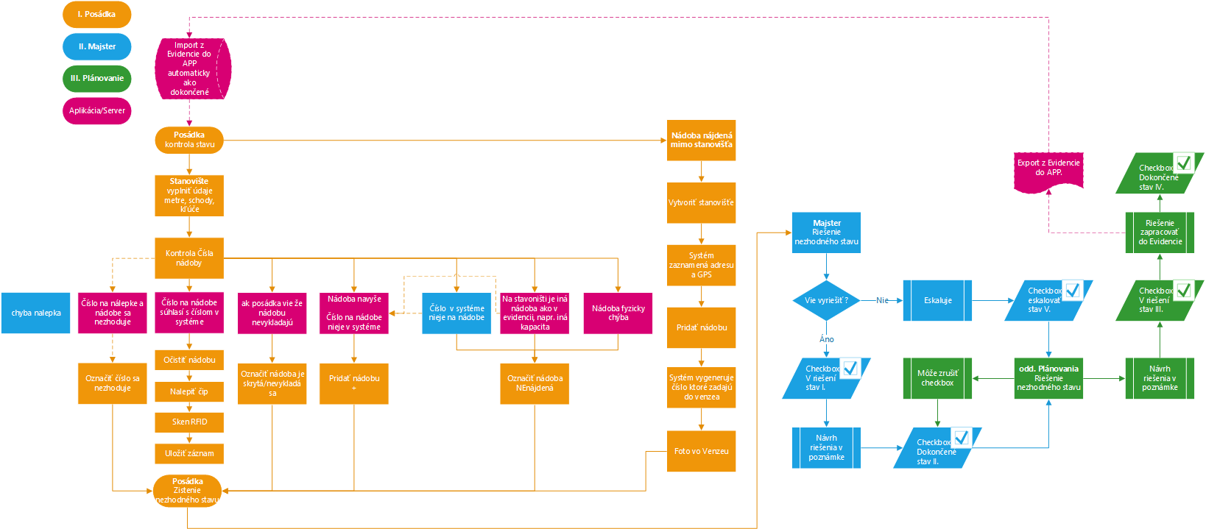

Stickers printing
Functionality enabling to print formatted technical and information stickers. Requires the option to create and edit the print layout and parameters. Printing of individual stickers or sticker batches based on the selected parameters.
Example of stickers visualisation; design will be adapted during implementation.
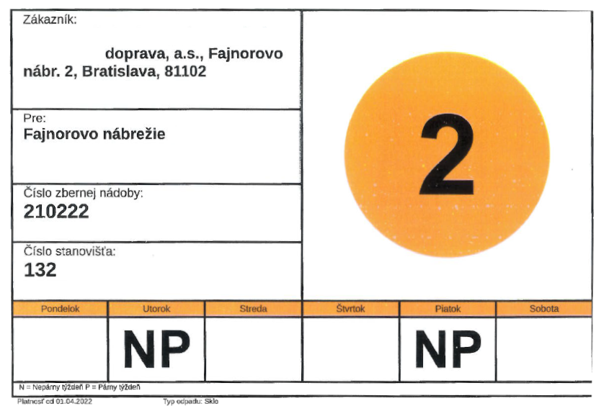
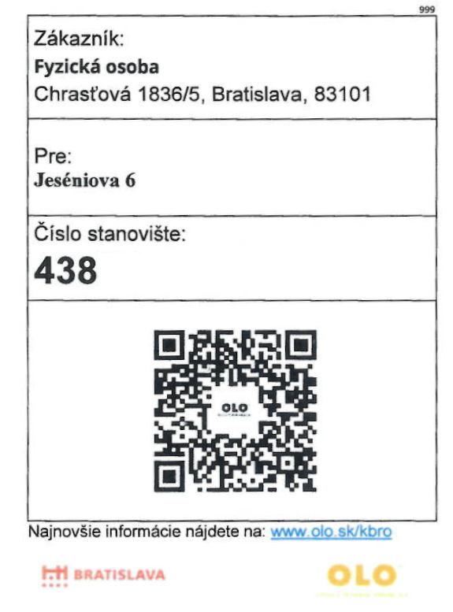

Change and lifecycle log
Functionality for automatically generating a change log for data, enabling to monitor long-term development of changes, tracking life cycle of containers by commodity parameters, zone, vehicles, crews. Monitoring container quality through registered Defects and Maintenance of containers.

2.0 Fleet Management Module

This module contains data collection and processing functionality from vehicles through the operation of monitoring units in the form of IaaS (Infrastructure as a Service) installed on the vehicles, delivery and operation of monitoring units and provision of the services of GPS monitoring of the location of the vehicles of the Contracting Entity, monitoring vehicle consumption and other operational values, creating an electronic vehicle logbook and reports.
General description of the service parameters for Module :
- Operating monitoring units and monitoring vehicle consumption.
The service includes:
  - Delivery of monitoring units for lorries and passenger cars, ,
  - The tenderer will submit a data sheet of the offered monitoring unit,
  - Delivery of capacitance probes for the purpose of measuring fuel level in the fuel tank,
- The tenderer will submit a data sheet of the offered capacitance probe,
- installation of the monitoring units in vehicles at the premises of the Contracting Entity as per an approved schedule, which will for an annex to the contract,
- connecting the monitoring units to CAN BUS or FMS (as per technical conditions of the vehicle)

- On-line collection and transfer of monitoring data described in Paragraph 2 (including GSM connection to the mobile operator – the contract price includes SIM cards and mobile data service and comprehensive SIM card administration)
- Automatic processing of the data from the monitoring unit into a database.
- maintenance, exchange or repair of monitoring units to ensure at least 99.95% availability of data,
- Collection and transfer of operational status and data to the Platform and the Module.
The service includes:
  - Collection of data for a defined number of monitoring units in vehicles,
  - GSM/GPRS transfer;
  - Connection of the Module and transfer of selected data to the other Modules of the Platform and internal systems of the Contracting Entity (ERP, Collection management, BI)
  - For passenger vehicles importing refuelling data based on fuel cards and automatic verification of the correctness of refuelling data for all vehicles, for lorries importing refuelling data through integration to the fuel dispensers (Paragraph 4.0)
Displaying and administration of data through web, SW, or app interface:
    - Administration for all vehicles for which the service provided: vehicle editing, creating groups and subgroups of vehicles and drivers, creating and administration of vehicles, fuel cards, names and perimeters of own locations – polygons (reporting inputs/outputs from locations and notifications when leaving a location and drive-through speed), users, opportunity to add and edit data on individual drives (refuelling, mileage, calibration)
    - Vehicle registration
      - Vehicle registration number
      - Make
      - Model
      - Additional information (such as type of superstructure, type of lift-tipping mechanism, etc.)
      - Overview of past and scheduled service inspections of vehicles,
    - Driver registration
      - Name and surname
      - Personal number
      - Statistics generated in time for follow-up driver evaluation – acceleration, breaking, mileage, current speed, current consumption
    - Option of assigning drivers and rest of the crew to vehicles
    - Monitoring all data from vehicles in real time in miscellaneous form (table, maps, etc.)
    - Vehicle position on the map
      - Actual GPS
      - Historical GPS
    - Vehicle status
      - Ignition turned on
      - Engine running
      - Revolutions
      - Speed
      - Current consumption
      - Breaking
      - Acceleration
      - Time since vehicle engine started running
      - Journey duration
      - Stationary vehicle with engine running
      - Engine running + superstructure on
      - Turned off
      - Measuring fuel drop during engine off, by way of inspection and comparing it against the last status
      - Alternative parameters as per technical options of each vehicle:
        - Fuel level based on the vehicle fuel gauge
        - Option to monitor number of persons on board of the vehicle (only for certain vehicles: sensors inside the seats)
        - Engine temperature (for CAN BUS)
    - Crating a electronic vehicle logbook for all vehicles for a selected period (simple and detailed – each stand/collection point), in a printable format. The logbook will include a summary of work mileage measured based on the input of work activities of the lorries (total mileage, individually per each input, parallel mode, mileage excluding work activities input turned on) and numbers of roads driven on (option to define road categories by numbers). The logbook thus needs to contain:

      - Statement of fuel consumption for the vehicle, journey, driver,
      - Transferring points of interest (POI) defined by the Contracting Entity into the logbook,
      - Basic data (vehicle registration number, vehicle type, time of departure/arrival, mileage, route, fuel level for lorries – consumed fuel, refuelling, consumption per individual sections)
      - Information about the current road number as per the road database (including records of any change that splits a route), the vehicle is moving on,
      - Special records of work distances driven (vehicle in work mode, i.e. superstructure and hydraulics are on) based on information from the connected external inputs of the lorries (vehicle superstructure and container tipping mechanism) (including when several inputs are turned on at the same time),
      - Special records (outside of work mode) of journeys without work activities inputs turned on
      - Registering data regarding place and time of turning on/off work inputs without the need to stop the vehicle,
      - Arrival,
      - Departure,
      - Mileage,

    - Creation and evidence ofan electronic STAS – Daily electronic evidence - report of LKW regular operation - logbook only for lorries, that contains parameters (see the example bellow)
STAS example
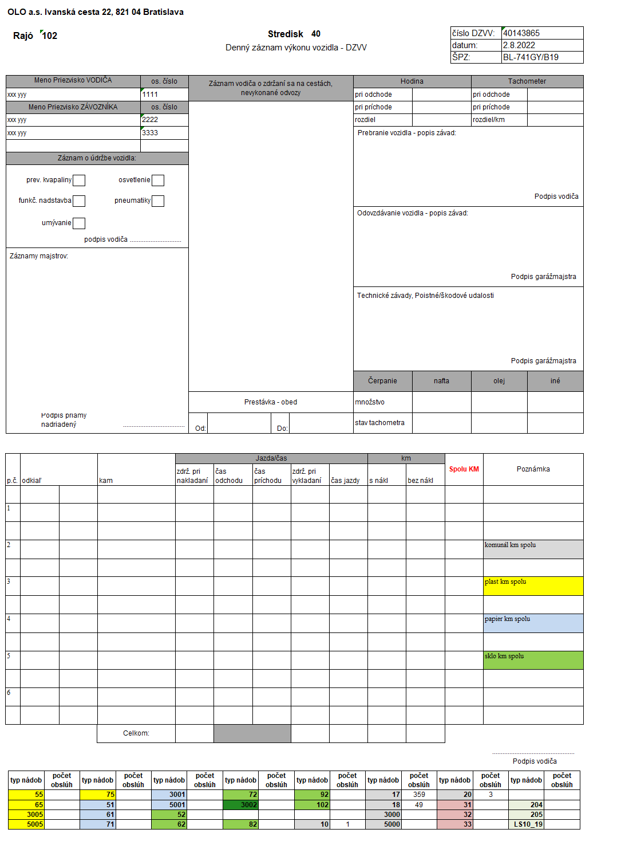

      - Data incoming from several sources
        - Collection management system
        - Work attendance
        - Vehicle logbook
        - Weight, weight statement
        - Vehicle maintenance
      - Processing data into STAS format
      - Filing and transfer of created STAS into the bookkeeping system (4.6 eSTAS)
    - Distance per drive
    - Mileage
    - Monitoring private and business trips (only for passenger cars)
    - Current speed
    - Refuelling
      - Date, time
      - Volume
      - Mileage at the time of refuelling
    - Generating reports, charts, and statistics for vehicles and drivers internally in the module or through MS Power BI, number and type of reports to be determined during implementation.
      - Daily, weekly, monthly, quarterly, annually or individually
    - Monitoring information about driving style
      - Speed
      - Acceleration and breaking manner
      - By sections and maximum speed limit per section
      - Exceeding maximum speed limit
      - Creating polygons on the map with the option to set the following polygon rules: maximum speed limit
      - Creating Point Of Interest (headquarters, ZEVO, collection yards, composting plan, etc.)
      - No entry
      - Time spent within polygon
      - Ban to leave polygon
    - Evaluating vehicle driving and drivers
      - Mutual comparison
      - Creating a Top 1 ranking of drivers
      - Monitoring driving style of drivers in vehicle – driving style as per accelerometer and GPS data or based on real CAN BUS statistics – max. speed, average speed, idling time, drive duration per individual section (as per filter). 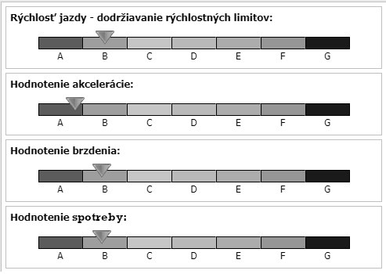
    - Impact of driving style on vehicle wear, calculation of costs

Pic 1 Illustrative example of possible evaluation

2.1 General technical requirements regarding the Fleet Management Module:
  - Supplying and installing monitoring units enabling to connect to CAN BUS/FMS according to the Schedule in Annex 5,
  - In case that there is already another unit or device in the vehicle that prevents the connection of the monitoring unit to the vehicle, Provider informs Customer about this issue and Customer decides on the dismantling of this unit or device.
  - Supplying user documentation to the monitoring units including detailed technical description, description of protocols, links and data transfers,
  - Implementing and commissioning of the Fleet Management Module,
  - Successful collection and processing of data from the monitoring units: 100% for all functional monitoring units,
  - Automatically generating reports:
    - Daily and monthly statements of the operation of all vehicles;
    - Statements per drivers;
    - Statements of fuel consumption, including evaluation of driving style of all vehicles and drivers;
    - Evaluating driving efficiency depending on driving style;
    - Functionality of reporting the history of visited location;
    - Statistical data regarding the use of vehicles, described below (reports example);
    - Overview of operational costs – vehicles;
    - Statement of complying with the preset path per individual drivers;
    - Comprehensive records of vehicle driving route, annual history of movements including option to display on map;
    - Reporting average consumption in relevant month.
  - Sending selected alerts and measured values by each authorised employee to dispatch, email, mobile phone, and tablet in the vehicle for the driver, with the option to select from the following alerts
    - Revolutions when idling at 0km/h in excess of 5minutes (customisable)
    - Hydraulics turned on outside of scheduled collection point
    - Detour outside of scheduled route 3% (customisable)
    - Exceeding maximum speed limit on road or within polygon
    - Wrong-way driving
    - Inappropriate acceleration, accident or breakdown
    - Notifying the vehicle owner in miscellaneous situations (such as driving without authorisation)
    - Alert of vehicle theft or towing
    - Setting up notification of fuel tank tampering (sudden leakage of fuel tank) through e-mail or SMS for lorries
    - Notification of vehicles driving in reverse with waste collector standing on the stoop
  - As part of the Module graphical presentation of measured values depending on time (speed, vehicle fuel level)
  - Displaying vehicles in miscellaneous maps (Google Maps) in real time with the option to filter and custom settings regarding data arrangement.
  - Defining custom GEO – zones of optional shape and POI including administration.

2.2 Technical specification of the monitoring units:
The Contracting Entity does not insist on the supply of one monitoring unit that would cover the entire Functionality; however, the supplied solution must, as a whole, have the specified Functionality (i.e. it is possible to supply several units of which each covers a portion of the specified Functionalities and together, they form one functional unit). At the same time, Customer does not insist that PKWs will be equipped with the same monitoring unit/monitoring units as LKWs and leaves Provider with the option of offering monitoring units for different types of vehicles, at its own discretion, while the overall solution must again meet all the specified Functionalities and is at Providers discretion to offer the solution it considers the most appropriate in terms of the competitiveness of its offer. Due to the wide range of vehicle types, manufacturers and models, a unified gateway (data collection gateway) is required – the monitoring unit complying with the requirements below. Replacing the functionality of the monitoring unit by using a table is not admissible.
As part of the implementation stage, the Contracting Entity requires the supply, installation, and activation of the monitoring units on vehicles, in the amount specified in Annex 2 List of Vehicles.
The Contracting Entity requires that 5 monitoring units be supplied throughout the term of the contract for the lorries to be kept in stock by the Contracting Entity. These will be used as backup units for instances of monitoring unit failure or breakdown.
In the event of monitoring unit failure, the Provider shall provide for replacement or repair of the monitoring unit at the premises of the Contracting Entity as per the SLA and support (Annex 4).
If, during the contract term, the fleet of the Contracting Entity is renewed or the new vehicles are added to the fleet, the Provider shall at its own cost provide for the supply, installation, and activation of a monitoring unit as per SLA and assistance (Annex 4).

- Monitoring unit – Lorry:
    - Dedicated, compact, mechanically resistant equipment located either in or outside the vehicle cabin, secured against any outside interference. Monitors vehicle movements, collects vehicle data, emptying recognition, collects data on containers located around the vehicle.
    - SIM card slot and GSM data sending functionality
    - Sensor for identification of the driver and rest of the crew with an employee card, sending information about the current vehicle crew to the Fleet management module (2.0), for attendance processing and registration in eSTAS and in the logbook
    - If the monitoring unit is located in the vehicle cabin, it is required that equipment with external antennas is supplied, so that GPS signal is available also when vehicles are moving between high-rises and GSM signal is available to transfer data.
    - Option to detect and record inappropriate acceleration, deceleration, or overload (by way of a sensor that is capable to record information about inappropriate breaking, deceleration, acceleration) and software equipment that is capable of diagnosing any potential accident or breakdown and send an alert to previously specified recipients (dispatch, emergency services, etc.),
    - Automatic self-diagnostics of monitoring unit failure and of all connected interfaces (GPS, RFID antennas, attendance card readers) in the vehicle with automatic notification of the Provider of the equipment failure (removing the failure as per the SLA and assistance (Annex 4).
    - If the monitoring unit is located in the vehicle cabin, it is required that the accelerometer is located on a stable (unsprung) part of the vehicle to read data about acceleration and breaking for the purpose of driving style calculation.
    - Option to communicate with the equipment when vehicle is turned off.
    - Recording any power supply breakdowns, service interventions and connection of the equipment.
    - Remote administration, option to setup operational parameters, and remote control of overall function remotely (to be carried out by the Provider as per the requirements provided in the SLA plus assistance (Annex 4).
    - Internal event log recording all information according to the specification of the Monitoring Unit in time and recording no less than each 5 seconds YYYYY MM DD HH MM SS. For each event, in particular Date-Time, GPS, Speed, current consumption, confirmed container emptying RFID, confirmed crew attendance. Sending the event log automatically no less than each 10 minutes.
    - “Data buffer” mode – the equipment sends collection data automatically online, in the event of loss of connectivity the equipment stores the data in its internal memory and sends it once connection is re-established. After sending the data, the equipment awaits feedback from the server confirming receipt of the data and quality of the data. The equipment stores the data during the entire day/collection into an internal memory and at the end of the collection, once the vehicle arrives to the depo, all the data are sent in one go to the server. This safeguards multi-level protection of data against loss or damage.
    - Option to establish current-real time position of vehicle, upon request of the SW user.
    - Feedback on arriving to a pre-defined area or point within the defined polygon for POI identification.
    - Comprehensive data about the route of vehicle movement, available as part of the platform throughout the term of the contract.
    - Backup battery and internal memory to record at least 5 hours of continuous collection of data in the event of loss of the mobile operator signal or loss of connectivity or interruption of power supply,
    - Combined reading of RFID tags using the UHF frequency UHF 865 – 868 2W ERP; 916,1 – 918,9 4W ERP and LF 125 – 134,2KHz RFID
      - 2 exterior short-range antennas during emptying of containers, when the container is turned upside-down.
      - 2 exterior long-range antennas during drive/downtime of vehicle, reading the containers around the vehicle, during journey, etc.
      - Exterior LF antennas for a very short distance on the “ridge” and on the loader
      - For the avoidance of doubt, the contract subject does not include the supply of RFID.
      - The solution cannot be limited to the number of registered and read RFIDs.
      - The Contracting Entity will carry out bag collection without RFID reading or other readings (QR code, etc.).
    - Connection to ECU/FMS for collecting data on vehicle operation (status, speed, motor speed, braking, acceleration, fuel consumption)
    - Collection of sorting waste in bags is not a subject to evidence via RFID/QR
    - Customer does not require RFID reading for 110l round metal containers "kuka"
    - Technical pre-preparation of the monitoring unit for connecting the system of dynamic container weighing. Pre-preparation means the possibility of future connection of dynamic container weighing technology - connectors, data buses, electronics, etc. so that after connection, the monitoring unit can send data from the scales to the Platform for further recording and processing. The subject of current public procurement is not the supply and installation of weighing equipment.
    - The vehicles of Customer are not pre-prepared for the installation of a dynamic container weighing system
- Monitoring unit – Passenger vehicle:
  - Reader to identify driver and the rest of the crew based on employee card, by sending info on current crew to the Fleet Management Module, to process attendance and STAS records and vehicle logbook,
  - Realtime reading of GPS position of vehicle,
  - Recording of starting and destination points (street, city)
  - Driving time recording,
  - Equipment roaming (for passenger vehicles)
  - If data are transferred while roaming, optimising data volume depending on roaming fees, which shall not exceed three times the cost of the fee for transferring data nationally (Slovakia).

2.3 Specific requirements regarding Module functionality:
- Quick arrival regime to record vehicle downtime when it is not necessary to turn of the ignition of the monitored vehicle, detailed records (logs) for all vehicles.

3.0 Collection Planning Module

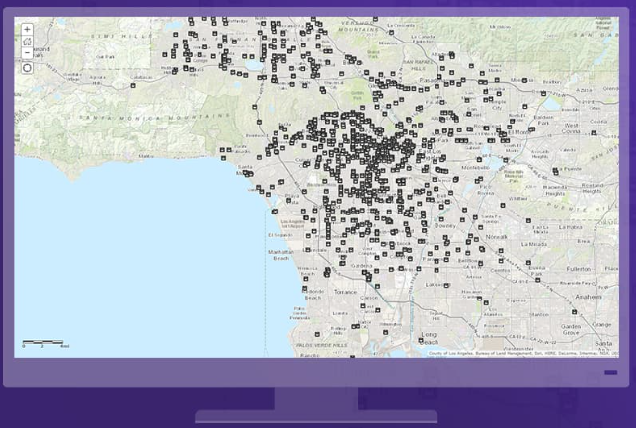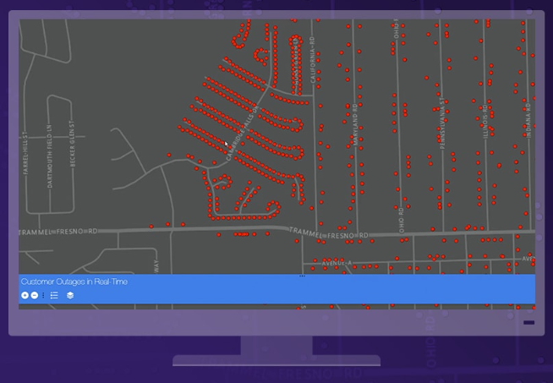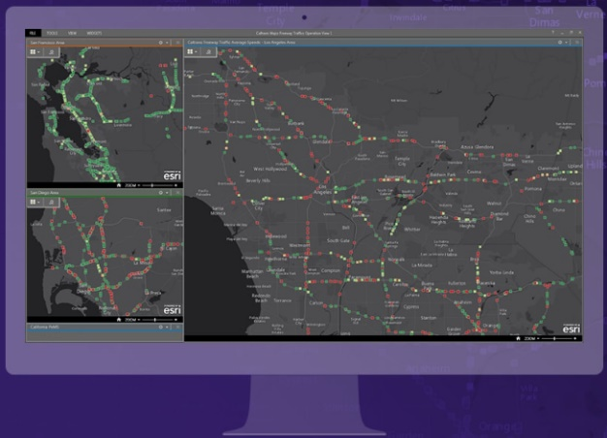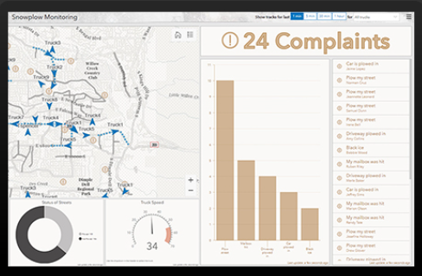

Geographic Information System that generates, processes, analyses, and maps all types of data. The system combines data and map layers by using localisation data including all types of descriptive information (metadata). The manner of data processing in the GIS enables staff to recognise templates and relationships within a geographic context, which contributes to increased efficiency and improvement of management decisions. The system is expected to offer native integration (supported by the system manufacturer) with Power BI.

The Module consists of two main interlinked parts, which form one functional unit.

After platform launch, the initial plan will be created based on the data imported from the SW of Protank Dynamics (requirement for platform integration with this SW is further specified in subparagraph 4.0 of this document).

The tool for automated and manual creation of draft plans. Data-oriented planning.

Part 1. Creating plans

In addition to automatically creating and manually editing plans, the tool enables to manually generate a general plan based on basic inputs from the contract and the field parameters without the information from previous collections. The initial plan is created for instance if a new category/commodity of waste collection is introduced (such as BRO, Oil, KBRO, Bagged waste collection), containers disinfection, skip containers or in the event of a change to the planning strategy and optimizing waste collection by the Company management or the Town Council (such as combining or separating commodities within an area, cancelling a waste collection day, crew workload, vehicle capacity utilization, fuel cost). The exact algorithm for creating plans will be designed during implementation stage based on technical requirements.

Part 2. Waste collection evaluation
- Collecting data from the Fleet Management Module
- Evaluation of the plan vs. execution of the collection
- Recognising, evaluating and visualising trends
- Generating reports
- Monitoring KPI performance

Evaluation at driver level:

On the tablet, drivers can evaluate their current waste collection job in the form of a quick overview based on the number of containers, waste type, containers picked up not picked up, containers for which a recent change entry has been made, text list of orders for a specific waste collection, extraordinary and alternative waste collection, reference trajectory – usual collection route, to a certain extent, it may replace navigation, particularly if the vehicle driver does not know the route. At the end of shift, the driver has the opportunity to visually check the collection, add a comment to the containers, order, street and entire waste collection.

Evaluation at foreman level:

The foreman evaluates, adds comments to containers, finalises a collection job.
When evaluating a completed waste collection, the system sends a notification to the head of customer department, to give them a heads up in terms of complaints (Customer Services capacities).

Evaluation at planning level:

Creating trends and mathematic models, comparison of models, evaluation and choosing the best model as input for plan and schedule creation. Assessing accuracy of chosen model after completion of waste collection and model fine-tuning.
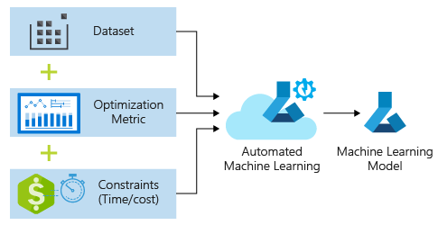

Creating an optimised plan based on input from waste collection evaluation, includes, in particular detailed adjustment of parameters to improve waste collection efficiency.
The planning system should enable to create draft plans (template) based on input parameters (data from individual Modules) and expected deliverables (defined by the user authorised to create plans). The draft plans contain estimates of the plan parameters, savings, efficiency, etc. Allows to run a software simulation and visualisation of plan implementation based on maps. Based on this the planning department staff chooses the most suitable plan applies it to Waste Collection.

Requires the creation of two types of plans: Zone Plan and Waste Collection Plan. Based on the partial Zone Plan and the Waste Collection Plan
an Overall Plan will be created, consisting of zones and their parameters using a table, line, and cascading layout.
Collection planning as a whole based on inputs and zone parameters.
Zone and Collection Planning are linked, any change to one area affects the other area.
The inputs to create both types of plans (zones and collection) include the following parameters – actual number of crew staff, vehicles, collection points, etc. – specified in section Data Registration Module will enable automatic modelling of plans based on user-provided arbitrary KPI, parameters and their combinations. The Source of the parameters may be parameters manually put in through the user interface of the Planning Module, selecting parameters based on maps, choice of databases from the Fleet Module or Electronic Registration.

Total Time | Total Distance | Maximum Plan capacity
Employee Overtime | Missed Collections | Road Restrictions
Employee Workload | Seasonal planning | Speed limits
Mileage | Vehicle type/capacity | Area/territory constraints
Fuel cost | Waste type | Time constraints
CO2 emissions | Capacity vehicle/waste type | Cost profiles
Driver regulation | Customer based obstructions | Additional services

The resulting plan will be modelled so as to allow for the pre-defined KPI:
- lowest consumption,
- Efficient use of worktime fund,
- fleet – number of working hours of the engine, number of pickups mileage,
- performance of the determined schedule.
- Efficiency of collection in terms of “smoothness” and speed - e.g. sampling rate 5 consecutive points speed more than 10kmh and less than 50kmh distance more than 200m outside the city

The planning tool needs to enable ad hoc adjustments to the plan through adding and taking away containers based on daily changes to customer contacts. The created plan should anticipate such changes and provides a buffer.

The Planning Module will optimise the resulting plan based on data from the individual modules using the principles of AI and machine learning based on the determined arbitrary KPI parameters and:
Analysis of input data (machine learning), specifically:
- Vehicle data collected in the Fleet Management Module
  - Engine revolutions
  - Engine temperature
  - Fuel consumption
  - Fuel level
  - Mileage
  - Vehicle speed (maximum, throughout the journey)
  - Status of additional equipment, such as hydraulics – lifting mechanism, RFID - scan
  - Vehicle breakdowns (breakdown reports, breakdown codes)
- Data collected by the system
  - Crew login data through RON employee card
    - Registered data for collection job
  - Electronic STAS (logbook)
    - Data registration (as per STAS above) for the purpose of storing the data in electronic STAS
  - Vehicle location
    - Displaying vehicle location through system GUI
    - Recording vehicle route
  - Container emptying data
    - Reading QR codes or container RFIDs at the moment of container emptying

Offline and historical data (created internally in OLO, manually or automatically collected historical data, imported to the platform during the platform implementation stage):
- Municipality parameters
- Street map
- Passability – the system automatically recognises the type of vehicle that was able to pass through the route
- One -way streets
- Dead-end streets – without the possibility of making a U-turn, vehicle needs to reverse to the collection point
- No entry for our vehicles
- Regular traffic congestions
- Temporary restrictions
- Regular restrictions
- Maximum speed limit
- Noise restrictions – static parameter set up by staff per container stand, street, or commodity – the plan does not enable to collect glass during night in the city centre
- Weather conditions/seasonality
- Current weather conditions (including changes)
- Weather forecast
- Historical weather (using historical data)

- Route planning
  - Task assignment
    - Identifying zone
    - Identifying crew
    - Identifying route by streets and address points
  - Automatic rerouting in the event of changes to online data
  - Evaluating and displaying deviations from real route against planned route
- Online data - collected from existing online platforms, used by the crew of the collection vehicle on the respective collection day, on the planned route, displaying alerts and recommendations on the tablet.
  - Traffic density (historical data, online data)
  - Predictions of traffic density based on historical data
  - Restrictions
  - Weather
  - Weather effects on traffic
- Collecting data from glass containers (bell-shaped containers)
  - The Contracting Entity expects that the supplied platform will be able to receive and process data from the sensors mounted on the waste containers.
  - For the avoidance of doubt, the contract subject does not include the supply of sensors.
  - Online data on the level of container fill degree (waste level in container) from the sensors.
  - A sensor is an equipment that needs to be mounted on the waste container
  - It measures the waste level by sending an audible signal and measuring the time from when the signal is emitted until it bounces back
  - It sends the recorded data online through LPWAN (LoRaWan, SigFx and other) to the central database
  - The Planning Module analyses the data and based on the set level of fill assigns containers to the collection plan
  - In future, the Contracting Entity expects to receive and process data from 2000 sensors
  - The Contracting Entity expects to register the sensors through the existing passportisation app that is not limited by the manner of ID reading (Bluetooth, QRcode, UHF RFID, BARcode)

3.1 Further requirements for the Planning Module:

Notifications/alerts functionality:
  - Sending and displaying error alerts
  - Sending and displaying alerts of discrepancies based on proposed plan
  - Displaying real estimates of performance of the proposed drive plan including measured/established deviations
  - Estimated return of crew – allocating vehicle to next shift
We require that the proposed system be able to work with external data that may affect/affect the level of optimisation of the route planning. Jointly with other data, these data will be used by the system to calculate and evaluate the most optimal route.
The system needs to contain maps that will display the position of vehicles, their planned routes and any potential deviations from the routes, the location of container stands or containers.
Container stands and containers data:
To calculate routes or route optimisation, the system may also use all data that affect the positive result of performance, with an emphasis on indicators such as speed, consumption or duration, etc. It is necessary that the administrator is able to set each performance target for each plan individually. The performance target will be defined by the administrator with view of the above parameters as per “Evaluation at planning level”.
The data on containers stands and containers will be sourced from external systems, passportisation, application for takeover of container stands, imports from .xls sheets. Over time, a single central database will be created.

3.2 “Rebeka” Planning Regime

As part of the Planning Module, the Contracting Entity also requires Functionality that enables testing parameters of equipment, site, and crew. The required Functionality should enable running a test of collection plans to create test collections tailored to all the parameters, and assigning the test collection job to a specific crew that will perform it to evaluate of the performance feasibility. Assigning a test collection to a crew through setting up availability in the tablet. The crew will run the plan on the tablet and take the planned route, which will enable to collect information on the passability of the route by the vehicle. The system will generate a report to which the crew may add comments regarding implementation of the test collection. The planning department will then apply the collected information to the individual entities (roads, streets, container stands, containers, collection points, etc.).
The aim here is to collect data that will be then used to confirm or change the collection parameters before the collection job is added to the collection plan.

3.3 Planning regimes supply/takeaway/exchange of containers

The planning regime proper as a Functionality of the Planning Module enables to plan based on the status defined on the containers (for delivery, for exchange, for takeaway) the performance of the crew that are in charge of this activity. Integration to the passportisation app and Module 3.16 Stock Management System for Containers. Including integration to Noris and Softip where requests for new containers, takeaway or exchange are made.
Preparing delivery route, informing the customer on the expected delivery time based on the created schedule, information sent to the Container Stock Module to prepare container and print a sticker. Creating a loading bill with precise loading and unloading sequence using the First In Last Out principle.
Example of delivery note from Softip

Example of delivery note in the app
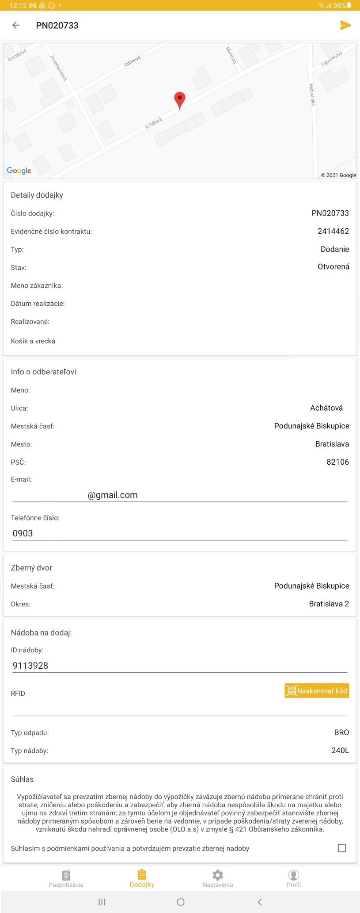

3.4 Planning Regime for OLO Taxi

Stand-alone Functionality in the Planning Module, enables to plan HR capacities for OLO Taxi. OLO Taxi is a service offered to transport bulky waste, most often furniture, that is offered to households in the capital - for a fee, a vehicle including crew (a flatbed truck) is made available on site. The crew then makes sure the waste is loaded onto the truck and transport it to ZEVO. It is required that the Functionality offers the planning of staff capacity, planning of OLO Taxi vehicles capacity. It is required that the Functionality enables integration to the future CRM solution which will include a customer zone where customers can order and pay for a service and choose a date for the services.

3.5 Skip containers (VKK) Planning Regime

Stand-alone Functionality in the Planning Module, enables planning, monitoring, and evaluating the use of available skip containers (number of available skips in stock and number of skips located with customers), allocated vehicles – truck equipped with hook loaders.
Long-term use of skips (for the purposes of the Contracting Entity)/skips used by third parties (for the purposes of contractual customers of the Contracting Entity) and ad hoc third-party planning (based on ad hoc orders of customers).
The plan needs to enable dynamic data inputs from CRM / Softip, Contracts and Orders.
During the term of a Contract that is a product of this tender, integration to a future CRM solution is required which will include a customer zone where customers can order and pay for a service and choose a date for the services.
Integration to Softip contracts and orders registry which will serve as source of information for planning capacities and activities.

As part of the Functionality, we also require Asset Management to monitor the distribution of skips on maps, monitoring available skips, with the information then used as input data for Sales Department for the purpose of further sale. Distribution of the skips is automatically recorded by the monitoring unit upon unloading from or loading the skip onto the truck based on GPS coordinates and in time.
The functionality must make it possible to coordinate the planning of internal and external orders (one-time and long-term) and to plan the capacities of vehicles, drivers and Skip containers based on defined priorities (internal use of Skip containers takes priority). Enable the reserve capacity of skip containers. Integration for time personnel capacity planning. Planning in the form of time slots, taking into consideration the time for transport and loading.

3.6 “Freestyle” Planning Regime
Stand-alone Functionality in the Planning Module, enables to plan other types of activities based on existing documents and data. For instance, planning the distribution of new commodities or bags requires viewing the current location of containers, container stands, and address points on a map in selected areas, with the option to place distribution points on the map and assigning and calculating relating objects in the area, displaying totals.

4.0 Integration interfaces
The Platform will be integrated into the following existing and prepared system of OLO and the Town Council. The integrations will be carried out in stages; for each integrated Software a separate analysis will be drafted, the analysis will include a list of parameters that are to be transferred, transfer requirements, editing mode and responsibilities for individual parameters, change logs. This analysis will be part of the implementation analysis for individual modules (see Contract, point 7.2 and Appendix No. 5 Schedule). For these integrations, functionality or a tool is required to enable OLO staff analysing and editing data prior to uploading into the main database; this oversight higher quality of the data recorded.
When it comes to integration outwards from OLO, a tool is required that will enable checking the data prior to sending.

Noris
A system administered by the Town Council and used to processing data for the purpose of collecting local taxes and fees by OMDPaL (Oddelenie Miestnych Daní Poplatkov a Licencií). It is the main source for OLO to carry out its business. It is required that the data from Noris be synchronised with the central database through the integration API or using an alternative tool through Web Scraping. As part of the integration, the regime of the integration, synchronisation and editing of data will be defined. The integration needs to contain a change log based on which any changes can be clearly identified, so that the competent staff is able to take the necessary steps or launch an automatic process based on the change.
The table below shows the data currently processed by Noris and Protank.

Title of column in NORIS | PD OLD | Title of column in Protank Dynamics | Title of PD Contract item | Title of column PD Customers
Year |  |  | Year (new column see mission)
 | AKU - municipality
 | AKU - district
Address – collection place | AKU - street |  | Collection place - street
OČ | AKU – orientation No. |  | Collection place – orientation No.
SČ | AKU – descriptive No. |  | Collection place – descriptive No.
Land plot No.
District or borough of land plot | AKU - borough
Place description |  |  | Collection place
 | Description
“Address of collection place”
Orientation No. of collection place
Descriptive No. of collection place
Customer | Customer | Customer
Brackets for Customer
Contract | Customer - Contact |  | Collection place - contact
Phone No. | Phone - container
Contact for SMS
E-mail | Email - container |  | Collection place - contact
Note |  |  |  | Contact
Reg. No. | Ref. No. of order | Contract Ref. No.
 | Container No.
Container type |  |  | Container type
Name of container type |  |  | Container note
 | Volume
Waste type | Material |  | Waste type
Frequency | Interval |  | Number of collections per week/days
 | Frequency
 | Even week
 | Odd week
Weekdays |  |  | Frequency
Number of containers | Number |  | Number
Reg. No. of containers | Reg. no. of container |  | Reg. No. of container
RFID Tag
 | RFID
 | Container material
 | Zone
 | Plant
 | Stand No.
 | Stand name
 | Stand - municipality
 | Stand - district
 | Stand - borough
 | Stand - street
 | Stand – orientation No.
 | Stand -descriptive No.
Equipment status |  |  | External status
Staff in charge |  |  | Staff in charge
Price type (field empty in NORIS)
 | Price type
TP/Seat - municipality | Customer - municipality |  |  | Borough
 | Customer - district
 | Customer - borough
TP/Seat - street | Customer - street |  |  | Street
TP/Seat-orientation No. | Customer – orientation No. |  |  | Orientation No.
TP/Seat-descriptive No. | Customer – descriptive No. |  |  | Descriptive No.
TP/Seat – ZIP Code | ZIP Code |  |  | ZIP Code
Business ID | Customer – Business ID |  |  | Business ID
Tx ID |  |  |  | Tax ID
Valid from | Valid from | Valid from
Valid through | Valid through | Valid through
 | Season from
Season (start day) | Merged in the background |  | Season from
Season (start month) |  |  | Season from
 | Season to
Season (end day) |  |  | Season to
Season (end month) |  |  | Season to
Last change |  |  | Date and time of last change
Initial status |  |  | Original number of containers
To be delivered |  |  | Containers added
Takeaway |  |  | Containers taken away
Closing status |  |  | Final number of containers
Container - note |  |  | Note
Container – user note |  |  | Customer note
User status |  |  | User status
PA - municipality |  |  | KA - municipality
PA - street |  |  | KA - street
PA – orientation No. |  |  | KA – orientation No.
PA – descriptive No. |  |  | KA – descriptive No.
PA – ZIP Code |  |  | KA – ZIP Code

Softip
Business, accounting and ERP software.

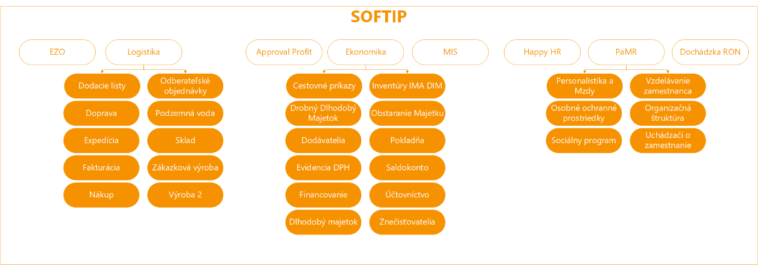

Protank
Software used for waste collection activities. It records Noris contracts, containers, container stands, zones, crews, vehicles, collection schedules. Collecting and evaluating data of completed waste collections. The data processes are shown in Table 4.1 NORIS

Passport App / Delivery Takeaway Exchange
App used to collect data about waste containers in the field
Data processed in the app

Delivery note/Delivery | Delivery note/Takeaway | Delivery note/Exchange
Detail | Detail | Detail
Delivery note No. | Delivery Note No. | Delivery note No.
Contract Ref. No. | Contract Ref. No. | Contract Ref. No.
Type | Type | Type
Status | Status | Status
Customer name | Customer name | Customer name
Realisation date | Realisation date | Realisation date
Realised | Realised | Realised
Basket and bags
Customer Info | Customer Info | Customer Info
Name | Name | Name
Street | Street | Street
Borough | Borough | Borough
 | Municipality | Mesto
ZIP Code | ZIP Code | ZIP Code
E-mail | E-mail | E-mail
Phone | Phone | Phone
Collection Yard | Container Stand | Container Stand
Borough | Borough | Borough
District | District | District
Container for delivery | Original container | Original container
Container ID | Container ID | Container ID
RFID | RFID | RFID
Waste type | Waste type | Waste type
Container type | Container type | Container type
 | Other than original container | Other than original container
 | Container not in system - Checkbox | Container not in system - Checkbox
 | Container ID + Search | Container ID + Search
 | RFID + Scan & Search | RFID + Scan & Search
 | Waste type | Waste type
 | Container volume | Container volume
 |  | Container for exchange
 |  | Container ID
 |  | RFID + Scan
 |  | Waste type
 |  | Container type
Consent | Consent | Consent
Checkbox | Checkbox | Checkbox

App to takeover container stands and quality control
App used to register new container stands, recording stands and quality control of waste collection in the field. App running on MS Power Apps
The application for taking over and evidence of container stands, serves for:
• evidence of existing container stands and the performance of periodic inspections for the purpose of updating the status of the stands
• Approval process of new stands (classic container stands + semi-underground containers(PPK)
• quality control of collection performance in the field

Subject of integration:
• Integration to the central DB r/w (transfer of all types of data to container stand)
• Synchronization/delivery of the current list of container stand and collection sites
• evidence of the items/parameters for the collection stand (according to the application form)
• evidence and status monitoring
- New
- For approval – approval process in the collection stand application
- Pre-approved semi-underground containers (PPK) – approval process in the collection stand application
- Approved – approval process in the collection stand application
- Unapproved - approval process in the collection stand application
- Imported – status for objects that will be imported into the application from ext. system or DB
- Canceled – approval process in the collection stand application

eSTAS
Integration of several of the above systems for the purpose of logically grouping data to create a daily vehicle performance report.

Ron
Attendance management system for OLO staff.

MS Sharepoint
Intranet and miscellaneous administrative and supporting apps. Integration is expected with the functionality Time and HR planning of crews by foremen as part of the electronic STAS.

Venzeo
App used to manage reports of inconsistencies and issues during waste collection in the field. Photo documentation of container stands, containers, place of delivery, pollution of objects, etc.
The system should ensure the possibility of import and communication of data, e.g. import of photos, GPS coordinates

CRM
Central service software used to electronically process business processes and service requirements (internal and external). Customer zone will be in CRM, i.e. access of households to data from the procured solution will be in CRM. Registration and authentication of households will happen through the CRM system. By way of integration, CRM and the procured solution will share the necessary data, including but not limited to contract data, contract items, schedules, orders.

Fleet maintenance system
System of planning and recording vehicle maintenance. Integration is expected at the level of electronic STAS to keep records of established vehicle defects prior to ride.

Hemak Scalis – Automated vehicle weighing system
Automated vehicle weighing system into ZEVO. The Contracting Entity expects integration into the software for the purpose of transferring data on planned and completed waste collections. The main data transferred will be vehicle data, commodity data and quantity data.

MS Power BI
Sending data for statistical processing
Generating initial reports on initial integration. The Contracting Entity expects that the Provider create 15 basic reports upon implementation. The table below contains examples of reports. The number and the scope of reports will be defined in the scope of the implementation analysis. The Provider may assume the need of report generation for all types of processed data, subject to several variations and summaries and filters.
In the event of a need to generate reports during contract term, not generated based on an implementation analysis, the generation of such reports will be governed by the requirements of change management provided in SLA and support (Annex4).
Table of report examples
Collection – Summary  - Collection (Zone/ID/Day)  - Operation (Foreman)  - Collection date (Plan date)  - Shift (Morning/Afternoon/Daily/Night)  - Vehicle (Vehicle registration + ID)  - Driver (Name/Surname/Personal ID)  - Waste collector 1 (Name/Surname/Personal ID)  - Waste Collector 2 (Name/Surname/Personal ID)  - Waste Collector x (Name/Surname/Personal ID)  - Assistance vehicle (Yes/No)  - Departure time  - Arrival time  - Collection duration (Hours/Minutes)  - Container pickup (Planned number/Reality)  - Street pickup  - Collection completed (Yes/No/Name of staff completing collection)  - Mileage  - Pickup per km  - Number of vehicle loads  - Waste weight per load (t)  - Fuel used | Notifications  - Idling revolutions at 0km/h in excess of 5 mins. (customisable)  - Hydraulics on outside of planned collection place  - Detour outside planned route 3% (customisable)  - Exceeding maximum speed limit on the road or within polygon  - Wrong-way driving  - Inappropriate acceleration, breaking, accident or breakdown  - Notifying the vehicle owner in miscellaneous situations (such as driving without authorisation)  - Alert of vehicle theft or towing  - Setting up notification of fuel tank tampering (sudden leakage of fuel tank) through e-mail or SMS for lorries  - Notification of vehicles driving in reverse with waste collector standing on the stoop  - Exiting or entering a polygon
Driving Style / Vehicle Activity  - Vehicle (Vehicle registration + ID)  - Driver (Name/Surname/Personal ID)  - Start of monitored period  - End of monitored period  - Chart showing engine revolutions  - Chart showing speed  - Chart showing consumption  - Chart showing acceleration  - Chart showing breaking  - Mileage  - Map showing route | Vehicle Report  - Vehicle (Vehicle registration + ID)  - Monitoring unit (ID)  - Unit status  - SIM (mobile number)  - Data connection status  - Vehicle type  - Date and time of last activity  - Error message code
Fuel – Consumption  - Vehicle (Vehicle registration + ID)  - Driver (Name/Surname/Personal ID)  - Vehicle type  - Plant  - Mileage  - Refuelling (litres)  - Consumption (litres)  - Consumption (litres/km)  - Consumption (litres/100 thousand rev.)  - Consumption cap per 100km  - Consumption per 100km per refuelling  - Deviation  - Operating time (hh:mm)  - Stay duration (hh:mm)  - Idling (hh:mm) | Collection – Container Details  - Collection (Zone/ID/Day)  - Container Stand (ID + Address)  - Collection Date (Plan Date)  - Vehicle (Vehicle registration + ID)  - Customer  - Municipality  - Street  - Orientation number  - Number of containers (1)  - Waste type  - Volume  - Pickup type (GPS/RFID Scan)  - Pickup time (Date/Time)  - RFID  - Container ID  - Attribute of container not picked up

“Waze”
Using the market available platforms to obtain information on traffic conditions.
https://developers.google.com/waze

Plus Codes
System of latitude and longitude coordinates and numbers and letters enabling to define a location on the map. The Contracting Entity expects use of these codes mainly for locating container stands and collection points.
https://maps.google.com/pluscodes/technology/

Infopanels
Displaying information and statistics regarding collection on information panels. Displaying distribution of staff into crews prior to collection start. The information is expected to be displayed in the form of tables through the Platform website.

Handheld Chainway RFID UHF 2D Sled - Android APP BT Integration
Scanner of RFID, BAR, and QR codes, independent Bluetooth connection to a mobile device.
https://www.chainwayeurope.com/en/download#R6

XStation
Software used to keep records of refuelling vehicles. Vehicles and drivers are identified by RFID cards when refuelling. Refuelling data are available through web services or DB query. Integration is expected for collection of data on refuelling, for statistics and planning collection to optimise consumption.

Google maps
Map layers and Street View in planning module.
https://developers.google.com/maps/apis-by-platform

Mapy.CZ
Map layers containing orientation and descriptive numbers of properties. https://api.mapy.cz/

ArcGIS
GIS platform to display data on maps in layers and including background information. Integration to the Cadastral Portal will be carried out through ArcGIS of Bratislava Town Council to display land plots, land plot numbers, and to obtain descriptive numbers in the scope of occupancy permit proceedings of property.
Alternatively, it is possible to use integration by way of https://zbgis.skgeodesy.sk/mkzbgis/sk/kataster?pos=48.170032,17.180475,18

Samsung Galaxy Tab Android 10“ Tablet
Tablets in vehicles where the apps are installed. Tablets together with their operating system will be provided by the Customer and for the avoidance of doubt, their procurement and delivery is not part of the subject of the contract.

