**RAKár**

**Grafický tablet**

**Priemerná cena = (849,17+849,17+ 865,35)/3**

**= 854,56 EUR bez DPH = 1025,47 EUR s DPH**

<https://www.datart.sk/graficky-tablet-wacom-cintiq-22-dtk2260k0a.html>

**ELEKTROSPED, a.s.,** **Diaľničná cesta 6015/12A, Senec 903 01, IČO: 35 765 038**

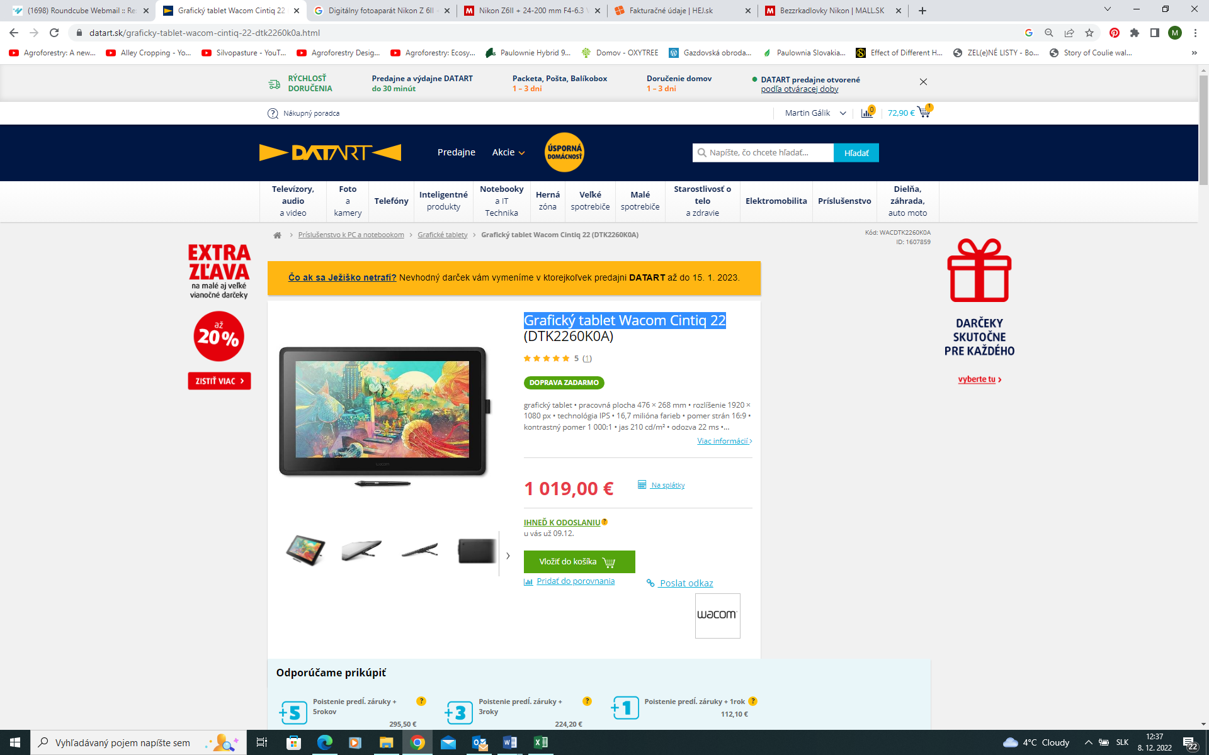

<https://www.alza.sk/wacom-cintiq-22-d5651096.htm?kampan=adw4_prislusenstvi-pro-it-tv_pla_all_prislusenstvo_ostatne_c_1012131___MF110g75_420984916719_~96772070156~&gclid=CjwKCAiAs8acBhA1EiwAgRFdwzw6PdfzubqNNHAT3qFdvbbcFPkHGPWWlQzddTw437hdNIdMC5ePmhoCdWQQAvD_BwE>

**Alza.sk s. r. o., Sliačska 1/D, 831 02 Bratislava, IČO: 36562939**

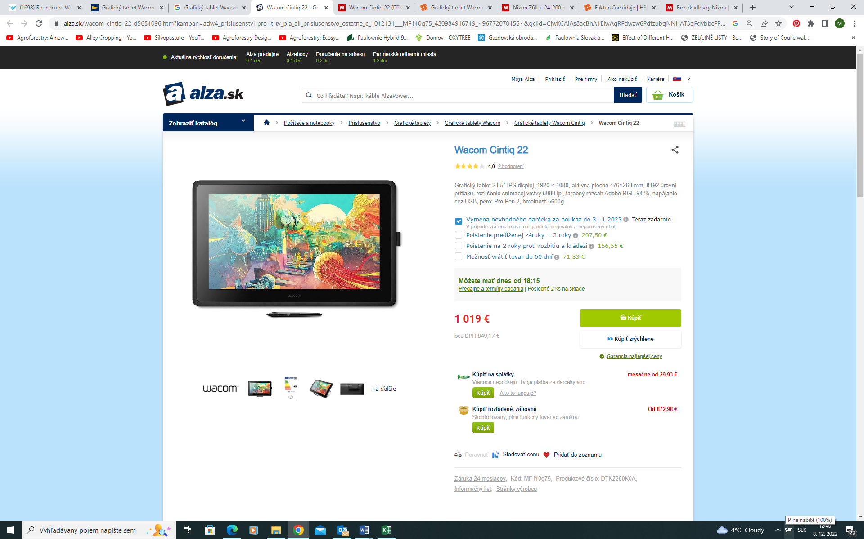

<https://www.mall.sk/kresliace-tablety/wacom-cintiq-22-dtk2260k0a-100059681252?gclid=CjwKCAiAs8acBhA1EiwAgRFdwwU9LOiIIwbkgvYJbFxrKdFXBcrXUAIWOYf0RHPd1-qvSd4PYY3_pxoCVLYQAvD_BwE>

**Internet Mall Slovakia s.r.o.,** **Galvaniho 6, 821 04 Bratislava IČ: 35950226**

