**RAKár**

**Notebook**

**Priemerná cena za 1 ks = (1507,42+1512,75+1507,39)/3 = 1509,19 EUR bez DPH,**

**2 kusy = 3018,37 EUR bez DPH = 3 622,04 EUR s DPH**

<https://www.datart.sk/notebook-hp-envy-17-ch1006nc-58x58ea-bcm-strieborny.html>

**ELEKTROSPED, a.s.,** **Diaľničná cesta 6015/12A, Senec 903 01, IČO: 35 765 038**

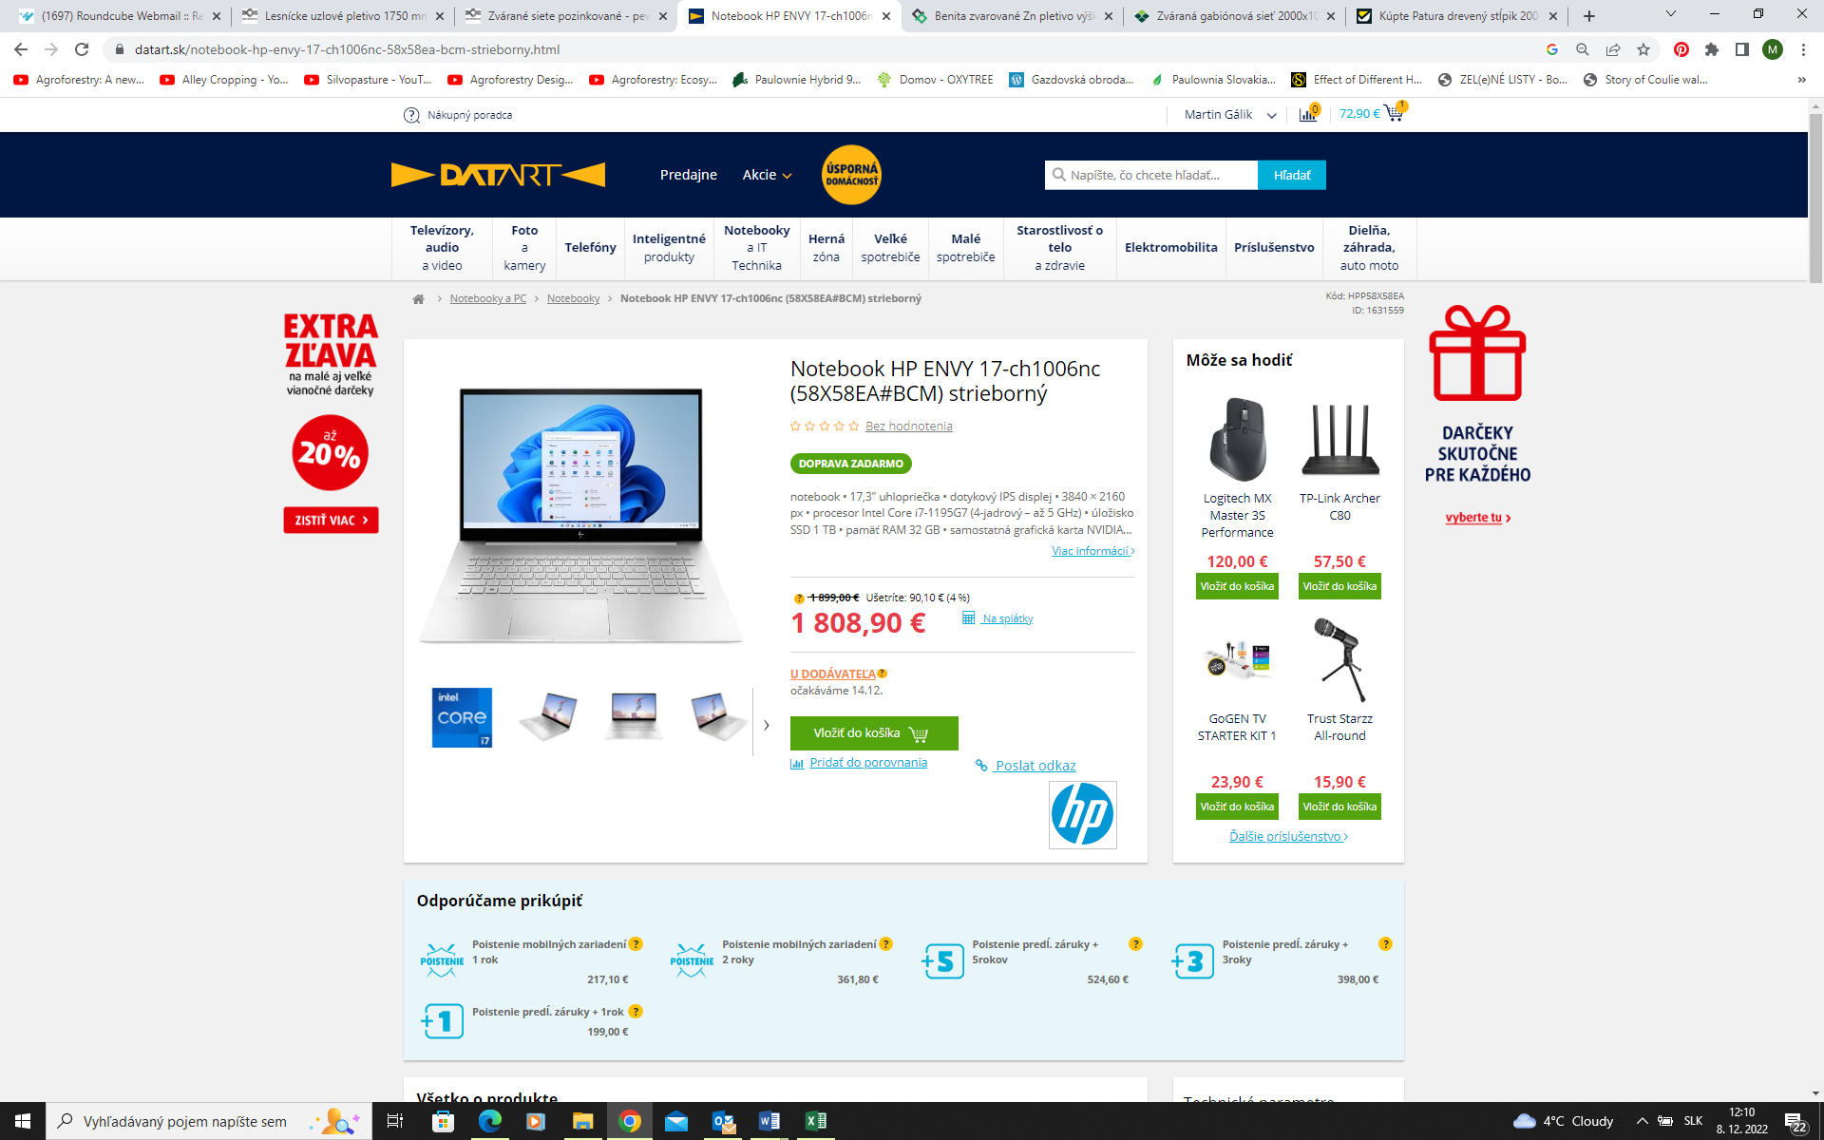

<https://www.mall.sk/notebooky/hp-envy-17-ch1006nc-58x58ea-strieborna-100071725104?tab=description>

**Internet Mall Slovakia s.r.o.,** **Galvaniho 6, 821 04 Bratislava IČ: 35950226**

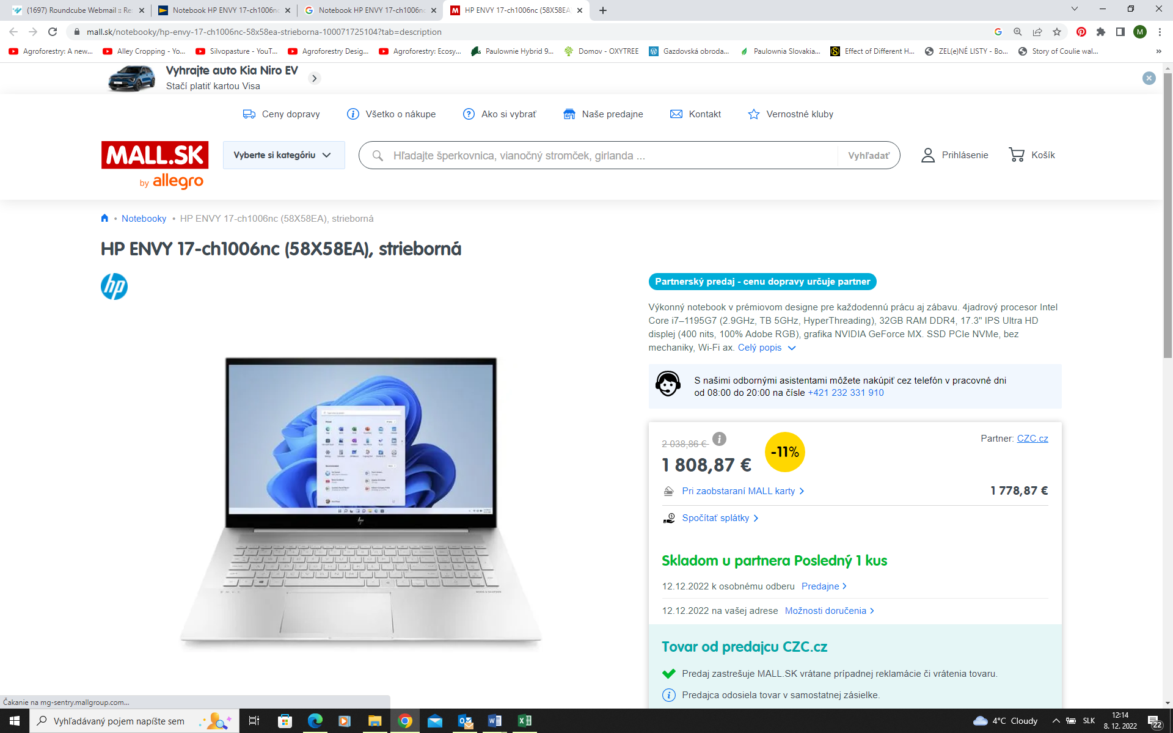

<https://www.hp-shop.sk/produkty/hp-envy-17-ch1006nc-natural-silver-58x58ea>

**Euroline computer s.r.o., Svätoplukova 7, 036 01 Martin, IČO: 36395994**

