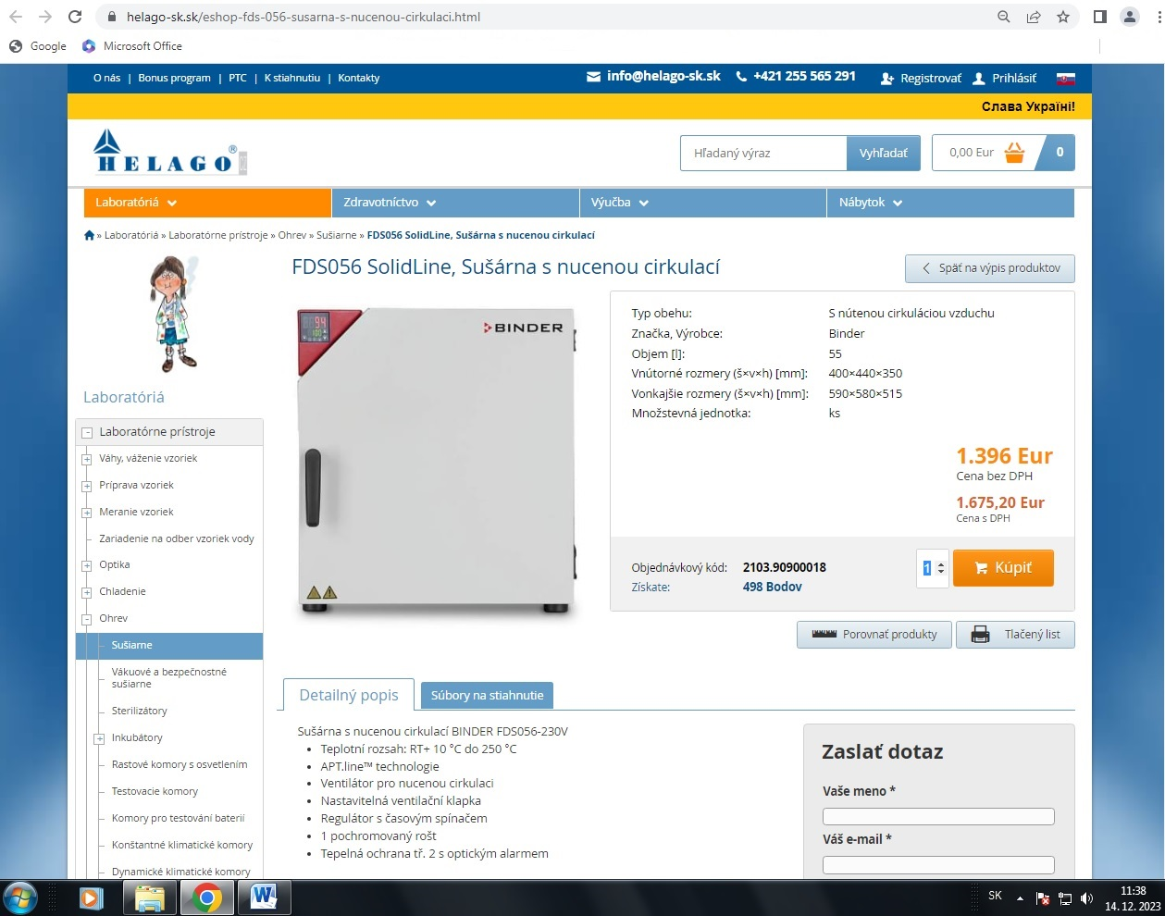
https://www.helago-sk.sk/eshop-fds-056-susarna-s-nucenou-cirkulaci.html
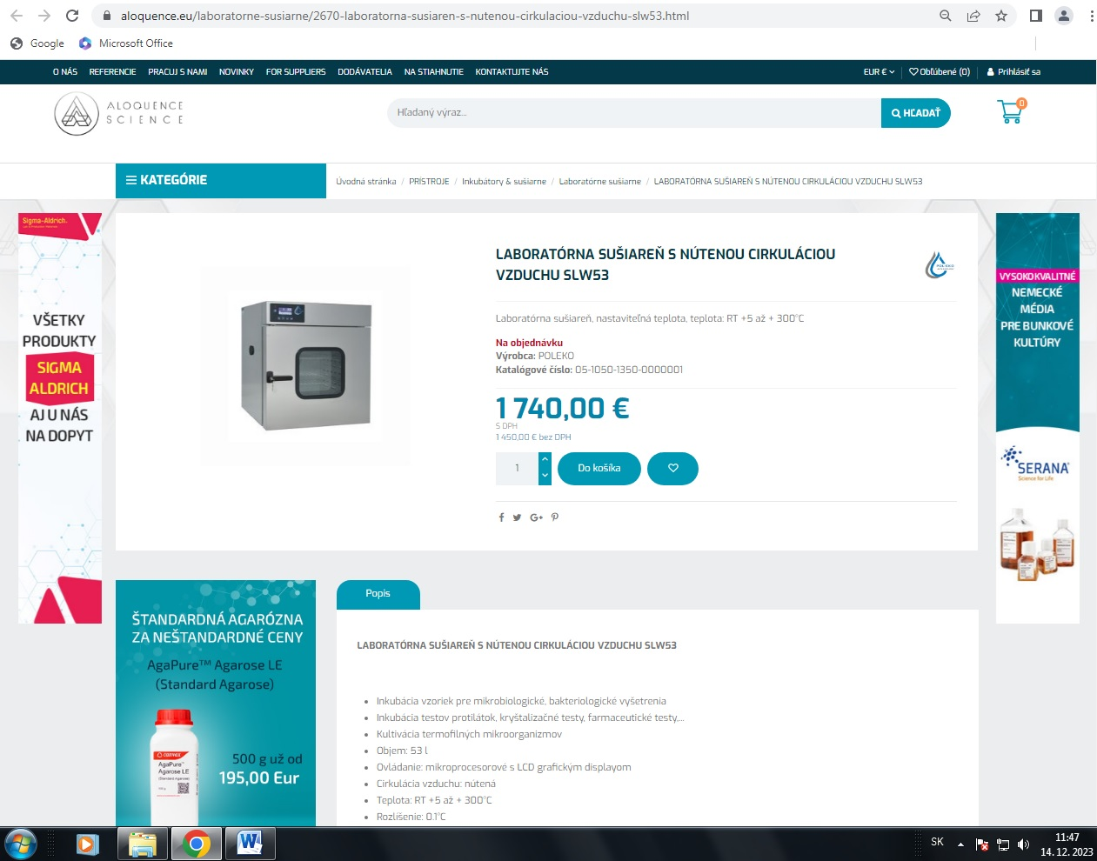
https://aloquence.eu/laboratorne-susiarne/2670-laboratorna-susiaren-s-nutenou-cirkulaciou-vzduchu-slw53.html
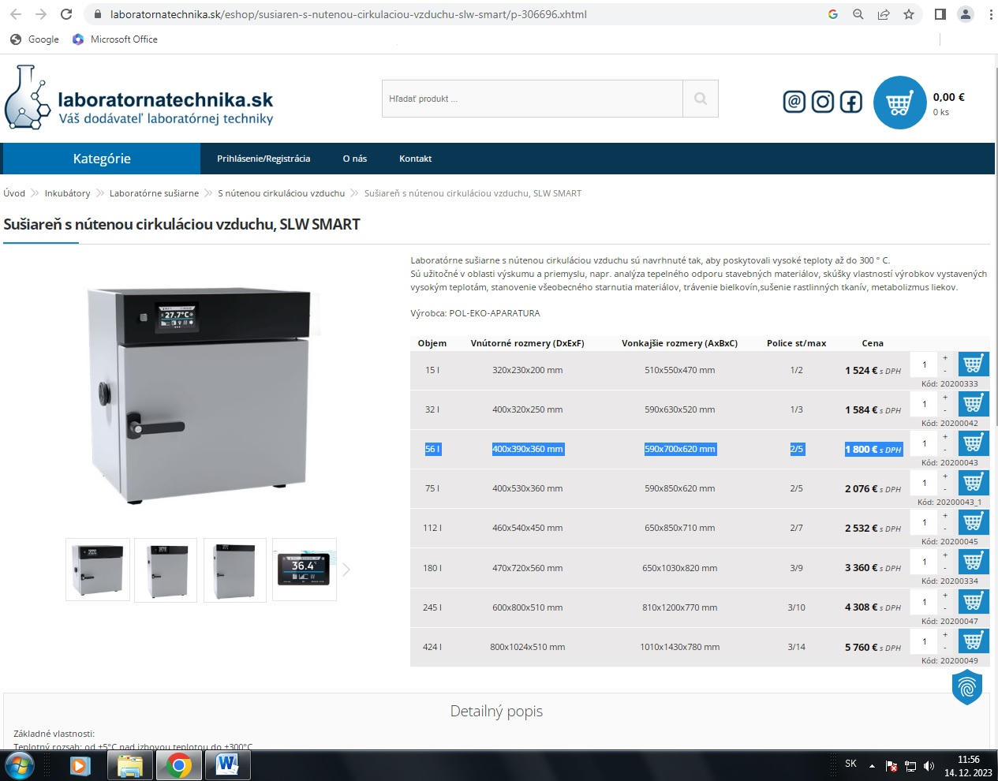
https://www.laboratornatechnika.sk/eshop/susiaren-s-nutenou-cirkulaciou-vzduchu-slw-smart/p-306696.xhtml

