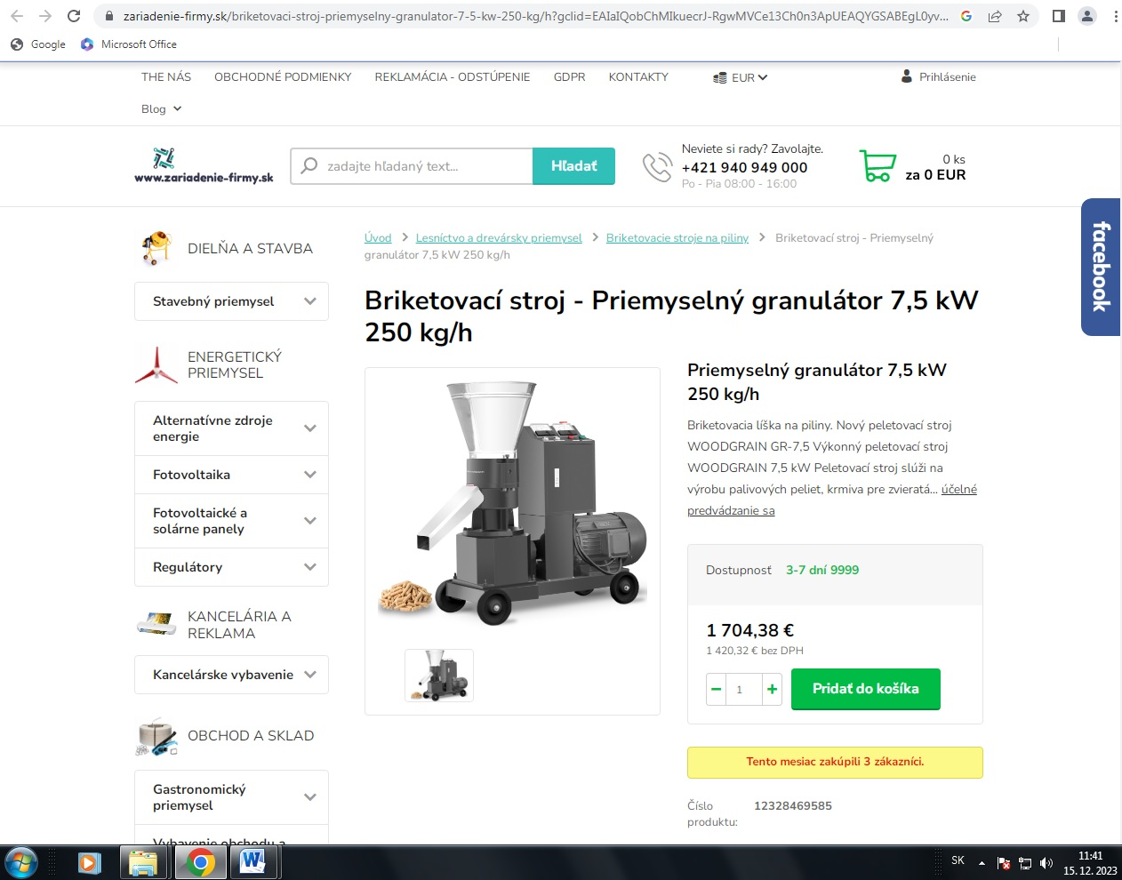
https://www.zariadenie-firmy.sk/briketovaci-stroj-priemyselny-granulator-7-5-kw-250-kg/h?gclid=EAIaIQobChMIkuecrJ-RgwMVCe13Ch0n3ApUEAQYGSABEgL0yvD_BwE#googtrans(sk)

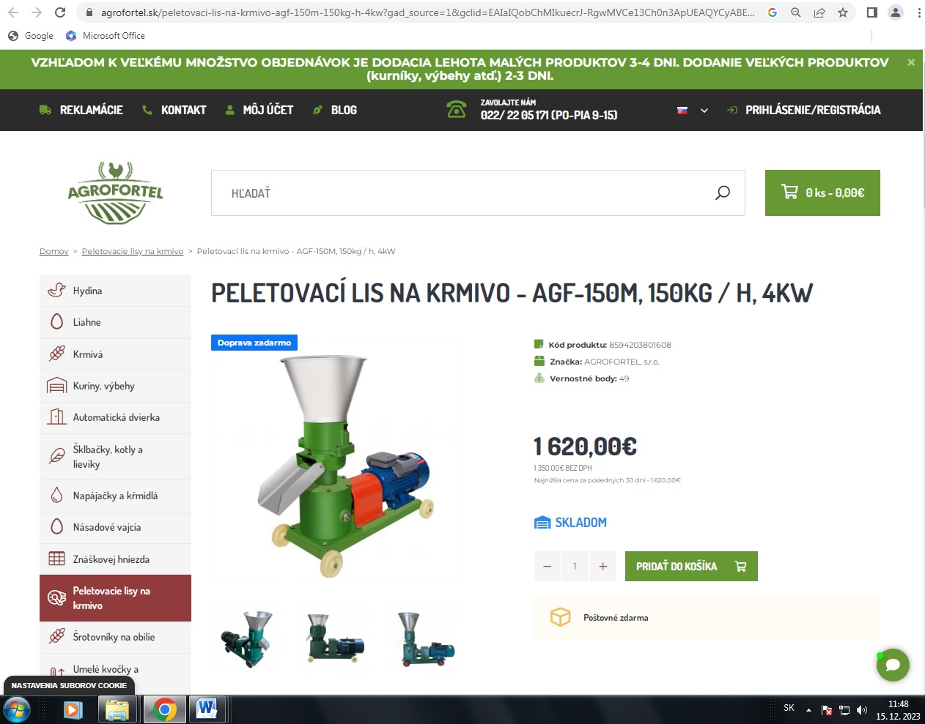
https://agrofortel.sk/peletovaci-lis-na-krmivo-agf-150m-150kg-h-4kw?gad_source=1&gclid=EAIaIQobChMIkuecrJ-RgwMVCe13Ch0n3ApUEAQYCyABEgJfn_D_BwE

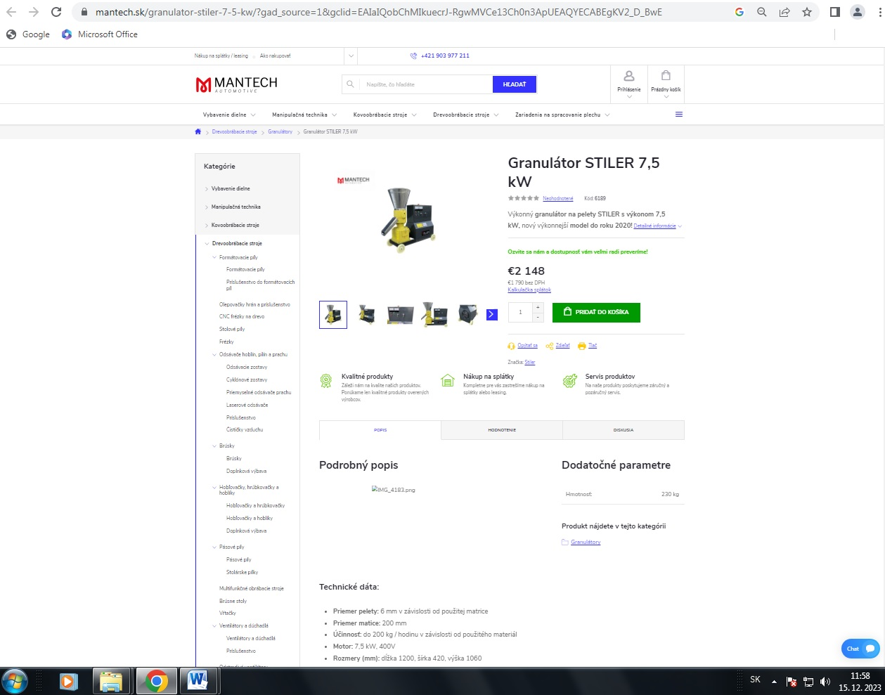
https://www.mantech.sk/granulator-stiler-7-5-kw/?gad_source=1&gclid=EAIaIQobChMIkuecrJ-RgwMVCe13Ch0n3ApUEAQYECABEgKV2_D_BwE

