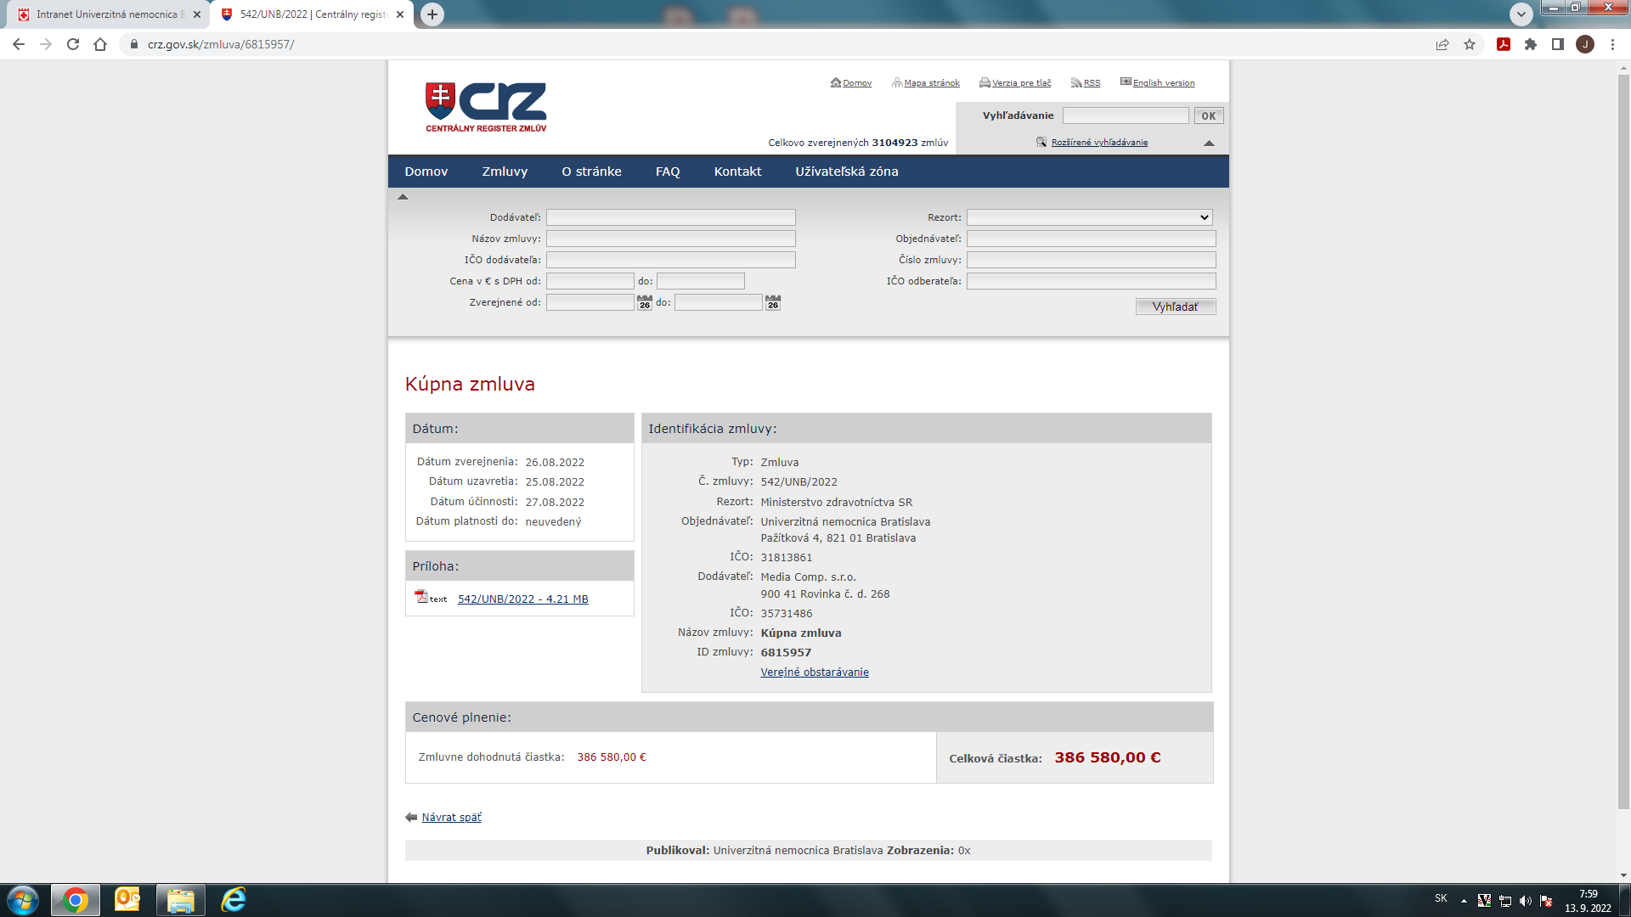

https://www.crz.gov.sk/zmluva/6815957/

