Questions and answers to the tender for „Big boxes for fruit storage – 1200 pcs (ID53372):

**Question 1:**

1. Hello, can you send me the information to print the logo you require on the boxes? Number of colors, logo on how many sides of the box, etc. well thank you

**Explanation:**

1. The requirement for embossing the name of the company was added to annex no. 1 of the tender documents, line no. 11. The actualized annex is available in the documents of this tender. Name of the document is „*Actualization1_Annex 1_Technical specification and price proposal_Big boxes*“.

We also attach an illustration of the embossed logo on the box:

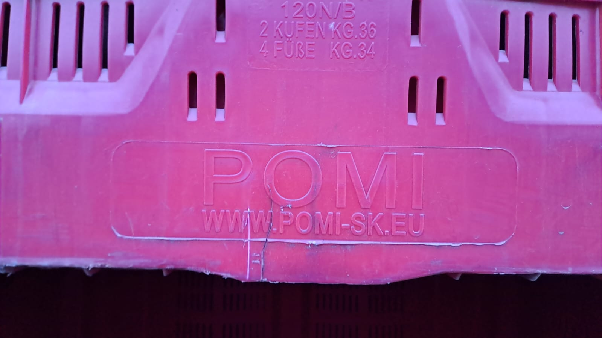

**Question 2:**

2. will you also accept equivalent dimensions, i.e. 100 x 120 x 76 cm, which meet the +/- 5% deviation?

**Explanation:**

2. In accordance with Article 1, par. 1.3 of the Tender documents An equivalent solution is accepted only if it meets „the utility, operational, **functional** and aesthetic characteristics that are necessary to provide the purpose for which the equipment is intended.”

In the Annex 1 to the Tender documents, in second row: „External dimensions including legs 1200x1000x780mm“ **the contracting authority set the required dimensions,** **which must be met in order to ensure compatibility with the contracting authority's existing boxes**.

The tendered Big boxes are intended for the collection and storage of fruit and are certified for stacking 13 containers in a cold store with a weight of 4500 kg.

Based on the above, we therefore state that the equivalent solution proposed by you is not in accordance with the Tender documents.